# ALLAMA IQBAL OPEN UNIVERSITY, ISLAMABAD

***(Department of Business Administration)***

**WARNING**

1. **PLAGIARISM OR HIRING OF GHOST WRITER(S) FOR SOLVING THE ASSIGNMENT(S) WILL DEBAR THE STUDENT FROM THE AWARD OF DEGREE/CERTIFICATE IF FOUND AT ANY STAGE.**
2. **SUBMITTING ASSIGNMENT(S) BORROWED OR STOLEN FROM OTHER(S) AS ONE’S OWN WILL BE PENALIZED AS DEFINED IN THE “AIOU PLAGIARISM POLICY”.**

**Course: Business Research Methods (8431) Semester: Spring, 2025**

**Level: BBA**

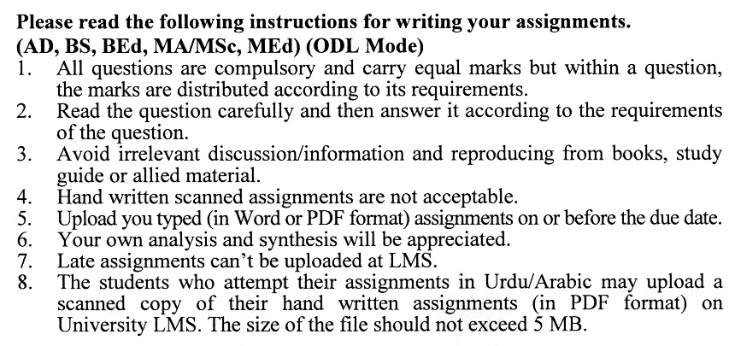

**Total Marks: 100 Pass Marks: 50**

## ASSIGNMENT No. 1

Q. 1 Research performs a distinct function to assist managers to enhance in the decision-making process while effectively gathering information. Elaborate this statement. **(20)**

Q. 2 Being a researcher in the services organization, how can you search the opportunities and monitor the threats to your product? **(20)**

Q. 3 Develop a correlation between concept, hypothesis and theory. Discuss the significant features and classifications of developing theory. **(20)**

Q. 4 Discuss in detail the research data procedure. Elaborate the nature and types of primary and secondary data sources. **(20)**

Q. 5 Analyze logically data acquiring legitimacy relating to internal and external analysis. What special problems do open-ended questions have and how can these be reduced? In what situations the open-ended question is most useful? (**20)**

**ASSIGNMENT No. 2**

**Total Marks: 100 Pass Marks: 50**

Q. 4 What are the various methods of collecting primary data for research in business? Discuss with examples. **(20)**

Q. 2 Discuss and evaluate the basics of exploratory research and its effects on business research with examples. **(20)**

Q. 3 Explain the concept of observation. Discuss the strengths and weaknesses of observation with examples. **(20)**

Q. 4 Define non-probability sampling. Discuss the various types of non-probability sampling with examples. **(20)**

Q. 5 What are the various fundamentals of a business research report? Discuss with examples. **(20)**

