ALLAMA IQBAL OPEN UNIVERSITY, ISLAMABAD

**(Department of Business Administration)**

**WARNING**

1. **PLAGIARISM OR HIRING OF GHOST WRITER(S) FOR SOLVING THE ASSIGNMENT(S) WILL DEBAR THE STUDENT FROM THE AWARD OF DEGREE/CERTIFICATE IF FOUND AT ANY STAGE.**
2. **SUBMITTING ASSIGNMENT(S) BORROWED OR STOLEN FROM OTHER(S) AS ONE’S OWN WILL BE PENALIZED AS DEFINED IN THE “AIOU PLAGIARISM POLICY”.**

## Course: International Marketing (8433) Semester: Spring, 2025

**Level: BBA**

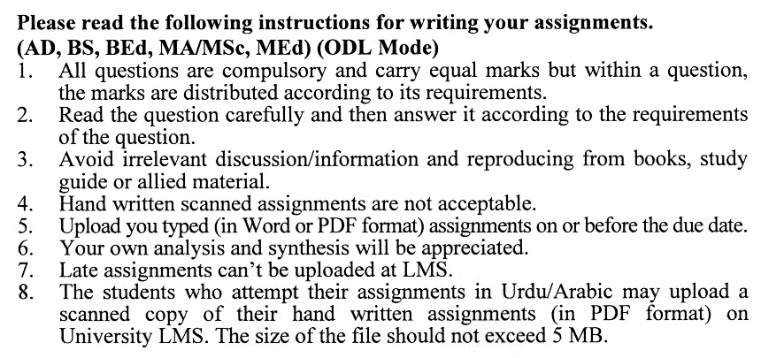

**Total Marks: 100**

**Pass Marks: 50**

**ASSIGNMENT No. 1**

**(Units: 1–5)**

Q.1 How domestic marketing is different from international marketing? Discuss the significance and problems of international marketing in detail. **(20)**

Q. 2 Elucidate the various stages of the product life cycle in an international environment. Which stage do you think is most critical and why? **(20)**

Q. 3 Marketing research is a process of gathering, analyzing and interpreting information about a market, about a product or service to be offered for sale in that market, and about the past, present and potential customers for the product or service. But conducting research in an international environment is a cumbersome process that cannot be executed without coordinated efforts. Highlight the constraints involved in marketing research in an international environment. **(20)**

Q.4 What are the different factors which can inhibit the ability of a marketing firm to enter into the international market? Explain with the help of examples. **(20)**

Q.5 Discuss the role of the Export Promotion Bureau and Trade Development Authority of Pakistan. Suggest strategies to improve exports of Pakistan. **(20)**

**Total Marks: 100 Pass Marks: 50**

**ASSIGNMENT No. 2**

This assignment is a research activity. You are required to visit any business/commercial organization and study their marketing system as a whole of marketing of product and prepare a research report of about 15 to 20 pages on one of the topics given below. To avoid the duplication, you are required to select the topic according to the last digit of your roll number. For example, if your roll number is I-342718 then you will select topic # 8 from the list given below (last digit).

**Topics**

1. International Trading Environment
2. Identifying and Analyzing International Marketing Opportunities
3. Role of Trade Commissioners, Delegations and Trade Development Authority of Pakistan.
4. International Market Entry Strategies
5. International Product Development and Management
6. International Pricing
7. Promoting Products in foreign Markets
8. International Channels of Distribution
9. Organizing for International Marketing Efforts
10. Current issues of Pakistani Exports

**The assignment should be developed in the following format:**

• Introduction

• Review of literature

• The data collection

• Data analysis

• Conclusion and recommendations

• References

• Annexes

**Guidelines for submission of assignments**

You are required to prepare two copies of 2nd assignment. Submit one copy to your tutor/teacher for evaluation and the second copy for presentations in the workshop in the presence of the resource persons and classmates, which will be held at the end of the semester prior to the final examination.

**INTERNTIONAL MARKETING (BBA-8433)**

**Course Introduction:**

For organizations to grow in the global markets, or even just to survive in domestic markets which are increasingly attacked by international players, it is essential that their managers understand the complexity of international marketing and develop the skills, aptitudes and knowledge necessary to compete effectively in the market. Therefore, students who plan to enter marketing profession will need to understand and apply the principles of international marketing.

This course is designed to introduce you to advanced marketing concepts and practices in a global business perspective. A comprehensive overview of the dynamics and trends in international marketing include market analysis, strategic planning, product development, product positioning, distribution and pricing. Special emphasis is placed on the development and delivery of global launches and campaigns. The course addresses the skills necessary for evaluating, developing and delivering marketing programs for a global and multicultural audience. Tutorials, class discussions, assignments, workshops and presentations will help develop strong analytical, creative, team-work and communication skills in the participants along with the key tools and techniques of the discipline.

**Course Objectives:**

**On completion of the course participants will be able to:**

1. Recognize the nature of international marketing and understand the challenges of conducting business in foreign markets;
2. Identify and analyze the foreign market opportunities;
3. Evaluate the alternative foreign market entry modes available to organizations;
4. Demonstrate a sound understanding of how to manage the firm’s marketing mix and activities in international markets;
5. Apply analytical skills in reading case studies, scenarios and international business press.

**Brief Course Outline:**

Unit–1: Introduction to International Marketing

Unit–2: International Trading Environment

Unit–3: Identifying and Analyzing International Marketing Opportunities

Unit–4: International Market Entry Strategies

Unit–5: International Product Development and Management

Unit–6: International Pricing

Unit–7: Promoting Products in Foreign Market

Unit–8: International Channels of Distribution

Unit–9: Organizing for International Marketing Efforts

**DETAILED COURSE OUTLINE (8433)**

**UNIT–1: INTRODUCTION TO INTERNATIONAL MARKETING**

• Developments in international market

• Nature of international marketing

• Strategic importance of international marketing

• International marketing planning

• International marketing vs domestic marketing

• Methods of entering foreign markets

• Factors to be considered before entering export field

• Determinants of international marketing policies

• Stages of international marketing

• Opportunities and challenges in international marketing

**UNIT–2: INTERNATIONAL TRADING ENVIRONMENT**

• Introduction to basic theories of world trade

• Institutions affecting world trade

• Cultural environment

• Sources of cultural knowledge

• Economic environment

• Economic alliances and their impact on international trade

• International political and legal environment

• International trade barriers

• Motivations to internationalization

• Internationalization process

• Change agents

• Trends in exporting, licensing and franchising

• Developments in enabling technology

**UNIT–3: IDENTIFYING AND ANALYZING INTERNATIONL MARKETING OPPORTUNITIES**

• **Management information system**

• Classification of world markets

• Understanding global buyers behaviour

• Market entry conditions

• Investigation of market potentials

• Identifying and measuring potential market information

• Role and organization of international marketing research

• Role of Trade Commissioners, Delegation, and Trade development authority of Pakistan

• Planning a market survey

• Methods and techniques of Market Research

• How to analyse the competition

**UNIT–4: INTERNATIONAL MARKET ENTRY STRAGEGIES**

• Internationalizing marketing operations

• Geographic market choices and their evaluation

• Country selection decision

• Selecting a marketing strategy

• Understanding market entry strategies

– Indirect and direct exporting

– Licensing

– Franchising

– Local manufacturing

• Ownership strategies

– Wholly owned subsidiaries

– Joint ventures

– Strategies alliances

• Entering markets through mergers and acquisitions

• Exit strategies

**UNIT–5: INTERNATIONAL PRODUCT DEVELOPMENT AND MANAGEMENT**

• International market segmentation

• Standardization vs adaptation

• Factors affecting adaptation

• Test marketing

• Assessing the market environment related to the product

– Government regulations

– Non-tariff barriers

– Customer expectations

– Economic conditions

– Competitive offerings

– Climate and geography

• Building product characteristics

– Product constituents

– Branding

– Labeling and packaging

• Product life cycle in international marketing

• Branding decisions

**UNIT–6: INTERNATIONAL PRICING**

• Nature of international pricing

• Factors affecting international pricing

• International pricing strategies

• Understanding terms of sale

• Deciding terms of payment

• Dealing with export transportation

• Managing foreign exchange risk

• Assessing sources of export financing of pricing

• International price negotiation skills

• International price quotations

• Leasing

• Dumping

**UNIT–7: PROMOTING PRODUCTS IN FOREIGN MARKETS**

• Nature of international promotion

• Sales promotion in international markets

• Personal selling

• International public relations

• International advertising strategy

• Role of advertising agency

• Factors affecting selection of advertising agency

• Managing advertising campaign

• Trade fairs and exhibitions

• International branding

**UNIT–8: INTERNATIONAL CHANNELS OF DISTRIBUTION**

• Nature of international channels

• Structure of the international distribution system

• Analyzing national channels

• International channel alternatives

• Factors affecting selection of channel members

• Managing international distribution

• Approaches to channel strategy

• Trends in global distribution

**UNIT–9: ORGANIZING FOR INTERNATIONAL MARKETING EFFORTS**

• Determinants of international marketing organization

• Alternative organization structures

• Phases in the development cycle of international marketing organization

• Assessing the suitability o the organization structure

• Trends in global organization structures

• Control in the international organization

• Conflicts between headquarters and subsidiaries

**RECOMMENDED BOOKS:**

1. Terpstra, V. and Sarathy, R. (2000) *International Marketing,* 8th ed., London; Fort Worth, Tex: Dryden Press.
2. Rugman, A. M., Collinson, S. and Hodgetts, R. M. (2006) *International Business,* Harlow: Financial Times Prentice Hall.
3. Cateora, P. R. and Graham, J. L. (2005) *International Marketing,* 12th ed. Boston: McGraw-Hill/Irwin series in marketing.
4. Gillespie, K., Jeannet, J.P. and Hennessy, H. D. (2004) *Global Marketing: An Interactive Approach, Boston,* MA: Houghton Mifflin.

======