# ALLAMA IQBAL OPEN UNIVERSITY, ISLAMABAD

***(Department of Business Administration)***

**WARNING**

1. **PLAGIARISM OR HIRING OF GHOST WRITER(S) FOR SOLVING THE ASSIGNMENT(S) WILL DEBAR THE STUDENT FROM THE AWARD OF DEGREE/CERTIFICATE IF FOUND AT ANY STAGE.**
2. **SUBMITTING ASSIGNMENT(S) BORROWED OR STOLEN FROM OTHER(S) AS ONE’S OWN WILL BE PENALIZED AS DEFINED IN THE “AIOU PLAGIARISM POLICY”.**

**Course: Marketing Research (5433/8435) Semester: Spring, 2025**

**Level: ADB**

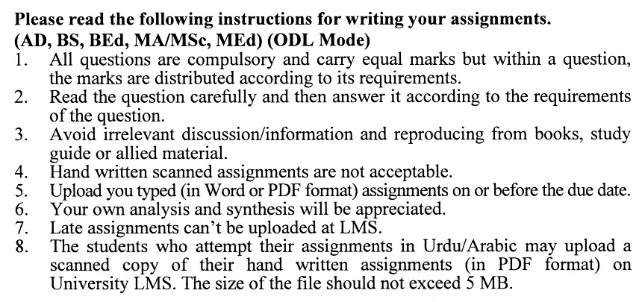

**Total Marks: 100 Pass Marks: 50**

**ASSIGNMENT No. 1**

# (Units: 1–5)

***Note: All questions carry equal marks.***

Q. 1 Why do we need marketing research? Explain the rationale. **(20)**

Q. 2 How marketing research help in decision-making for managers? **(20)**

Q. 3 What are the different types of marketing research? Enlist all and explain any two. **(20)**

Q. 4 What are different tools for collecting information in marketing research? **(20)**

Q. 5 Write short notes on the following: **(10+10)**

* Validation of Data
* Approaches to Determining Sample Size

**ASSIGNMENT No. 2**

**Total Marks: 100**

**Pass Marks: 50**

This assignment is a research-oriented activity. You are required to select one of the following topics according to the last digit of your roll number. For example, if your roll number is D-3427185 then you will select topic # 5 from the list given below (last digit). Visit any business/commercial organization and write a paper of about 1000 words on the topic allotted to you. Prepare two copies of this report; submit one copy to your tutor for evaluation and use the other for presentation in the workshops, which will be held at the end of the semester prior to your final examination.

**Topics:**

1. Data Collection Methods
2. Validation of Data
3. Statistical Analysis for Marketing Research
4. Telephonic Interview
5. Data Collection through Questionnaire
6. Data Collection through Experimentation
7. Data Collection through Observation
8. Types of Research Reports
9. Ethical Issues to Treat Respondents/Subjects

0. Ethical Issues to Treat Researchers

**The report should follow the following format:**

1. Title page
2. Acknowledgements
3. An abstract (one-page summary of the paper)
4. Table of contents
5. Introduction to the topic (brief history & significance of topic assigned)
6. Practical study of the organization (with respect to the topic)
7. Data collection methods.
8. SWOT analysis (strengths, weaknesses, opportunities & threats) relevant to the topic assigned
9. Conclusion (one-page brief covering important aspects of your report)
10. Recommendations (specific recommendations relevant to topic assigned)
11. References (As per AFA format)
12. Annexes (if any)

**GUIDELINES FOR ASSIGNMENT # 2:**

* 1.5 line spacing
* Use headers and subheads throughout all sections
* Organization of ideas
* Writing skills (spelling, grammar, punctuation)
* Professionalism (readability and general appearance)
* Do more than repeat the text
* Express a point of view and defend it.

**WorkshoPS**

The workshop presentations provide you the opportunity to express your communication skills, knowledge & understanding of concepts learned during the practical study assigned in assignment # 2.

You should use transparencies and any other material for effective presentation. The transparencies are not the presentation, but only a tool; the presentation is the combination of the transparencies and your speech. Workshop presentation transparencies should only be in typed format.

**The transparencies should follow the following format:**

1. Title page
2. An abstract (one-page summary of the paper)
3. Introduction to the topic (brief history & significance of topic assigned)
4. Practical study of the organization (with respect to the topic)
5. Data collection methods
6. SWOT analysis (strengths, weaknesses, opportunities & threats) relevant to the topic assigned
7. Conclusion (one-page brief covering important aspects of your report)
8. Recommendations (specific recommendations relevant to the topic assigned)

**GUIDELINES FOR WORKSHOP PRESENTATION:**

* Make eye contact and react to the audience. Don't read from the transparencies or from the report, and don't look too much at the transparencies (occasional glances are acceptable to help in recalling the topic to cover).
* A 15-minute presentation can be practiced several times in advance, so do that until you are confident enough. Some people also use a mirror when rehearsing as a substitute for an audience.

**WEIGHTAGE OF THEORY & PRACTICAL ASPECTS IN ASSIGNMENT # 2 & WORKSHOP PRESENTATIONS:**

Assignment # 2 & workshop presentations are evaluated on the basis of theory & its applicability. The weightage of each aspect would be:

Theory: 60%

Applicability (practical study of the organization): 40%

**MARKETING RESEARCH**

**COURSE OUTLINE (5433)**

**Unit-l: Fundamentals of Marketing Research**

1. Introduction
2. Marketing decision-support system
3. Marketing information systems
4. Decision support mechanism
5. Expert systems and decision support

1.3 Classification of marketing research

1. Business-to-business marketing research
2. Research into services
3. Global marketing research
4. Marketing research process
5. Role of marketing research in marketing decision making
6. Value and limitations of marketing research
7. Users and doers of marketing research
8. Factors affecting marketing research decisions

**Unit-2: Applied Marketing Research**

2.1 Traditional applications of marketing research

1. New-product research
2. Pricing research
3. Distribution research
4. Promotion research

2.2 Contemporary applications of marketing research

1. Competitive advantage
2. Brand equity
3. Customer satisfaction
4. Total quality management

2.3 Emerging applications of marketing research

1. Database marketing
2. E-commerce
3. Relationship marketing
4. Marketing intelligence

**Unit-3: Planning the Research Project**

1. Marketing problems
2. Deciding whether to undertake marketing research
3. Marketing research proposal
4. Research objectives and plans
5. Types and sources of data
6. Tools of marketing research
7. Research Designs
8. The nature of research designs
9. Benefits of research designs
10. Major types of research designs

3.8 Experimental designs

1. The setting of experiments
2. True experimental designs
3. Extensions of true experimental designs
4. Flow to select an experimental design

3.9 Specifying data and acquisition methods

1. Data objectives, data types
2. Communication approaches
3. Formulating a data plan
4. Criteria for evaluating secondary data

3.10 Budgeting and scheduling the research project

**Unit-4: Measurement, Scaling and Questionnaire Design**

4.1 Measurement and scaling

1. Criteria for good measurement
2. Primary scales of measurement
3. Comparative scaling techniques
4. Non-comparative scaling techniques
5. Scale evaluation
6. Sources of measurement problems
7. Managerial considerations for measurement error avoidance
8. Selecting the appropriate scale to use

4.2 Questionnaire design

1. Functions of questionnaire
2. Criteria for a good questionnaire
3. Questionnaire design process
4. Reliability and validity in questionnaire design
5. The observational form

**Unit-5: Sampling**

1. Managerial objectives of sampling
2. The sampling design process
3. Classification of sampling techniques
4. Probability sampling techniques
5. No probability sampling techniques

5.4 Probability sampling methods

1. Fundamental conditions
2. Distribution relationships
3. Interval estimating
4. Estimating the population mean and its precision
5. Estimating a proportion and its precision
6. Validation

5.5 Sample size decisions

1. Approaches to determining sample size
2. Non-response issues in sampling

**Unit-6: Data Collection**

1. Data collection process
2. Data collection methods
3. Observation
4. Interviewing
5. Questionnaire
6. Experimentation
7. Error sources in fieldwork
8. Managing the fieldwork
9. Selection and training of field workers
10. Supervision and validation of fieldwork
11. Evaluation of field workers
12. Classification of survey methods by model administration
13. Telephone methods
14. Personal methods
15. Mail methods
16. Electronic methods
17. Evaluation of survey methods
18. Selection of survey methods
19. Comparison of survey and observation methods

**Unit-7: Data Preparation**

7.1 Data preparation and processing

1. Validation
2. Editing
3. Coding
4. Data-processing methods
5. Utilizing computers
6. Statistically adjusting the data
7. Conducting data processing
8. Classification of statistical techniques
9. Selecting a data analysis strategy
10. Nature and functions of statistical analysis
11. Nature of interpretation
12. The interrelationship between analysis and interpretation
13. The interpretative process
14. Bringing the data into order
15. Statistical summarization
16. Measurers of dispersion
17. Graphical presentation
18. Selecting appropriate analytical methods

7.4 Statistical analysis

1. General hypothesis-testing procedure
2. Marketing and statistical decisions
3. Nonparametric statistics
4. Parametric statistics

**Unit-8: Data Analysis**

8.1 Analysis of experiments

1. Randomized block design
2. Latin square design
3. Factorial design
4. Analysis of covariance

8.2 Investigation of associations (Dependence Methods)

1. Measures of association between two nominal variables
2. Measures of association between two ordinal variables
3. Measurement of association between two or more interval variables
4. Additional measures of association

8.3 Investigation of associations (Interdependence Methods)

1. Factor analysis
2. Cluster analysis
3. Multidimensional scaling and conjoint analysis
4. Planning requirements for efficient analysis

**Unit-9: Report Presentation and Follow-Through**

9.1 Presentation of research findings and follow-through

1. Role of the report
2. Types of reports
3. Contents of the report for executives
4. Principles of report preparation
5. Personal presentations
6. Follow-through

9.2 Managing marketing research

1. Client/researcher interface revisited
2. Clients' research management concern
3. Managing marketing research departments
4. Marketing research agencies
5. Resources for marketing research

9.3 Ethical issues in marketing research

1. Code of ethics
2. Ethical issues involving the treatment of respondents/subjects
3. Ethical issues in the treatment of buyers/clients
4. Ethical issues relating to the treatment of researchers

***Recommended Books:***

Tull, D. S. and Hawkins, D. I. (2000) *Marketing Research: Measurement & Methods,* 6th Ed. Islamabad NBF.

Bradley, Nigel (2007) Marketing *Research: Loots & Techniques,* Oxford: Oxford University Press.

Malhotra, Naresh K. (2006) *Marketing Research: An Applied Orientation.* 5th Ed. Upper Saddle River. N.I: Pearson Prentice Hall.

Proctor, Tony (2005) *Essentials of Marketing Research.* 4lh Ed., Harlow: Financial Times Prentice Hall.

Aaker, David A. Kumar. V. and Day. George S. (2004) *Marketing Research,* 8th Ed., New York; Chichester: John Wiley.