# ALLAMA IQBAL OPEN UNIVERSITY, ISLAMABAD

**(Department of Business Administration)**

Warning

1. Plagiarism or hiring of ghost writer(s) for solving the assignment(s) will debar the student from award of degree/certificate, if found at any stage.
2. Submitting assignment(s) borrowed or stolen from other(s) as one’s own, will be penalized as defined in “AIOU Plagiarism Policy”.

**Course: Human Resource Development (8437) Semester: Spring, 2025**

Level: BBA (4 Years)

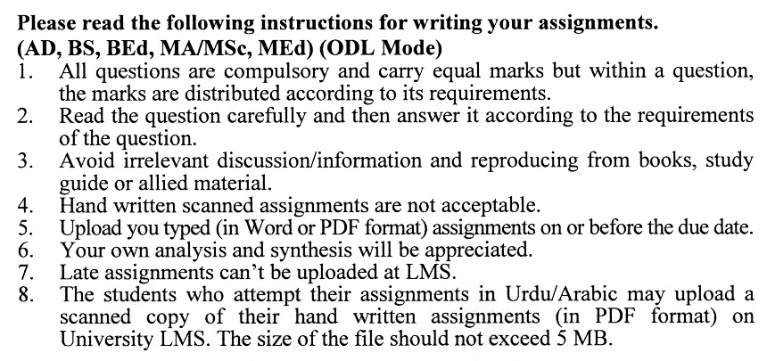

Total Marks: 100 Pass Marks: 50

##### Assignment No. 1

Q. 1 Explain the concept of learning as an individual activity in the context of training and development. How can individuals take ownership of their learning journey and enhance their professional growth? **(20)**

Q. 2 Discuss strategies for improving the processes of learning within organizations. How can organizations create an environment that fosters continuous learning, innovation, and knowledge sharing among employees? **(20)**

Q. 3 Explore the various generic approaches to conducting needs assessments in organizations. How can organizations tailor these approaches to align with their unique goals, challenges, and cultural contexts? **(20)**

Q. 4 What steps should be followed to ensure the successful implementation of a training program, and how can potential challenges be addressed during the design phase? **(20)**

Q. 5 Discuss the importance of preparing and organizing program activities for training sessions. How can proper preparation enhance the learning experience for participants? (**20)**

**ASSIGNMENT No. 2**

**Total Marks: 100 Pass Marks: 50**

Q. 1 Discuss the various methods used for collecting data during the evaluation of training programs. How can organizations ensure that data collection methods are appropriate and reliable? **(20)**

Q. 2 Compare and contrast various methods employed in group work. How can facilitators and team members leverage different techniques to optimize group performance and achieve desired outcomes? **(20)**

Q. 3 Reflect on the role of organizational culture in shaping the approach to training implementation, monitoring, and follow-up. How can a supportive and learning-oriented culture contribute to the success of training initiatives? **(20)**

Q. 4 Explain the concept of self-development and its significance in personal and professional growth. How does self-development differ from other forms of learning and development initiatives? **(20)**

Q. 5 Evaluate the role of reflection and debriefing in experiential learning experiences. How do these processes enhance learning, promote self-awareness, and facilitate knowledge transfer? **(20)**

