**ALLAMA IQBAL OPEN UNIVERSITY, ISLAMABAD**

**(Department of Business Administration)**

**WARNING**

1. **PLAGIARISM OR HIRING OF GHOST WRITER(S) FOR SOLVING THE ASSIGNMENT(S) WILL DEBAR THE STUDENT FROM THE AWARD OF DEGREE/CERTIFICATE IF FOUND AT ANY STAGE.**
2. **SUBMITTING ASSIGNMENT(S) BORROWED OR STOLEN FROM OTHER(S) AS ONE’S OWN WILL BE PENALIZED AS DEFINED IN “AIOU PLAGIARISM POLICY”.**

**Course: Training and Development (8438/5006) Semester: Spring, 2025**

**Level: BBA (4 Years)/MSc**

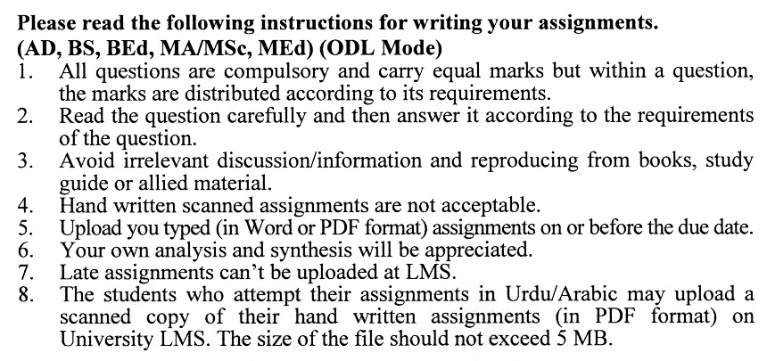

**Guidelines FOR ASSIGNMENT No. 1 & 2:**

You should look upon the assignments as a test of knowledge, management skills, and communication skills. When you write an assignment answer, you are indicating your knowledge to the teacher:

* Your level of understanding of the subject;
* How do you think?
* How well you can reflect on your knowledge & experience?
* How well you can use your knowledge in solving problems, explaining situations, and describing organizations and management?
* How professional you are, and how much care and attention you give to what you do?

To answer a question effectively, address the question directly, bring important related issues into the discussion, refer to sources, and indicate how principles from the course materials apply. You must also be able to identify important problems and implications arising from the answer.

For citing references, writing bibliographies, and formatting the assignment, APA format should be followed.

## Total Marks: 100 Pass Marks: 50

## ASSIGNMENT No. 1

## (Units: 1–5)

#### 

#### Q. 1 A manager at a mid-sized company struggles to motivate their team due to insufficient leadership training. How can the manager apply the learning cycle and learning styles to improve their effectiveness? (20)

#### Q. 2 A training manager needs to address declining productivity in a department. What tools and techniques should they use to conduct a result-oriented training needs assessment?

#### (20)

Q. 3 After executing a new employee training program, the company receives mixed feedback. What data collection methods can they use to evaluate the program's effectiveness and identify areas for improvement? **(20)**

Q. 4 An employee wants to advance their career but lacks confidence in decision-making. How can they use self-development methods and experiential learning to enhance their skills? (**20)**

Q. 5 A training session aims to teach problem-solving skills using the case method. What types of cases should be selected, and how can the trainer ensure the method’s effectiveness? **(20)**

## Total Marks: 100 Pass Marks: 50

**ASSIGNMENT No. 2**

This assignment is a research-oriented activity. You are required to submit a term paper. You will have to prepare a paper of about 15 to 20 pages on the topic allotted to you.

Include the following main headings in your report: -

1. Introduction to the topic
2. Important sub-topics
3. Practical aspects for the topic
4. Review of theoretical and practical situations
5. Merits, demerits, deficiencies or strengths of the organization for your topic
6. Conclusions and recommendations
7. Annex, if any

You are required to select one of the following topics according to the last digit of your roll number. For example, if your roll number is D-3427185 then you will select topic No.5 (the last digit): -

**Topics:**

1. Role of Managers in Adapting to Changing Business Practices
2. Steps in Conducting a Result-Oriented Training Needs Assessment
3. Approaches to Evaluating the Success of Training Programs
4. Experiential Learning Methods for Management Development
5. Using Simulation Techniques to Enhance Decision-Making Skills
6. Trends in Technology-Driven Training Methods
7. Characteristics and Benefits of Learning Organizations
8. Management and Administration of Open and Distance Learning
9. Competencies Required for Entrepreneurial Managers
10. Building Effective Self-Development Strategies for Managers

**DETAILED COURSE OUTLINE (8438/ 5006)**

**Unit 1 Management Development in Perspective**

* 1. Managers and their Competencies:

1.1.1 Role of Managers

1.1.2 Functions of Managers

1.1.3 Managerial Competence and Changes in Business Practice

* 1. Learning of Managers

1.2.1 Learning from Real Work

1.2.2 Learning as an Individual Activity

1.2.3 Definition of Learning: Theories of Learning

1.2.4 Application of Learning Cycle and Learning Styles

1.2.5 People Who Help Development

1.2.6 Improving Processes of Learning

* 1. Concepts and Components of Training and Development:

1.3.1 Formal Education and Training Methods

1.3.2 Conditions for Effective Management Development

1.3.3 From Fragmented Training to a Learning Organization

**Unit 2 Management Development Cycle**

* 1. Problem Identification and Training Needs Assessment:

2.1.1 General Concepts and Dimensions for Needs Assessment

2.1.2 Result-Oriented Needs-Assessment Process

2.1.3 Generic Approaches to Needs Assessment

2.1.4 Tools and Techniques for Needs Assessment

2.1.5 Needs-Assessment

2.1.6 Rating Techniques

* 1. Training Program Design:

2.2.1 Main Elements of Program Design

2.2.2 Program Logistics

##### Unit 3 Program Implementation, Evaluation & Follow-Up

##### Program Implementation, Monitoring and Follow-Up

3.1.1 Planning Program Implementation

3.1.2 Preparing and Organizing Program Activities

3.1.3 Executing Program

3.2 Evaluate Training

3.3 General Approaches to Evaluation

3.4 Focus of Training and Evaluation

3.5 Data Collection Methods

##### Unit 4 Self-Development Methods, Experiential & Action Learning

* 1. Self-Development Methods:

4.1.1 Self-Development Defined

4.1.2 Evolution of Management Self-Development and Issues for Future

4.1.3 Development of Self

4.1.4 Process of Self-Development

4.1.5 Self-Development Methods

* 1. Experiential and Action Learning:

4.2.1 Defining Process of Experiential and Action Learning

4.2.2 Approaches to Experiential Learning

4.2.3 From Approaches to Methods

4.2.4 Programs for Making the Most of Experiential Learning

##### Unit 5 Group Work, Discussion, Simulation, Case, Lectures & Presentation Methods

* 1. Group Work & Discussion Methods:

5.1.1 Group Processes: Principles and Features

5.1.2 The Elements of Group Training

5.1.3 Group Work Methods

* 1. Simulation Methods:

5.2.1 Simulation: Definition and Features

5.2.2 Main Objectives of Simulation

5.2.3 Merits of Using Simulations

5.2.4 Criteria of Successful Simulations

5.2.5 Different Aspects of Simulations

5.2.6 Major Forms of Simulation

* 1. Case Method:

5.3.1 Case Method Components and Problem-Solving

5.3.2 Types of Cases

5.3.3 Case Methods: Advantages & Disadvantages

* 1. Lectures & Presentation Methods

5.4.1 Lecture Method, Definition and Process

5.4.2 Elements of Lecture Process

##### Unit 6 Communication Technologies

6.1 Basic Visual Aids

6.2 Managers and Technology

6.3 Technologically Delivered Input in Traditional Courses

6.4 Technological Delivery of Complete Courses and Packages

6.5 Factors Affecting Selection of Training Methods

6.6 Principles of Learning and Methods Selection Factors

6.7 Trends in Training Methods Selection

##### Unit 7 Learning Organization

7.1 Changing Business Environment

7.2 Changing Organization

7.3 Learning Organization

7.4 Characteristics of Learning Organizations

7.5 Organizational Learning in Large Projects

7.6 Trainer and Learning Organization

7.7 Approaches and Programs for Learning Organizations

**Unit 8 Open & Distance Learning**

8.1 Open Learning and Self-Development

8.2 Benefits of Open Learning

8.3 Disadvantages of Open Learning

8.4 Learning Materials

8.5 Management and Administration of Open and Distance Learning

8.6 Role of Computers in Open Learning

Unit 9 Training & Development for Public Service Organizations & Entrepreneur-Managers

9.1 Nature and Characteristics of Public Services

9.2 Management in Public Service Organizations

9.3 Implications for Management Development Programs

9.4 Management Development Approaches

9.5 Competencies Required of Entrepreneur-Managers

9.6 Training and Development Needs of Entrepreneur-Managers

9.7 Training and Development Approaches

**Recommended Books:**

# Prokopenko, J. (2010).Management Development: A Guide for the Profession. UK: McGraw Hill.

# Moskowitz, M. (2008). *A Practical Guide to Training and Development.* UK: McGraw Hill.

* Steve, (2010). *Handbook of Training and Development.* USA: Blackwell

