**ALLAMA IQBAL OPEN UNIVERSITY, ISLAMABAD**

***(Department of Business Administration)***

Warning

1. Plagiarism or hiring of a ghost writer(s) for solving the assignment/s will debar the student from the award of degree/certificate if found at any stage.
2. Submitting assignment/s borrowed or stolen from other/s as one’s own, will be penalized as defined in “AIOU Plagiarism Policy”.

**Course: Compensation Management (8439/9507) Semester: Spring, 2025**

Level: BBA/PGD (Human Resource Management)

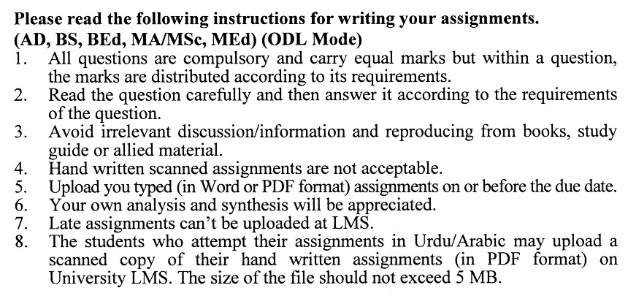

**GUIDELINES FOR ASSIGNMENT NO. 1 & 2:**

The student should look upon the assignments as a test of knowledge, management skills, and communication skills. When you write an assignment answer, you are indicating your knowledge to the teacher:

* Your level of understanding of the subject;
* How do you think?
* How well you can reflect on your knowledge & experience?
* How well you can use your knowledge in solving problems, explaining situations, and describing organizations and management?
* How professional you are, and how much care and attention you give to what you do?

To answer a question effectively, address the question directly, bring important related issues into the discussion, refer to sources, and indicate how principles from the course materials apply. The student must also be able to identify important problems and implications arising from the answer.

For citing references, writing bibliographies, and formatting the assignment, APA format should be followed.

**Total Marks: 100 Pass Marks: 50**

## ASSIGNMENT No. 1

## (Units: 1–5)

***Note: Attempt all questions.***

Q.1 Your organization plans to introduce a new pay structure to stay competitive in the industry. As compensation manager, describe how you would audit and review the current wage and salary program, build a pay structure, and create a communication plan to ensure employee acceptance. **(20)**

Q.2 Your team has been tasked with conducting a job analysis to determine pay rates for newly created roles. Outline the steps you would take to collect and analyze data for this purpose and ensure alignment with the company’s compensation strategy. (**20)**

Q.3 The HR department needs to implement a wage and salary budget for the next fiscal year. Describe how you would design and implement a staff budget program, including training sessions for stakeholders and a follow-up process to ensure accuracy. **(20)**

Q.4 You are leading the development of a performance appraisal system to determine wage and salary changes. How would you design the system to avoid rating errors and legal issues while ensuring fairness and effectiveness? **(20)**

Q.5 Your organization is setting up a new wage and salary administration unit. What factors would you consider when determining its role within the HR function, and how would you ensure it operates effectively? **(20)**

## Total Marks: 100 Pass Marks: 50

## ASSIGNMENT No. 2

This assignment is a research-oriented activity. You are required to obtain information from a business/commercial organization and prepare a report of about 1000 words on the topic allotted to you to be submitted to your teacher for evaluation.

You are required to select one of the following topics according to the last digit of your roll number. You will select the topic as follows:-

**List of Topics:**

1. Job Analysis for Effective Pay Determination
2. Building a Comprehensive Wage and Salary Program
3. Creating and Managing a Wage and Salary Budget
4. Performance Appraisal Systems and Compensation Decisions
5. Managing the Role of Wage and Salary Administration Units
6. Conducting Effective Wage and Salary Surveys
7. Streamlining Payroll Systems for Salary Administration
8. Automating Wage and Salary Administration Functions
9. Adopting a Total Compensation Approach for Future Success
10. Aligning Incentive Programs with Organizational Pay Policies

**The report should follow the following format:**

1. Title page
2. Acknowledgements
3. An abstract (one-page summary of the paper)
4. Table of contents
5. Introduction to the topic (brief history & significance of topic assigned)
6. Practical study of the organization (for the topic)
7. Data collection methods
8. SWOT analysis (strengths, weaknesses, opportunities & threats) relevant to the topic assigned
9. Conclusion (one-page brief covering important aspects of your report)
10. Recommendations (specific recommendations relevant to the topic assigned)
11. References (as per APA format)
12. Annexes (if any)

**GUIDELINES FOR ASSIGNMENT # 2:**

* 1.5 line spacing
* Use headers and subheads throughout all sections
* Organization of ideas
* Writing skills (spelling, grammar, punctuation)
* Professionalism (readability and general appearance)
* Do more than repeat the text
* Express a point of view and defend it.

**compensation Management**

**COURSE OUTLINE (8439/9507)**

**Unit 1 Establishing Wage and Salary Program**

* 1. Building a Wage and Salary Program
  2. Auditing and Reviewing Current Wage and Salary Program
  3. Building an Information Base
  4. Job Description Compilation
  5. Determining Organization’s Pay Policy
  6. Developing Wage and Salary Administration Program
  7. Providing an Inventory of Job Descriptions to use in the Job Evaluation Process
  8. Determining the Appropriate Method of Job Evaluation
  9. Building Pay Structure
  10. Creating a Wage and Salary Budget
  11. Providing a Manual for the Program
  12. Promoting Organization-Wide Communication
  13. Develop Relationships Outside Organization
  14. Auditing and Reviewing Program regularly

**Unit 2 Job Analysis and Job Description**

* 1. Analyze Jobs to Determine Pay Rates
     1. Collecting, Documenting and Analyzing Data for Job Analysis
     2. Job Analysis for Functions Other than Wages and Salary Administration
     3. Planning the Job Analysis Program
     4. Collecting Data for the Job Analysis Program
     5. Analyzing the Data
  2. Creating Job Description to Facilitate Wage and Salary Evaluation
     1. Determining When to Prepare Job Description
     2. Determining Who Should Prepare Job Description
     3. Job Description Forms
     4. Steps in the Job Description Process

**Unit 3 Budgeting and Auditing**

* 1. Designing a Staff Budget Program
     1. Defining Basic Terms
     2. Implementing a Wage and Salary Budget
     3. Conducting Training Sessions
     4. Following Up with Assistance and Advice to Staff
     5. Completing Budget
     6. Other Budget Issues

3.2 Auditing and Reviewing Wage and Salary Program for Overall Effectiveness

* + 1. Performing Wage and Salary Audit
    2. Reviewing Organization’s Current Wage and Salary Program

**Unit 4 Use of Performance Appraisal and Incentives in Wage & Salary Program**

* 1. Using Performance Appraisal Process to Determine Wage and Salary Changes
     1. Developing the Performance Appraisal System
     2. Using Performance Appraisal for Various Purposes
     3. Planning a Performance Appraisal System
     4. Avoiding Potential Problems with Performance Appraisal

Designing Forms for the Performance Appraisal System

* + 1. Rating Errors in the System
    2. Designing a Rater Training Program
    3. Avoiding Legal Problems in the Performance Appraisal
  1. Making Incentives Part of the Wage and Salary Program
     1. Identifying the Key Components of a Successful Incentive Program
     2. Implementing Specific Types of Incentive Programs
     3. Awarding Discretionary Incentives Based on Suggestion Systems
     4. Choosing Different Types of Incentive Payments
     5. A Word About Intrinsic Rewards
     6. Negative Incentives
     7. Incentive Plan
     8. Benefits and Perquisites as Incentive

**Unit 5 Staffing & Managing Wage & Salary Administration Unit**

* 1. Determining Role and Size of Compensation within Human Resources Function
  2. Wage and Salary Administration Units
  3. Managing Wage and Salary Administration Units

**Unit 6 Developing Wage and Salary Surveys to Determine Pay Policies**

* 1. Developing Wage and Salary Survey
  2. Using Consultants to Conduct Salary Survey
  3. Survey Methods
  4. Participation of Wage and Salary Professionals in Surveys

**Unit 7 Wage & Salary Administration Functions**

* 1. Effective Payroll Systems
  2. Working with Payroll to Process Salary Actions
  3. Working with Payroll on Critical Aspects of Routine Pay Period
  4. Auditing Payroll to Ensure Proper Implementation of Wage and Salary Actions
  5. Legal Issues

**Unit 8 Automating Wage & Salary Administration Function to Increase Efficiency**

* 1. Role of Computer in Wage and Salary Administration
  2. Eight Steps to Implementing Change
  3. Analyzing the Impact of Change on Other Units in Organization
  4. Project from Idea to Implementation
  5. Designing System Internally
  6. Designing System Externally
  7. Selecting Appropriate System
  8. Automation Details

**Unit 9 Future of Wage and Salary Administration Function**

* 1. Total Compensation Approach
  2. Direct Pay for Performance
  3. Performance Management
  4. Consideration for Smaller Organizations
  5. Consultant/Internal Customer Service Approach

**Recommended Books:**

* Deluca, M. (2010). *Handbook of Compensation Management.*UK: Prentice Hall.
* Milkovich, G; Newman, J; Milkovich, C. (2010). *Compensation.*UK: McGraw-Hill.
* Henderson, R. (2005). *Compensation Management in a Knowledge-Based World.* UK: McGraw Hill.

