**ALLAMA IQBAL OPEN UNIVERSITY, ISLAMABAD**

**(Department of Business Administration)**

**WARNING**

1. **PLAGIARISM OR HIRING OF GHOST WRITER(S) FOR SOLVING THE ASSIGNMENT(S) WILL DEBAR THE STUDENT FROM AWARD OF DEGREE/CERTIFICATE, IF FOUND AT ANY STAGE.**
2. **SUBMITTING ASSIGNMENT(S) BORROWED OR STOLEN FROM OTHER(S) AS ONE’S OWN WILL BE PENALIZED AS DEFINED IN “AIOU PLAGIARISM POLICY”.**

**Course: Financial Markets and Institutions (8441) Semester: Spring, 2025**

**Level: BBA**

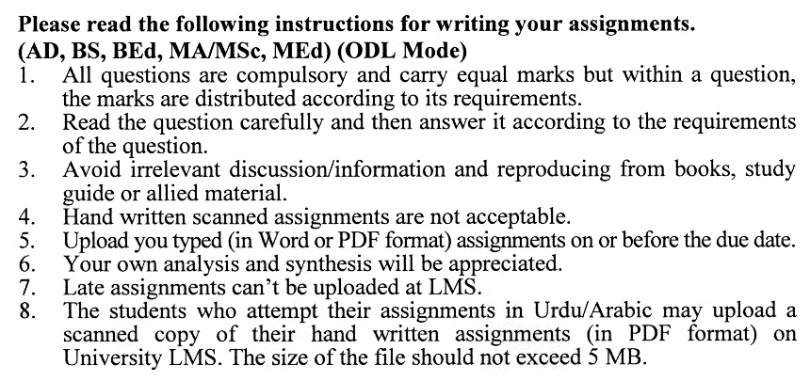

**Total Marks:100 Pass Marks: 50**

**ASSIGNMENT No. 1**

Q. 1 Discuss the **role of financial markets and financial institutions** in facilitating economic growth and stability. Provide examples of how these entities interact to support the global economy.  **(20)**

Q. 2 Explain the **mechanics and trade-offs of monetary policy**. How does monetary policy influence money market operations and yields? **(20)**

Q. 3 Compare and contrast the **types of bonds** available in the bond market. How do institutional investors utilize the bond market for portfolio diversification? **(20)**

Q. 4 Explain the **concept and valuation of mortgages**. What are the key characteristics of residential mortgages, and how do they differ from other types of loans? **(20)**

Q. 5 Discuss the **methods of stock valuation** and the risks associated with investing in stocks. How do these methods differ for domestic and foreign stock valuation? **(20)**

**ASSIGNMENT No. 2**

**Total Marks: 100 Pass Marks: 50**

This assignment is a research-oriented activity. You are required to prepare a detailed report of about 3000 words on the topic allotted to you to be submitted to your teacher for **evaluation**.

You are required to select one of the following topics according to the last digit of your registration number. For example, if your registration number is 18-IDM-3427183 then you will select topic # 3(the last digit): -

**List of Topics:**

1. Institutional Use of Money Markets
2. Valuation and Risk of Money Market Securities
3. Interaction Among Money Market Yields
4. Globalization Trends in Money Markets
5. Institutional Use and Globalization of Mortgage Markets
6. Stock Offering and Monitoring of Publicly Traded Companies
7. Stock Valuation Methods and Risks
8. Foreign Stock Valuation
9. Globalization Trends in Stock Markets
10. Mechanics and Trade-offs in Monetary Policy

**GUIDELINES FOR ASSIGNMENT # 2:**

* 1.5 line spacing
* Use headers and subheads throughout all sections
* Organization of ideas
* Writing skills (spelling, grammar, punctuation)
* Professionalism (readability and general appearance)
* Do more than repeat the text
* Express a point of view and defend it.

# **ALLAMA IQBAL OPEN UNIVERSITY, ISLAMABAD**

**(Department of Business Administration)**

**Course:** Financial Markets and Intuitions C**ourse Code**: 8441,5086,8525

**Level:** MBA, BBA, M.Com **Credit hours**: 03

**Unit 1 Overview of Financial Markets and Institutions**

* 1. Role of Financial Markets and Financial Institutions
  2. Securities Traded at Financial Markets: Types and Their Valuation
  3. Global Financial Markets
  4. Global Expansion by Financial Markets

**Unit 2 Monetary Policy and Money Markets**

* 1. Monetary Policy: Mechanics and Trade-Off
  2. Institutional Use of Money Market
  3. Valuation of Money Market Securities and Risk Involved
  4. Interaction among Money Markets Yields
  5. Globalization of Money Markets

**Unit 3 Bond Markets**

1. Bond: Concept and Types
2. Institutional Use of Bond Market
3. Globalization of Bond Market
4. Bond Market Efficiency
5. Returns and Risk of International Bonds
6. Bond Investment Strategies

**Unit 4 Mortgage Market**

1. Mortgage: Concept and Valuation
2. Risk Involved in Mortgages
3. Residential Mortgage Characteristics
4. Institutional Use of Mortgage Market
5. Mortgage Credit Crises and Its Impact
6. Globalization of Mortgage Market

**Unit 5 Equity Markets**

1. Stock Offering and Monitoring Publicly Trading Companies
2. Stock Valuation Methods and Stock Risks
3. Foreign Stock Valuation
4. Execution of Stock Market Transactions
5. Globalization of Stock Markets

**Unit 6 Swap and Foreign Exchange Derivative Markets**

1. Foreign Exchange Markets: Concept and Significance
2. Factors Affecting Foreign Exchange Rate
3. Background of Swap Markets
4. Credit Default Swap
5. Rates, Derivatives and International Arbitrage

**Unit 7 Thrift and Financial Operations**

1. Saving Institutions: An Overview
2. Exposure to Risk and Crises
3. Sources and Uses of Funds
4. Regulations and Valuation of Financial Institutions
5. Multinational Financial Companies

**Unit 8 Mutual Funds and Securities Operations**

1. Mutual Funds: Concept and Categories
2. Growth and Mix Concept
3. Performance of Mutual Funds
4. Impact of Credit Crises on Security Firm
5. Globalization of Securities Markets

**Unit 9 Insurance and Pension Funds Operations**

9.1 Insurance Companies: An Overview

9.2 Regulation and Valuation of Insurance Companies

9.3 Multinational Insurance Corporations

9.4 Pension Funds: Background, Management and Performance

9.5 Pension Funds Participation in Financial Markets

**Recommended book**

Madura, J. (2010). *Financial Markets and Institutions*. (9th edition). Mason OH:   
South-Western Cengage Learning.

**Additional Readings**

Peter, H. and Keith, B. (2007). *Financial Markets and Institutions*. Prentice Hall

Stephen, V. (2007). *An Introduction to the Global Financial Market*. Palgrave Publications.

****