**ALLAMA IQBAL OPEN UNIVERSITY, ISLAMABAD**

***(Department of Business Administration)***

Warning

1. Plagiarism or hiring of ghost writer(s) for solving the assignment(s) will debar the student from THE award of degree/certificate if found at any stage.
2. Submitting assignment(s) borrowed or stolen from other(s) as one’s own, will be penalized as defined in THE “AIOU Plagiarism Policy”.

**Course: Entrepreneurship (5026/8503/8424) Semester: Spring, 2025**

Level: BS (A & F)

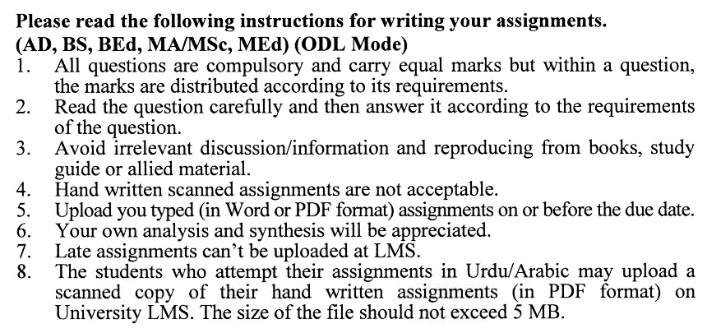

Total Marks: 100 Pass Marks: 50

##### Assignment No. 1

**(Units: 1–5)**

Q1. Provide a comprehensive outline of the phases in the entrepreneurship process. (20)

Q2. Examine the challenges associated with International Entrepreneurship. (20)

Q3. Discuss the problems linked to idea generation and propose strategies for overcoming them. (20)

Q4. Elaborate on the importance of a Business Plan and provide a brief outline of the steps involved in the planning process. (20)

Q5. Offer an overview of financial aspects and their significance in the success of a venture. (20)

**Guidelines FOR ASSIGNMENT No. 1:**

The student should look upon the assignments as a test of knowledge, management skills, and communication skills. When you write an assignment answer, you are indicating your knowledge to the teacher:

* Your level of understanding of the subject;
* How clearly do you think?
* How well you can reflect on your knowledge & experience?
* How well you can use your knowledge in solving problems, explaining situations, and describing organizations and management?
* How professional you are, and how much care and attention you give to what you do?

To answer a question effectively, address the question directly, bring important related issues into the discussion, refer to sources, and indicate how principles from the course materials apply. The student must also be able to identify important problems and implications arising from the answer.

For citing references, writing bibliographies, and formatting the assignment, APA format should be followed.

**Total Marks: 100 Pass Marks: 50**

**ASSIGNMENT No. 2**

This assignment is a research-oriented activity. You are required to submit a term paper and present the same in the classroom prior to the final examination. Presentation component is compulsory for all students. You will have to participate in the activity fully and prepare a paper of about 15 to 20 pages on the topic allotted to you. The students are required to prepare two copies of Assignment No. 2. Submit one copy to your teacher for evaluation and the second copy for presentation in the classrooms in the presence of your resource persons and classmates, which will be held at the end of the semester prior to the final examination.

**Include the following main headings in your report:-**

1. Introduction to the topic
2. Important sub-topics
3. Practical aspects with respect to the topic
4. Review of theoretical and practical situations
5. Merits, demerits, deficiencies or strengths of the organization with respect to your topic
6. Conclusions and recommendations
7. Annex, if any

You must use transparencies, charts or any other material for effective presentation. You are also required to select one of the following topics according to the last digit of your roll number. For example, if your roll number is D-3427185 then you will select topic No.5 (the last digit):-

**List of Topics**

0. Elements of a Prosperous Business

1. Company's Business Framework

2. Angel Investors in Business Ventures

3. Replicating Entrepreneurial Ideas

4. Plan for Business Processes

5. Significance of Creativity and Novelty

6. Entry of a New Competitor in the Market

7. Creating a Winning Strategy

8. Income and Spending Analysis

9. Insolvency or Financial Distress

**ENTREPRENEURSHIP**

**Course Outlines (5026/8503/8424)**

**COURSE DESCRIPTION:**

The role of entrepreneurship in an economy is well documented and is of interest to businesspeople, politicians, university professors, and students. Many individuals desire to start and grow new ventures, but few are able to successfully accomplish these tasks. This course is based on an understanding of all the functional areas of business and applies the tools and techniques of these areas to the process of new venture creation. The course explores the following aspects:

* the meaning of entrepreneurship, from a historical and research perspective
* the process of creating and evaluating opportunities for new ventures
* writing and presenting a business plan for such opportunities
* acquiring resources, both human and financial, required for the venture
* sales and marketing for the new venture
* legal issues relating to new ventures and intellectual property protection
* identifying challenges in new ventures, and identifying how to overcome them, and
* managing the growing venture

**Learning Objectives:**

This course aims to develop students’ entrepreneurial skills and qualities. By the end of the course, students should be able to:

* understand the process of starting and growing a new venture
* assess the strengths and weaknesses of a new venture opportunity
* write and present an effective and professional business plan
* integrate functional area material as it applies to new venture creation
* develop an understanding of the entrepreneurial process
* learn what role they should take in the entrepreneurial process

**BRIEF COURSE OUTLINE:**

UNIT 1 POWER OF ENTREPRENEURSHIP

UNIT 2 INITIAL STEPS TO SET-UP ENTREPRENEURIAL PROJECT

UNIT 3 Understanding Business Model and Developing YOUR Strategy

UNIT 4 Business Planning Process

UNIT 5 Building Pro-Forma Financial Statement

UNIT 6 Financial Entrepreneurial Ventures Worldwide

UNIT 7 Debt and Other Forms of Financing

UNIT 8 Legal and Tax Issues

UNIT 9 Entrepreneurial Growth

**ENTREPRENEURSHIP**

**Course Code (5026/8503/8424)**

**Unit No. 1 Entrepreneurial Process**

1. Entrepreneurship in Global Perspective
2. Factors for Starting a New Enterprises
3. Personal Attributes
4. Environmental Factors
5. Other Sociological Factors
6. Evaluating Opportunities for New Businesses
7. Ingredients of a Successful Business

**Unit No. 2 Initial Steps to Set-Up an Entrepreneurial Project**

1. Opportunity Recognition, Shaping and Reshaping
2. From Glimmer to Action: How Do I Come Up With a Good Idea
3. Finding Passion
4. Idea Multiplication
5. Ideas and Opportunities
6. Selection of the Founding Team
7. Bootstrapping: Building Team Based on Stage-of-Venture Life
8. External Team Members
9. Keeping the Team Together
10. Burnout
11. Family Pressure
12. Interpersonal Conflict

**Unit No. 3 Understanding the Business Model and Developing Strategy**

1. Business Model
2. Revenue Model
3. Cost Model
4. First Mover Myth
5. Formulating a Winning Strategy
6. People Centric Strategy
7. Entry Strategy
8. Growth Strategy
9. Marketing and Entrepreneurship
10. Marketing Strategies for Entrepreneurs
11. Marketing Skills for Managing Growth

**Unit No. 4 Business Planning Process**

1. Planning Process
2. Story Model
3. Business Plan
4. Types of Business Plans and its Components

**Unit No. 5 Building Pro-Forma Financial Statement**

1. Overview of Financial Statements
2. Building Pro-Forma Financial Statement
3. Expected Revenue and Expenditure
4. Revenue Projections
5. Cost of Goods Sold
6. Operating Expenses
7. Preliminary Income Statement
8. Building Integrated Financial Statements
9. Income Statement
10. Balance Sheet
11. Cash Flow Statement

**Unit No. 6 Financial Entrepreneurial Ventures Worldwide**

1. Microfinance and Entrepreneurship
2. Entrepreneurs and Informal Investors
3. Venture Capital
4. Factor Effecting Availability of Financing
5. Bootstrapping New Ventures Valuation
6. Financing New Venture
7. Informal Investors
8. Business Angels
9. Venture Capitalists
10. Harvesting Investment
11. Initial Public Offering
12. Selling the Company
13. A Strategic Acquisition

**Unit No. 7 Equity and Debt Financing**

1. Equity Financing
2. Common Stock
3. Deferred Stock
4. Debt Financing
   * 1. Bonds
     2. Debentures

**Unit No. 8 Legal and Tax Issues**

1. Choosing a Name of Entrepreneurial Venture
2. Legal and Tax Issues in Hiring Employees
3. Insurance
4. Raising Money and Legal Issues

**Unit No. 9 Entrepreneurial Growth**

1. Making Transition from Startup to Growth
2. Driving Forces of Growth
3. Growth Process
4. Exit Strategy

**Recommended Books:**

Bygrave D.W., & Zacharakis A. (2010). *Entrepreneurship* (2nd ed.). U.S.A.: John Wiley& Sons

Hisrich D.R., Peters P.M., &Shepherd A. D. (2009). *Entrepreneurship* (8th ed.). Illinois, U.S.A.: McGraw-Hill/Irwin

Kuratko F.D., & Hodgetts M. R. (2008). *Entrepreneurship: Theory, Process, and Practice* (8th ed.). Ohio, U.S.A.: South-Western Pub

