# ALLAMA IQBAL OPEN UNIVERSITY ISLAMABAD

**(Department of Business Administration)**

**WARNING**

1. **PLAGIARISM OR HIRING OF GHOST WRITER(S) FOR SOLVING THE ASSIGNMENT(S) WILL DEBAR THE STUDENT FROM THE AWARD OF DEGREE/CERTIFICATE IF FOUND AT ANY STAGE.**
2. **SUBMITTING ASSIGNMENT(S) BORROWED OR STOLEN FROM OTHER(S) AS ONE’S OWN WILL BE PENALIZED AS DEFINED IN THE “AIOU PLAGIARISM POLICY”.**

**Course: Managerial Economics (5048/8522)** **Semester: Spring, 2025**

## Level: BS (A&F)/MBA

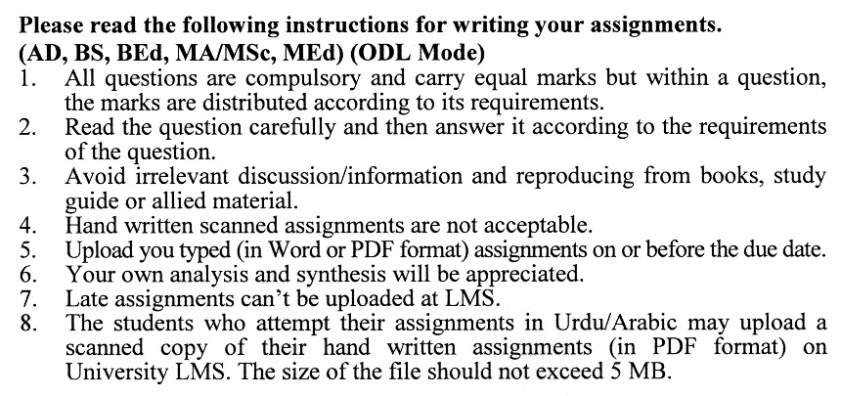

**Guidelines FOR ASSIGNMENT # 1:**

You should look upon the assignments as a test of knowledge, management skills, and communication skills. When you write an assignment answer, you are indicating your knowledge to the teacher:

* Your level of understanding of the subject;
* How clearly do you think?
* How well you can reflect on your knowledge & experience?
* How well you can use your knowledge in solving problems, explaining situations, and describing organizations and management?
* How professional you are, and how much care and attention you give to what you do?

To answer a question effectively, address the question directly, bring important related issues into the discussion, refer to sources, and indicate how principles from the course materials apply. You must also be able to identify important problems and implications arising from the answer.

For citing references, writing bibliographies, and formatting the assignment, APA format should be followed.

##### ASSIGNMENT No. 1

Total Marks: 100 Pass Marks: 50

Q. 1 Can market forces and corporate responsibility alone ensure that businesses act in the public interest, or is government intervention essential? **(20)**

Q. 2 What are the potential pitfalls of relying on historical data for demand estimation in markets that are highly volatile or subject to external shocks (e.g., pandemics, economic crises)? **(20)**

Q. 3 “Rapid innovation in the development, assembly, and delivery of personal computers has led to a sharply downward-sloping market demand curve for Dell, Inc.” Discuss this statement. **(20)**

Q. 4 What are the risks of using barometric methods in industries where external factors (e.g., regulatory changes or geopolitical events) can render indicators obsolete or misleading? **(20)**

Q. 5 Explain the differences between short-run and long-run cost curves, focusing on the factors that influence their shapes. Discuss how a firm's decision-making process differs in the short run versus the long run, and provide examples of industries where these distinctions are particularly significant. How might a firm's ability to adjust its scale of production in the long run impact its competitive strategy and market positioning? **(20)**

**assignment No. 2**

**Total Marks: 100 Pass Marks: 50**

This assignment is a research-oriented activity. You are required to obtain information on a given topic and **write in your own words** and prepare a report of about 2000 words on the issue allotted to you to be submitted to your teacher for evaluation. (**IN CASE OF COPY PASTED “ZERO” MARKS WILL BE AWARDED.)**

You are required to select one of the following issues according to the last digit of your roll number. For example, if your roll number is P-3427180 then you will select issue # 0 (the last digit): -

**Issues:**

1. Cost Curves in Long Run
2. Cost Curves in Short Run
3. Demand Forecasting
4. Dumping
5. Monopolistic Competition
6. Pricing Discrimination
7. Pricing of Multiple Products
8. Production Function
9. Risk Aversion
10. Utility Theory

**GUIDELINES FOR ASSIGNMENT # 2:**

* 1.5 line spacing
* Use headers and subheads throughout all sections
* Organization of ideas
* Writing skills (spelling, grammar, punctuation)
* Professionalism (readability and general appearance)
* Do more than repeat the text
* Express a point of view and defend it.

**GUIDELINES FOR WORKSHOP PRESENTATION:**

1. There will be twelve hours workshop for each course as per details given in the workshop schedule.

2. Please note that, **the students not signing up on the first day would not be allowed to participate in the workshop.**

3. The workshop coordinator would verify the students’ identity by means of **Original Computerized National Identity Cards (CNIC).**.

4. Attendance of a student in all sessions of the workshop is mandatory, and they will not be permitted to skip any session of the workshops in which they are not supposed to present. The resource persons will have the power to award zero marks to such students who simply attend the session in which they have to present their own research paper/topic and leave the workshop after their presentation.

5. Students during their presentation in the workshop may consult their notes/points but they will not be allowed to complete paper reading during their presentation.

6. If a student fails or is absent from the workshop due to any reason, he/she is given two extra chances to reappear in the forthcoming workshops, by depositing the prescribed workshop fee in the university’s account and showing the respective bank receipt to the workshop coordinator.

**WEIGHTAGE OF THEORY & PRACTICAL ASPECTS IN ASSIGNMENT # 2 & WORKSHOP PRESENTATIONS:**

Assignment # 2 & workshop presentations are evaluated on the basis of theory & its applicability. The weightage of each aspect would be:

Theory: 60%

Applicability (practical study of the organization): 40%

**MANAGERIAL ECONOMICS (5048/8522)**

**COURSE OUTLINE**

**Unit-1: Nature and Scope of Managerial Economics**

* 1. Optimization Tools Analysis
  2. Multivariable Optimization
  3. Constrained Optimization

**Unit-2: Demand Analysis**

* 1. Application of Demand Theory
  2. Demand Estimation
  3. Simple and Multiple Regression Analysis and its Application

**Unit-3: Demand Forecasting**

* 1. Quantitative Forecast
  2. Time- Series Analysis
  3. Smoothing Techniques
  4. Barometric Methods
  5. Econometric Methods

**Unit-4: Government in the Market Economy**

* 1. Externalities and Public Goods
  2. Optimal Allocation of Social Resources
  3. Benefit Cost Methodology and Criteria
  4. Additional Methods of Improving Public Management

**Unit-5: Production Theory**

* 1. Production Function with One or Two Variables Inputs
  2. Optimal Combination of Inputs
  3. Empirical Production Function

**Unit-6: Cost Theory and Estimation**

* 1. Cost Curve in Short and Long Run
  2. Learning Curve
  3. Empirical Estimation of Cost Function

**Unit-7: Market Structure**

* 1. Perfect Competition, Monopoly & Monopolistic Competition
  2. Oligopoly and Market Concentration
  3. Oligopoly Models
  4. Strategic Behavior and Game Theory

**Unit-8: Pricing Practices**

* 1. Pricing of Multiple Products
  2. Price Discrimination
  3. International Price Discrimination and Dumping
  4. Transfer Pricing
  5. Pricing in Practices

**Unit-9: Risk Analysis**

* 1. Risk and Uncertainty in Managerial Decision Making
  2. Measuring Risk with Probability Distribution
  3. Utility Theory and Risk Aversion
  4. Valuation Model for Risk
  5. Adjusting Techniques for Incorporating Risk in Decision-Making
  6. Decision Making Under Uncertainty

**Recommended Book:**

Hirchey, M (2009). *Managerial Economics, An Integrative Approach***. Canada: Nelson Education Ltd.**

**Additional Books:**

**Salvatore,** D**.** *Managerial Economics In Global Economy*. **Oxford University Press.**

Froeb, L. M., & McCann, B. T. **(2009).** *Managerial Economics: A Problem Solving Approach***, (2nd ed.). Canada: Nelson Education Ltd.**

Png Ivan, & Lahman, D. **(2007).** *Managerial Economics* **(2nd ed.). USA, UK, Australia: Blackel Publishing Ltd.**

