# ALLAMA IQBAL OPEN UNIVERSITY ISLAMABAD

**(Department of Business Administration)**

**WARNING**

1. **PLAGIARISM OR HIRING OF GHOST WRITER(S) FOR SOLVING THE ASSIGNMENT(S) WILL DEBAR THE STUDENT FROM THE AWARD OF DEGREE/CERTIFICATE IF FOUND AT ANY STAGE.**
2. **SUBMITTING ASSIGNMENT(S) BORROWED OR STOLEN FROM OTHER(S) AS ONE’S OWN WILL BE PENALIZED AS DEFINED IN “AIOU PLAGIARISM POLICY”.**

## Course: Marketing of Services (8434/8528) Semester: Spring, 2025

**Level: BBA**

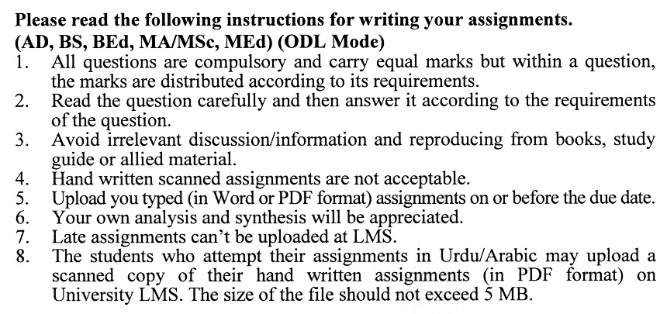

**GUIDELINES FOR ASSIGNMENT No. 1 & 2**

You should look upon the assignments as a test of knowledge, management skills, and communication skills. When you write an assignment answer, you are indicating your knowledge to the teacher:

* Your level of understanding of the subject;
* How you think;
* How well you can reflect on your knowledge and experience;
* How well you can use your knowledge in solving problems, explaining situations, and describing organizations and management;
* How professional you are, and how much care and attention you give to what you do.

To answer a question effectively, address the question directly, bring important related issues into the discussion, refer to sources, and indicate how principles from the course materials apply. You must also be able to identify important problems and implications arising from the answer.

For citing references, writing bibliographies, and formatting the assignment, APA format should be followed.

**ASSIGNMENT No. 1**

**Total Marks: 100 Pass Marks: 50**

Q. 1 Design a questionnaire and conduct a survey asking about two loyalty programs. **(20)**

Q. 2 Why is customer loyalty an important driver of profitability for service firms? **(20)**

Q. 3 What is the concept of Augmented Services? Explain in detail. **(20)**

Q. 4 What are the Seven P’s of services marketing? Explain all. **(20)**

Q. 5 Why do we need service innovation? Explain in detail. **(20)**

**ASSIGNMENT No. 2**

**Total Marks: 100 Pass Marks: 50**

This assignment is a research-oriented activity. You are required to upload a term paper and present the same in the classroom before the final examination. The presentation component is compulsory for all students. You will have to participate in the activity fully and prepare a paper of about 15 to 20 pages on the topic allotted to you. You are required to prepare two copies of Assignment No. 2. Upload one copy to your teacher for evaluation and the second copy for presentation in the classrooms in the presence of your resource persons and classmates, which will be held at the end of the semester before final examination.

Include the following main headings in your report: -

1. Introduction to the topic
2. Important sub-topics
3. Practical aspects for the topic
4. Review of theoretical and practical situations
5. SWOT analysis of the organization for your topic
6. Conclusions and recommendations
7. Annex, if any

You must use transparencies, charts or any other material for effective presentation. You are also required to select one of the following topics according to the last digit of your roll number. For example, if your roll number is D-3427185 then you will select topic No.5 (the last digit):-

**List of Topics:**

0. Using Technology for Marketing Services

1. Cultural Role in Service Marketing
2. Service Recovery
3. Communication Mix for Services Marketing
4. Service Delivery Mechanisms
5. Service Quality
6. Services Marketing for Entrepreneurs
7. Types of Services
8. Consumer Behavior for Services Customers
9. CRM in Services Marketing

**MARKETING OF SERVICES (BBA-8434)**

# UNIT-1: INTRODUCTION TO SERVICES

# Concept of services

* 1. Characteristics of services vs products
  2. Rationale of studying marketing of services
  3. Impact of technology on services
  4. Services marketing mix

**UNIT-2: CONSUMER BEHAVIOUR IN SERVICES**

* 1. Categories of consumer products (search qualities, experience qualities and credence qualities)
  2. Consumer decision-making Processes
  3. Service quality gaps
  4. Role of culture in services

**UNIT-3: CUSTOMER EXPECTATIONS OF SERVICES**

3.1 meaning and types of service expectations

3.2 Factors influencing customer expectations of services

3.3 Model of Customer Service Expectations

3.4 Issues involved in customer service expectations

**UNIT-4: CUSTOMER SATISFACTION**

4.1 Concept of customer satisfaction and service quality

4.2 Determinants of Customer Satisfaction

4.3 Outcomes of Customer Satisfaction

4.4 Service quality dimensions

4.5 Foundations for satisfaction and service quality

4.5.1 Service encounters or moments of truth

4.5.2 Importance of encounters

4.5.3 Types of Encounters

4.5.4 Sources of pleasure and displeasure in service encounters

4.5.5 Satisfaction with technology-based service encounters

4.6 Strategies for Influencing Customer Perceptions

**UNIT-5: BUILDING CUSTOMER RELATIONSHIPS**

5.1 Concept of relationship marketing

5.2 Goals of relationship marketing

5.3 benefits of a long-term relationship with customers and firms

5.4 Relationship value of customers

5.4.1 Quality in core service

5.4.2 Market segmentation and targeting

5.4.3 Process for market segmentation and targeting in services

5.5 Customer Profitability Segments

5.6 Expanded customer pyramid

5.7 Levels of Relationship Strategies

**UNIT-6: SERVICE RECOVERY**

6.1 Concept of Service Recovery

6.2 Importance of service recovery

6.3 Service recovery paradox

6.4 Customer complaint

6.5 types of customer complaint actions

6.7 Service Recovery Strategies

6.7.1 Fail-safe service

6.7.2 Welcome and encourage and encourage complaints

6.7.3 Act quickly

6.7.4 Treat your customers fairly

6.7.5 Learn from Recovery Experiences

6.7.6 Learn from lost customers

6.8 Concept of service guarantees

6.9 Benefits of service guarantees

6.10 types of service guarantees

6.11 Right time to use the guarantee

**UNIT-7: DELIVERING AND PERFORMING SERVICE**

7.1 Importance of service employees in creating customer satisfaction and Service quality

7.2 Challenges Inherent in boundary-spanning Roles

7.3 Importance of customers in successful service delivery

7.4 Roles of customers in service delivery

7.5 Strategies for participation enhancing Customer Participation

7.6 Concept of Service Intermediaries

7.7 Common Issues Involving Intermediaries

7.8 Key intermediaries for service delivery (franchising, brokers, agents)

7.9 Concept of electronic channels and its challenges in the services industry

7.10 Strategies for effective service delivery through intermediaries

**UNIT-8: INTEGRATED SERVICES MARKETING COMMUNICATIONS**

8.1 Concept of communications integrated Services Marketing Communications

8.2 reasons for service communication problems

8.3 Strategies to match service promises with service delivery

8.4 Concept of customer expectations

8.5 Managing internal marketing communication

**UNIT-9: PRICING OF SERVICES & INTEGRATED GAPS MODEL OF SERVICE QUALITY**

* 1. Approaches to pricing services
  2. Concept of value to customers
  3. Role of price as an indicator of service quality
  4. Ways of pricing services
  5. Strategies used by companies to price services
  6. Integrated gaps model of service quality
     1. Service quality gaps
     2. Factors Influencing Service Quality Gaps
     3. Applicability of Service Quality Gaps to Tanzanian Business Environment

**Recommended Books:**

Zeithaml, M. (2010). *Services Marketing, Integrating Customer Focus Across the Firm.* USA: McGraw Hill.

Christopher, H. (2009). *Services Marketing.* UK: Prentice Hall.

Jha, S. (2008). *Services Marketing.* USA: McGraw Hill.

