ALLAMA IQBAL OPEN UNIVERSITY, ISLAMABAD

**(Department of Business Administration)**

|  |
| --- |
| **WARNING**   1. **PLAGIARISM OR HIRING OF GHOST WRITER(S) FOR SOLVING THE ASSIGNMENT(S) WILL DEBAR THE STUDENT FROM THE AWARD OF DEGREE/CERTIFICATE IF FOUND AT ANY STAGE.** 2. **SUBMITTING ASSIGNMENT(S) BORROWED OR STOLEN FROM OTHER(S) AS ONE’S OWN WILL BE PENALIZED AS DEFINED IN THE “AIOU PLAGIARISM POLICY”.** |

**Course: E-Marketing (5089/8529) Semester: Spring, 2025**

**Level: MBA (2½ Years)**

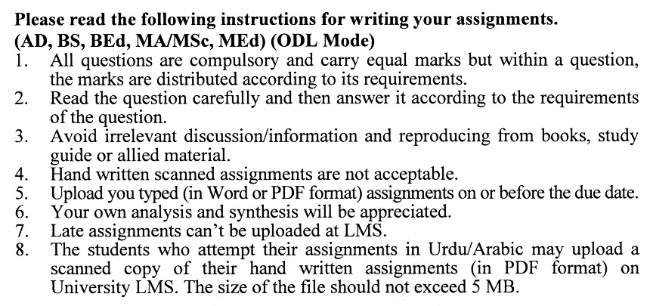

**GUIDELINES FOR ASSIGNMENT No. 1 & 2:**

The student should look upon the assignments as a test of knowledge, management skills, and communication skills. When you write an assignment answer, you are indicating your knowledge to the teacher:

▪ Your level of understanding of the subject.

▪ How do you think?

▪ How well you can reflect on your knowledge & experience?

▪ How well you can use your knowledge in solving problems, explaining situations, and describing organizations and management?

▪ How professional you are, and how much care and attention you give to what you do?

To answer a question effectively, address the question directly, bring important related issues into the discussion, refer to sources, and indicate how principles from the course materials apply. The student must also be able to identify important problems and implications arising from the answer.

For citing references, writing bibliographies, and formatting the assignment, APA format should be followed.

**Total Marks: 100 Pass Marks: 50**

**ASSIGNMENT No. 1**

**(Units: 1–5)**

Q. 1 What are the key functions and objectives of e-marketing, specifically in the context of Pakistan? **(20)**

Q. 2 What are the main elements of e-strategy, and how does it differ from traditional marketing strategy? **(20)**

Q. 3 Why is understanding online buying behaviour important, and what challenges exist in analyzing it in Pakistan? **(20)**

Q. 4 What strategies can Pakistani firms adopt for effective relationship marketing in an online environment? **(20)**

Q. 5 Write short notes on:

* **Digital radio** **(7)**
* **Customers’ expectations** **(7)**
* Search engine optimization **(6)**

**Total Marks: 100 Pass Marks: 50**

**ASSIGNMENT No. 2**

This assignment is a research-oriented activity. You are required to submit a term paper and present the same in the classroom before the final examination. The presentation component is compulsory for all students. You will have to participate in the activity fully and prepare a paper of about 15 to 20 pages on the topic allotted to you. The students are required to prepare two copies of Assignment No. 2. Submit one copy to your teacher for evaluation and the second copy for presentation in the classrooms in the presence of your resource persons and classmates, which will be held at the end of the semester the final examination.

Include the following main headings in your report: -

a) Introduction to the topic.

b) Important sub-topics

c) Practical aspects for the topic

d) Review of theoretical and practical situations

e) Merits, demerits, deficiencies or strengths of the organization for your topic

f) Conclusions and recommendations

g) Annex, if any

You must use transparencies, charts or any other material for effective presentation. You are also required to select one of the following topics according to the last digit of your roll number. For example, if your roll number is D-3427185 then you will select topic No.5 (the last digit): -

**List of Topics:**

0. Pricing strategy in an electronic environment

1. E-marketing programme

2. E-marketing strategy

3. Traffic building options

4. Viral marketing

5. E-CRM

6. Online buying process

7. Website copywriting process

8. Search engine marketing

9. Security challenges in an electronic environment

