**ALLAMA IQBAL OPEN UNIVERSITY, ISLAMABAD**

**(Department of Commerce)**

**WARNING**

1. **PLAGIARISM OR HIRING OF GHOST WRITER(S) FOR SOLVING THE ASSIGNMENT(S) WILL DEBAR THE STUDENT FROM AWARD OF DEGREE/CERTIFICATE, IF FOUND AT ANY STAGE.**
2. **SUBMITTING ASSIGNMENT(S) BORROWED OR STOLEN FROM OTHER(S) AS ONE’S OWN WILL BE PENALIZED AS DEFINED IN “AIOU PLAGIARISM POLICY”.**

**Course: Taxation Management (8531) Semester: Spring, 2025**

**Level: M. Com/BS**

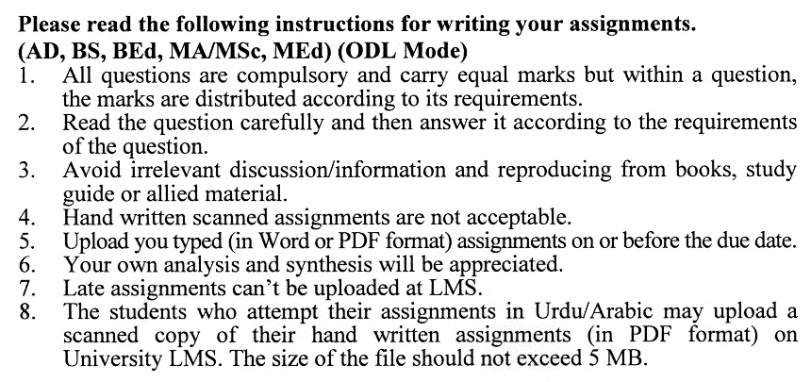

**Total Marks:100 Pass Marks: 50**

**ASSIGNMENT No. 1**

**(Units: 1–4)**

Q. 1 Discuss in detail the taxation of income from property under the Income Tax Ordinance 2001. **(20)**

Q. 2 (a) What is withholding tax? Explain the legal provisions as per the Income Tax Ordinance 2001. **(10)**

(b) Compute the tax liability of a registered firm XY where X & Y equal partners are working. **(10)**

|  |  |  |  |
| --- | --- | --- | --- |
| **Expenses** | **Rs.** | **Revenues** | **Rs.** |
| Purchases  Wages to workers  Maintenance  Personal expenses X  Personal expenses Y  Commission X  Commission Y  Depreciation  Salaries  Net Profit | 180,000  20,000  10,000  4000  5000  10,000  9000  12,000  50,000  515,000 | Sales  Interest on bank Deposits | 800,000  15,000 |
|  | 815,000 |  | 815,000 |

**Additional information:**

1. Tax depreciation is of Rs. 10,000
2. The travelling expenses of Rs. 14,000 have not been recorded.
3. The salaries include salary of X of Rs. 20000 & salary of Y of   
   Rs. 22000.
4. The maintenance expenses include a payment of Rs. 3000 to Mr. X.

Q. 3 (a) Calculate the tax liability of M.Y Ltd from the following records: **(10)**

|  |  |  |  |
| --- | --- | --- | --- |
| **Expenses** | **Rs.** | **Revenues** | **Rs**. |
| Cost of goods sold  Travelling  Legal fee  Zakat fee  Rent  Withholding tax paid  Net profit | 510,000  15,000  10,000  5000  16000  11000  572,000 | Sales  Dividend received  Capital gain on sale of shares of public company | 11,00,000  14000  25000 |
|  | 11,39,000 |  | 11,39,000 |

**Additional Information:**

1. Tax depreciation amounts to Rs. 25,000.
2. Cost of goods sold includes a payment of Rs.12000 to an advertising agency for last year's advertisement.
3. Travelling expenses of Rs.5000 are recorded without invoice proof.
4. Legal fee includes a payment of Rs.3000 to the settlement of a case.
5. The corporate income tax rate is 29% & alternate corporate tax rate is 17%.

(b) What are the requirements for the income tax return filing under the Income Tax Ordinance 2001. Explain in detail. **(10)**

Q. 4 Mr. Raheem has reported the following transactions for the tax year 2018. (Tax rates are given at the end of the assignment): **(20)**

1. Rent received Rs 30,000 per month.
2. Income from fruit selling business Rs.200000
3. Income from the Sale of juices Rs.10,00,000
4. Ground rent received=Rs.30000
5. Royalty income received=Rs.60000
6. Capital gain on sale of shares of a Pvt. Ltd of Rs.70000.  
   The holiday period is 6 months
7. Donation to a govt. school of Rs.15000
8. Share of income received from AOP Rs.90000
9. Mr Raheem is claiming a senior citizen tax rebate

Q. 5 (a) Calculate Sales Tax Due/Refundable in each case: **(10)**

GEE Ltd a registered manufacturer has reported the following transactions for December for the calculation of sales tax:

(1) Supplies to registered person Rs. 12,00,000.

(2) Supplies to an NGO Rs. 100,000.

(3) Supplies to non-registered persons at a discount (5%) Rs.80, 000.

(4) Supplies to registered government supplies Rs. 100,000.

(5) Purchases from registered persons Rs. 500,000.

(6) Imports of raw materials Rs. 40,000.

(7) Purchases from non-registered persons on discount (10%) = Rs.50, 000

(8) Sales tax refund due

(b) Explain in detail the key features of the Customs Act 1969. **(10)**

**Total Marks:100 Pass Marks: 50**

**ASSIGNMENT No. 2**

Select one of the following topics according to the last digit of your roll number/ID. For example, if your roll number/ID is P-3427180 then you will select issue # 0 (the last digit): -

**Topics:**

1. Do indirect taxes contribute to inflation in Pakistan?
2. Key features of the Federal Excise Duty Act 2005
3. Is taxation in Pakistan regressive in nature?
4. Tax evasion in the companies of Pakistan
5. Super tax on the incomes of banking companies in Pakistan
6. The future of property taxation in Pakistan
7. FBR, a facilitator or a hurdle in the revenue collection?
8. Alternate tax dispute resolution mechanism and its effectiveness in Pakistan
9. The prospects of tobacco taxes (sin tax) in Pakistan
10. The benefits of the E-Filing system of the FBR

The report should follow the following format:

1. Title page
2. Acknowledgements
3. An abstract (one-page summary of the paper)
4. Table of contents
5. Introduction to the issue (brief history & significance of issue assigned)
6. Detailed arguments with supporting data
7. Conclusion (one-page brief covering important aspects of your report)
8. Recommendations (specific recommendations relevant to the issue assigned)
9. References (as per APA format)
10. Annexes (if any)

**GUIDELINES FOR ASSIGNMENT # 2:**

* 1.5 line spacing
* Use headers and subheads throughout all sections
* Organization of ideas
* Writing skills (spelling, grammar, punctuation)
* Professionalism (readability and general appearance)
* Do more than repeat the text
* Express a point of view and defend it.

**Schedule of Income Tax Rates for the Tax Year 2024-25**

|  |  |  |
| --- | --- | --- |
| **S. No** | **Taxable Income** | **Rate of Tax** |
| 1. | Where taxable income does not exceed  Rs. 600,000 | 0% |
| 2. | Where taxable income exceeds Rs. 600,000 but does not exceed Rs. 1,200,000 | 5% of the amount exceeding  Rs. 600,000 |
| 3. | Where taxable income exceeds  Rs. 1,200,000 but does not exceed  Rs. 22,00,000 | Rs. 30,000 plus 15% of the amount exceeding Rs. 1,200,000 |
| 4. | Where taxable income exceeds  Rs. 22,00,000 but does not exceed  Rs. 32,00,000 | Rs. 180,000 plus 25% of the amount exceeding Rs. 32,00,000 |

****