# **ALLAMA IQBAL OPEN UNIVERSITY, ISLAMABAD**

**(Department of Business Administration)**

**WARNING**

1. **PLAGIARISM OR HIRING OF GHOST WRITER(S) FOR SOLVING THE ASSIGNMENT(S) WILL DEBAR THE STUDENT FROM THE AWARD OF DEGREE/CERTIFICATE IF FOUND AT ANY STAGE.**
2. **SUBMITTING ASSIGNMENT(S) BORROWED OR STOLEN FROM OTHER(S) AS ONE’S OWN WILL BE PENALIZED AS DEFINED IN “AIOU PLAGIARISM POLICY”.**

**Course: Retail Management ((5102/8549) Semester: Spring, 2025**

**Level: MBA (2.5 / 3.5 Years)**

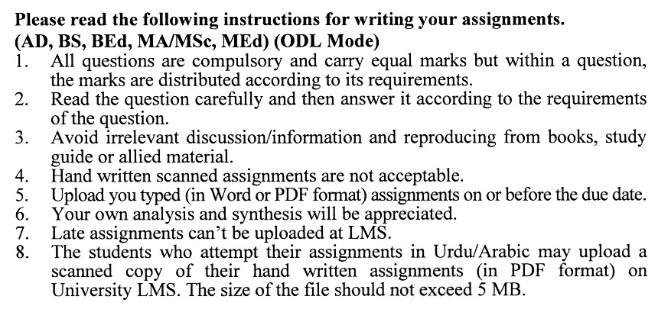

**Guidelines FOR ASSIGNMENT No. 1 & 2:**

You should look upon the assignments as a test of knowledge, management skills, and communication skills. When you write an assignment answer, you are indicating your knowledge to the teacher:

* Your level of understanding of the subject;
* How do you think?
* How well you can reflect on your knowledge & experience?
* How well you can use your knowledge in solving problems, explaining situations, and describing organizations and management?
* How professional you are, and how much care and attention you give to what you do?

To answer a question effectively, address the question directly, bring important related issues into the discussion, refer to sources, and indicate how principles from the course materials apply. The student must also be able to identify important problems and implications arising from the answer.

For citing references, writing bibliographies, and formatting the assignment, APA format should be followed.

## ASSIGNMENT No. 1

## (Units: 1–5)

## Total Marks: 100 Pass Marks: 50

Q. 1 Retail business involves the sale of merchandise from a single point of purchase directly to a customer who intends to use that product. Retailing is largely affected by the services offered by retail persons. Discuss the role and importance of services in retailing. **(20)**

Q. 2 Discuss various theories of structural change in retailing with examples from the local environment. **(20)**

Q. 3 Why is it important for retailers to understand the consumer behaviour of respective geographical areas? What are the key factors that affect consumer buying behaviour? **(20)**

Q. 4 Why a retailer had to segment the whole market into different groups? What can be the possible bases for segmentation? **(20)**

Q. 5 Explain the nature, role and significance of the merchandise planning system in organizations with special reference to Pakistan. **(20)**

**ASSIGNMENT No. 2**

**Total Marks: 100 Pass Marks: 50**

This assignment is a research-oriented activity. You are required to submit a term paper and present the same in the classroom before the final examination. The presentation component is compulsory for all students. You will have to participate in the activity fully and prepare a paper of about 15 to 20 pages on the topic allotted to you. The students are required to prepare two copies of Assignment No. 2. Submit one copy to your teacher for evaluation and the second copy for presentation in the classrooms in the presence of your resource persons and classmates, which will be held at the end of the semester the final examination.

Include the following main headings in your report:-

1. Introduction to the topic
2. Important sub-topics
3. Practical aspects concerning the topic
4. Review of theoretical and practical situations
5. Merits, demerits, deficiencies or strengths of the organization concerning your topic
6. Conclusions and recommendations
7. Annex, if any

You must use transparencies, charts or any other material for effective presentation. You are also required to select one of the following topics according to the last digit of your roll number. For example, if your roll number is D-3427185 then you will select topic No.5 (the last digit):-

**List of Topics:**

0. Role of IT in Retailing

1. Pricing Methods

2. Types of Store Layout in Pakistan

3. Documenting Customer Profile

4. Effective Merchandise Planning

5. New Trends in Retailing

6. Non-Store Retailing

7. In-Store Promotion

8. Retail Strategy

9. Future of Retailing

OUTLINE OF RETAIL MANAGEMENT (8549)

**Unit–1: Retailing Role Relevance and Trends**

1. Key Concepts and Functions of Retailing
2. Retailing Industry and Economy
3. Role of Services in Retailing
4. Relationship between the Retailer and their Suppliers
5. Retail Strategy
6. Challenges for Retail Management in Pakistan

**Unit–2: Retail Organizations**

1. Changing Structure of Retailing
2. Theories of Structural Change in Retailing
3. Classification of Retail Units
4. Variety of Merchandise Mix
5. Methods of Customer Interaction
6. Management of Retail Organizations in Pakistan

**Unit–3: Retail Customer**

1. Consumer Behavior in Retailing
2. Factors Affecting Consumer Decision Making
3. Stages of Consumer Decision Process
4. Types of Consumer Decision Making
5. Stage of the Consumer Decision Process
6. Influence of Situational Variables on Consumer Behavior

**Unit–4: Retail Market Segmentation**

1. Market Survey for Retail Market Segmentation
2. Market Segmentation and its Benefits
3. Kinds of Markets
4. Dimensions for Segmentation
5. Customer Profile
6. Survey of Buyer
7. Application of Retail Market Segmentation in Pakistan

**Unit–5: Merchandising Planning**

1. Planning for Customer Needs
2. Stock Turnover
3. Inventory Management and Control
4. Merchandise Budget Plan
5. Calculating Retail Price
6. Merchandise Planning System in Organizations of Pakistan

**Unit–6: Foundation for Retailing Price**

1. General Pricing Essentials
2. Pricing Methods
3. Types of Retail Locations
4. Location Decision and Consumer Place
5. Trading Areas

**Unit–7: Retailing Today and Tomorrow**

1. Personal and Non-Store Retailing
2. Carriers in Retailing
3. Future of Retailing
4. Retailing Today and Tomorrow in Pakistan

**Unit–8: Promotion Functions**

1. Purpose and Nature of Promotion
2. Basis of Promotion
3. Nature and Fundamentals of Personal Selling
4. Nature and Type of Retail Advertisement
5. Application of Promotion Functions in Pakistan

**Unit–9: Store Layout Design**

1. Layout Alternatives
2. Merchandise Placement
3. Design Basis
4. Object of Design
5. Current Trends in Store Organizations of Pakistan

**Recommended Books:**

Bajaj, C., Tuli, R., & Srivastava, N. V. (2010). *Retail Management* (2nd ed.). Pakistan: Oxford University Press.

Buskirk, R. H., & Buskirk, B. D. (2010). *Retailing*. USA: McGraw-Hill.

James, D. L., Walker, B. J., Etzel, M. J. (2011). *Retailing Today*. USA: Harcourt Brace Jovanovich.

