**ALLAMA IQBAL OPEN UNIVERSITY, ISLAMABAD**

**(Department of Commerce)**

**WARNING**

1. **PLAGIARISM OR HIRING OF GHOST WRITER(S) FOR SOLVING THE ASSIGNMENT(S) WILL DEBAR THE STUDENT FROM AWARD OF DEGREE/CERTIFICATE, IF FOUND AT ANY STAGE.**
2. **SUBMITTING ASSIGNMENT(S) BORROWED OR STOLEN FROM OTHER(S) AS ONE’S OWN WILL BE PENALIZED AS DEFINED IN “AIOU PLAGIARISM POLICY”.**

**Course: Public Sector Accounting (8555) Semester: Spring, 2025**

**Level: M. Com/BS**

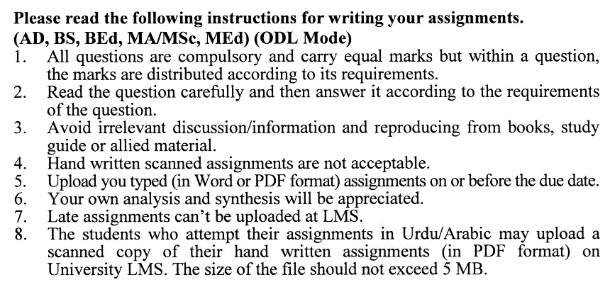

**Total Marks:100 Pass Marks: 50**

**ASSIGNMENT No. 1**

Q. 1 What is the consolidated fund? Discuss the various parts of the consolidated fund. How is it different from the public account? **(20)**

Q. 2 Discuss the following concepts as per the Manual of Accounting Principles: **(20)**

1. Modified Cash Basis of Accounting
2. Cash basis of accounting
3. Financial statements
4. Elements of Accounting

Q. 3 Regarding Manual of Accounting Principles, discuss in detail the financial and accounting responsibilities of: **(20)**

1. Principal Accounting Officer
2. Auditor General of Pakistan
3. Internal Audit Officer
4. Public Accounts Committee

Q. 4 Discuss in detail the accounting treatment of assets and liabilities to be adopted in the public sector accounting bodies as per the Manual of Accounting Procedures. **(20)**

Q. 5 Discuss in detail the budgetary procedures to be followed by the public sector accounting bodies as per the Manual of Accounting Procedures. **(20)**

**Total Marks:100 Pass Marks: 50**

**ASSIGNMENT No. 2**

This assignment is a research-oriented activity. Select one of the following topics according to the last digit of your roll number/ID. For example, if your roll number/ID is P-3427180 then you will select issue # 0 (the last digit): -

**TOPICS:**

0 Present status of public sector accounting in Pakistan

1. Role of Auditor General of Pakistan in public sector accounting
2. Public sector accounting and its role in promoting transparency in Govt. Departments
3. The adoption of International Public Sector Accounting Standards in Pakistan
4. Why do frauds occur in government accounting offices?
5. Impact of public sector accounting rules on development plans
6. Benefits of robust public sector accounting standards
7. Requirements for a good public sector accounting system
8. How corruption can be reduced by adopting a good public sector accounting model
9. The hurdles in the working of a public sector accounting system in Pakistan

The report should follow the following format:

1. Title page
2. Acknowledgements
3. An abstract (one-page summary of the paper)
4. Table of contents
5. Introduction to the issue (brief history & significance of issue assigned)
6. Main points of discussion
7. Conclusion (one-page brief covering important aspects of your report)
8. Recommendations (specific recommendations relevant to the issue assigned)
9. References (as per APA format)
10. Annexes (if any)

****