**ALLAMA IQBAL OPEN UNIVERSITY, ISLAMABAD**

**(Department of Commerce)**

**WARNING**

1. **PLAGIARISM OR HIRING OF GHOST WRITER(S) FOR SOLVING THE ASSIGNMENT(S) WILL DEBAR THE STUDENT FROM AWARD OF DEGREE/CERTIFICATE, IF FOUND AT ANY STAGE.**
2. **SUBMITTING ASSIGNMENT(S) BORROWED OR STOLEN FROM OTHER(S) AS ONE’S OWN WILL BE PENALIZED AS DEFINED IN “AIOU PLAGIARISM POLICY”.**

**Course: Financial Reporting-II (8568) Semester: Spring, 2025**

**Level: M. Com/BS**

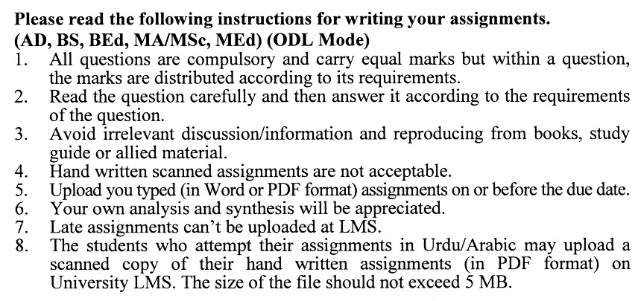

**Total Marks:100 Pass Marks: 50**

**ASSIGNMENT No. 1**

Q. 1 (a) Qasim Limited is a publicly listed company that has a diverse portfolio of properties. Some properties are held for specific purposes while the rest are surplus and not having any present usage for the company. The portfolio includes: **(10)**

1. 100 plots which are purchased by the company with the intention of capital appreciation and will be sold in future at a high price.
2. 20 buildings, which are currently vacant and not under any use. The management has also not decided on the use of these buildings. It is expected that soon, these buildings will remain vacant.
3. One section of Qasim Ltd. is working on housing projects. The main purpose of that section is to purchase land, contract houses and sell them in ordinary course of business.
4. Some houses are also held by the company to provide accommodation to the low-salaried employees at subsidised rentals and the rental income from these buildings is used to cover the repair maintenance expenses of the buildings.

**Required:** Determine the accounting treatment of above-mentioned properties of Qasim Ltd in the Financial Statements as per IAS-40.

(b)What is the gross investment in the lease? How it is different from the net investment in the lease? Also, discuss the lease amortization schedule. **(10)**

Q. 2 (a) Keeping in view the IAS-38, calculate the amount of amortization charges for each year: **(10)**

1. The Jan Ltd. has incurred Rs. 18,00,000 on developing an intangible asset. The expected useful life of the asset is 6 years with no residual value.
2. Zulfi Ltd. Ltd. has acquired software for Rs. 230,000 with three years of useful life.
3. A local brand was acquired with a goodwill of Rs. 23,000.
4. Long-term selling expenses incurred for Rs. 500,000.

(b) Discuss by keeping in view the IAS-38, discuss the treatment of the following expenses: **(10)**

1. Expenses on the research of new improved material of Rs. 18,000.
2. Expenses on applied research amounting to Rs. 90,000.
3. Donation to a research institution of Rs. 25,000.
4. Expenses on construction of prototypes of Rs. 10,000.
5. Expenses on a project of Rs. 150,000 which is commercially and technically viable

Q. 3 (a) A company has acquired a machine for Rs. 10,00,000 in 2016. The company charges depreciation on straight-line basis at 10%. The useful life of the machine is 10 years. At the end of 2016, the recoverable amount of the machine was Rs.750,000 causing an impairment loss. After 5 years of use, due to the technological change, the recoverable amount of the machine was 560,000 causing a reversal of impairment loss. You are required to show how these transactions will be treated in the financial statements. **(10)**

(b) Keeping in view the IAS-36, calculate the recoverable amount and impairment loss in each case: **(10)**

|  |  |  |  |  |
| --- | --- | --- | --- | --- |
| **Items** | **X** | **Y** | **Z** | **K** |
| Carrying value | 100,000 | 150,000 | 120,000 | 150,000 |
| Fair Value | 110,000 | 125,000 | 100,000 | 130,000 |
| Value in Use | 120,000 | 130,000 | 90,000 | 120,000 |
| Selling Cost | 5,000 | 2,000 | 3,000 | 4,000 |

Q. 4 Nasik Ltd. a leading group of companies, needs advice from an IFRS specialist on the following transactions in the light of IAS 24 what transactions need to be recorded and what disclosure of said transactions should be made in the notes. **(20)**

Salary and other employment-related benefits as detailed below have been paid to the Chief Executive Officer of the company during the financial year 2023

* 1. Gross annual salary paid amounting to Rs. 3 million
  2. Share-based payments made to CEO of worth.2 million
  3. Old age benefit plan - employer contribution amounting to Rs. 2 million
  4. Payment of travel and daily allowances made to CEO Rs. 1.7 million for official visits.

**Required:**

Suggest the treatment of the above transaction in the light of IAS 24 and also draft a sample note for disclosure purposes in the financial statement.

Q. 5 Discuss in detail the disclosure requirements in the following International Accounting Standards (IASs): **(20)**

1. IAS-20
2. IAS-11

**Total Marks:100 Pass Marks: 50**

**ASSIGNMENT No. 2**

This assignment is a research-oriented activity. Select one of the following topics according to the last digit of your roll number/ID. For example, if your roll number/ID is P-3427180 then you will select issue # 0 (the last digit): -

**Issue:**

1. Role of SECP in corporate governance
2. Financial reporting and its implications in capital markets
3. The disclosure requirements of IAS-17 & IAS 36
4. The violations of IFRS in the corporate sector of Pakistan
5. The impact of IFRS on reducing frauds in the corporate sector
6. Do IFRS require huge costs for their implementation?
7. The ICAP and standards-setting process in Pakistan
8. Why IFRS are required in a globalized world?
9. The role of IFRS and auditor report
10. The hurdles in the adoption of IFRS in Pakistan

The report should follow the following format:

1. Title page
2. Acknowledgements
3. An abstract (one-page summary of the paper)
4. Table of contents
5. Introduction to the issue (brief history & significance of issue assigned)
6. Practical study (for the issue)
7. Conclusion (one-page brief covering important aspects of your report)
8. Recommendations (specific recommendations relevant to the issue assigned)
9. References (as per APA format)
10. Annexes (if any)

**GUIDELINES FOR ASSIGNMENT # 2:**

* 1.5 line spacing
* Use headers and subheads throughout all sections
* Organization of ideas
* Writing skills (spelling, grammar, punctuation)
* Professionalism (readability and general appearance)
* Do more than repeat the text
* Express a point of view and defend it.

****