**ALLAMA IQBAL OPEN UNIVERSITY, ISLAMABAD**

**(Department of Commerce)**

**WARNING**

1. **PLAGIARISM OR HIRING OF GHOST WRITER(S) FOR SOLVING THE ASSIGNMENT(S) WILL DEBAR THE STUDENT FROM AWARD OF DEGREE/CERTIFICATE, IF FOUND AT ANY STAGE.**
2. **SUBMITTING ASSIGNMENT(S) BORROWED OR STOLEN FROM OTHER(S) AS ONE’S OWN WILL BE PENALIZED AS DEFINED IN “AIOU PLAGIARISM POLICY”.**

**Course: Fundamentals of Money and Banking (8593) Semester: Spring, 2025**

**Level: BS**

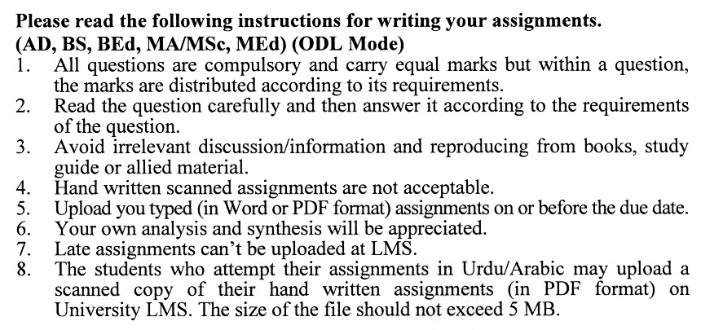

**Total Marks:100 Pass Marks: 50**

**ASSIGNMENT No. 1**

**(Units: 1–4)**

Q. 1 What is money? Explain the role and functions of money in a modern economy. **(20)**

Q. 2 What is inflation? Discuss the types of inflation and relevant remedies for reducing inflation. **(20)**

Q. 3 What are the financial assets? Discuss their types with examples. **(20)**

Q. 4 What are the financial markets? Briefly discuss the role of financial markets in an economy. **(20)**

Q. 5 What is the role and functions of the IMF? Discuss in detail. **(20)**

**Total Marks:100 Pass Marks: 50**

**ASSIGNMENT No. 2**

**(Units: 5–9)**

Q. 1 What is a commercial bank? Explain the different types of services provided by a commercial bank. **(20)**

Q. 2 What are the five Cs of credit? Discuss them in detail in the context of bank loans. **(20)**

Q. 3 What are the major types of bank advances and loans? Discuss in detail. **(20)**

Q. 4 Briefly discuss the role and functions of the State Bank of Pakistan. **(20)**

Q. 5 Write notes on the following: **(20)**

1. Islamic Banking
2. E-Banking
3. Mobile Banking
4. ZTBL.

****