ALLAMA IQBAL OPEN UNIVERSITY, ISLAMABAD

**(Department of Business Administration)**

|  |
| --- |
| **WARNING**   1. **PLAGIARISM OR HIRING OF GHOST WRITER(S) FOR SOLVING THE ASSIGNMENT(S) WILL DEBAR THE STUDENT FROM THE AWARD OF DEGREE/CERTIFICATE IF FOUND AT ANY STAGE.** 2. **SUBMITTING ASSIGNMENT(S) BORROWED OR STOLEN FROM OTHER(S) AS ONE’S OWN WILL BE PENALIZED AS DEFINED IN THE “AIOU PLAGIARISM POLICY”.** |

**Course: Strategic Management (8596) Semester: Spring, 2025**

**Level: BS**

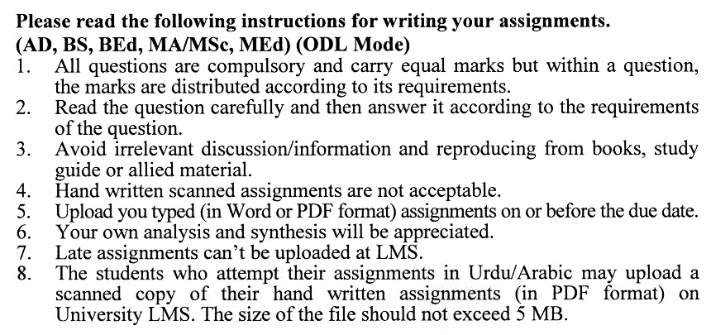

**Total Marks: 100 Pass Marks: 50**

**ASSIGNMENT No. 1**

***Note: Attempt all the questions.***

Q. 1 How do external environmental factors influence strategic decision-making? **(20)**

Q. 2 Explain how leaders influence strategy development, communication, and execution within an organization **(20)**

Q. 3 How does strategic management address risks and uncertainties in business? **(20)**

Q. 4 What are the differences between corporate-level, business-level, and functional-level strategies? **(20)**

Q. 5 How can organizations measure the success of their strategic management process? **(20)**

**Guidelines FOR ASSIGNMENT # 1**

The student should look upon the assignments as a test of knowledge, management skills, and communication skills. When you write an assignment answer, you are indicating your knowledge to the teacher:

* Your level of understanding of the subject.
* How you think;
* How well you can reflect on your knowledge & experience;
* How well you can use your knowledge in solving problems, explaining situations, and describing organizations and management;
* How professional you are, and how much care and attention you give to what you do.

To answer a question effectively, address the question directly, bring important related issues into the discussion, refer to sources, and indicate how principles from the course materials apply. The student must also be able to identify important problems and implications arising from the answer.

For citing references, writing bibliographies, and formatting the assignment, APA format should be followed.

**Total Marks: 100 Pass Marks: 50**

**ASSIGNMENT No. 2**

This assignment is a research-oriented activity. You are required to obtain information from a business/commercial organization and prepare a report of about 1000 words on the issue allotted to you to be submitted to your teacher for evaluation.

You are required to select one of the following issues according to the last digit of your roll number. For example, if your roll number is P-3427180 then you will select issue # 0 (the last digit): -

**List of Topics:**

1. Business Level Strategies and BCG Matrix
2. Role of ICT in Business Competition
3. Alignment of Organizational Resources and Strategy
4. Effect of Environment Turbulence on Strategy Implementation
5. Organizational Structure and Strategy Implementation
6. Managing Strategic Change
7. Strategic Information Systems (SISs)
8. Managing Finance in Strategy Implementation
9. Marketing Strategies
10. Strategy Failure: Reasons and Measures

**GUIDELINES FOR ASSIGNMENT # 2:**

* 1.5 line spacing
* Use headers and subheads throughout all sections
* Organization of ideas
* Writing skills (spelling, grammar, punctuation)
* Professionalism (readability and general appearance)
* Do more than repeat the text
* Express a point of view and defend it.

****