**ALLAMA IQBAL OPEN UNIVERSITY, ISLAMABAD**

***(Department of Educational Planning, Policy Studies and Leadership)***

|  |
| --- |
| **WARNING**   1. **PLAGIARISM OR HIRING OF GHOST WRITER(S) FOR SOLVING THE ASSIGNMENT(S) WILL DEBAR THE STUDENT FROM THE AWARD OF DEGREE/CERTIFICATE IF FOUND AT ANY STAGE.** 2. **SUBMITTING ASSIGNMENT(S) BORROWED OR STOLEN FROM OTHER(S) AS ONE’S OWN WILL BE PENALIZED AS DEFINED IN THE “AIOU PLAGIARISM POLICY”.** |

**Course: Management Strategies in Educational Institutions (8615)**

**Level: B.Ed (1.5 / 4 Years) Semester: Spring, 2025**

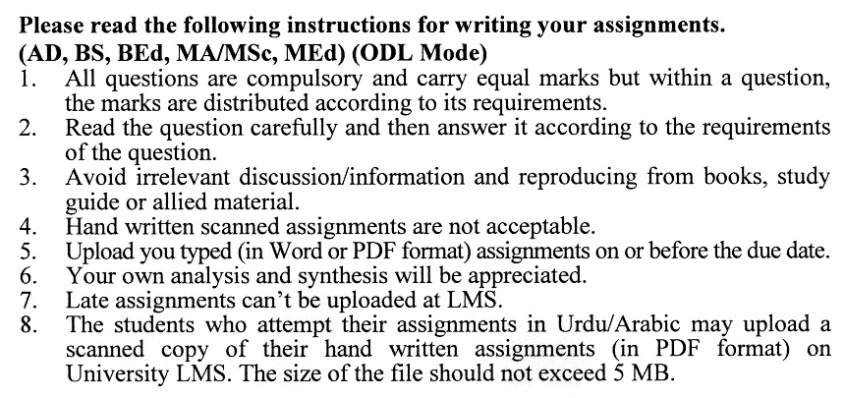

**Total Marks: 100 Pass Marks: 50**

**ASSIGNMENT No. 1**

**(Units: 1–4)**

***Note: Attempt all the questions.***

Q. 1 Define the concept of management. Explain its important features with examples. **(20)**

Q. 2 How do managers really work under the guidance of functions described by Fayol? **(20)**

Q. 3 Explain the PERT process is the key managerial tool to select an optimal decision. **(20)**

Q. 4 Describe SWOT analysis and also explain the importance of SWOT analysis in decision making. **(20)**

Q. 5 Explain different ways types of processes and benefits of reviewing and reporting. **(20)**

**Total Marks: 100 Pass Marks: 50**

**ASSIGNMENT No. 2**

**(Units: 5–9)**

Q. 1 Explain how behavioral change communication helps in positive educational outcomes. Give examples. **(20)**

Q. 2 Describe the limitations and benefits of system and process approaches in educational institutions. **(20)**

Q. 3 What do you mean by ‘Resistance Management’ and corrective actions that can be suggested during the change process? **(20)**

Q. 4 Discuss that there is a need for to understand the different DDIM functions for the data-driven decision-making. **(20)**

Q.5 Describe the Management information system with the factors that help the decision-making tasks for managers. **(20)**

****