**ALLAMA IQBAL OPEN UNIVERSITY, ISLAMABAD**

***(Department of Educational Planning, Policy Studies and Leadership)***

|  |
| --- |
| **WARNING**   1. **PLAGIARISM OR HIRING OF GHOST WRITER(S) FOR SOLVING THE ASSIGNMENT(S) WILL DEBAR THE STUDENT FROM THE AWARD OF DEGREE/CERTIFICATE IF FOUND AT ANY STAGE.** 2. **SUBMITTING ASSIGNMENT(S) BORROWED OR STOLEN FROM OTHER(S) AS ONE’S OWN WILL BE PENALIZED AS DEFINED IN THE “AIOU PLAGIARISM POLICY”.** |

**Course: Educational Planning and Management (8686)**

**Level: B.Ed (4 Years) Semester: Spring, 2025**

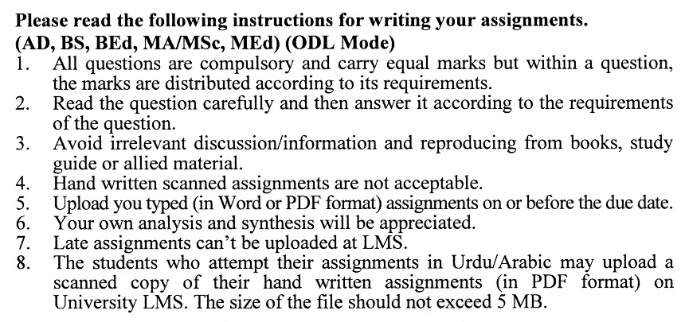

**Total Marks: 100 Pass Marks: 50**

**ASSIGNMENT No. 1**

**(Units: 1–4)**

Q. 1 What is the difference between management and administration in the context of national development plan implementation, and why is development management crucial for successful plan execution? **(20)**

Q. 2 What is the difference between a ratio and a rate in demographic data, and how are they typically expressed? **(20)**

Q. 3 What are the main components of population change, and how are fertility and mortality rates measured in demographic studies? **(20)**

Q. 4 How do social traditions and taboos influence educational decision-making, and what strategies can educational planners use to address the challenges posed by these cultural norms? **(20)**

Q. 5 How has the evolution of traditional educational delivery systems and methods, including the rise of correspondence and hybrid models, influenced the effectiveness of education in meeting contemporary challenges? **(20)**

**Total Marks: 100 Pass Marks: 50**

**ASSIGNMENT No. 2**

**(Units: 5–9)**

Q. 1 How does the educational sector reflect and reproduce the characteristics of the polity, and what are the implications of this relationship for educational planning and reform? **(20)**

Q. 2 What are the key challenges faced by national planning agencies in ensuring integrated development planning, and how do these challenges affect the coordination of sectoral programs and projects? **(20)**

Q. 3 What are the three principles of futurology, and how do they contribute to understanding the future? **(20)**

Q. 4 What are the main types of longitudinal research studies, and how do they differ in terms of data collection and focus in the field of education? **(20)**

Q. 5 What are the key challenges and strategies discussed in the Ninth Five-Year Plan (1998-2003) related to employment, education, and economic development in Pakistan? **(20)**

****