**ALLAMA IQBAL OPEN UNIVERSITY, ISLAMABAD**

***(Department of Islamic Thought, History and Culture)***

Warning

1. Plagiarism or hiring of ghost writer(s) for solving the assignment(s) will debar the student from award of degree/certificate, if found at any stage.
2. Submitting assignment(s) borrowed or stolen from other(s) as one’s own, will be penalized as defined in “AIOU Plagiarism Policy”.

**Course: Islamic Studies (9401 English) Semester: Spring, 2025**

Level: BS (Islamic Studies)

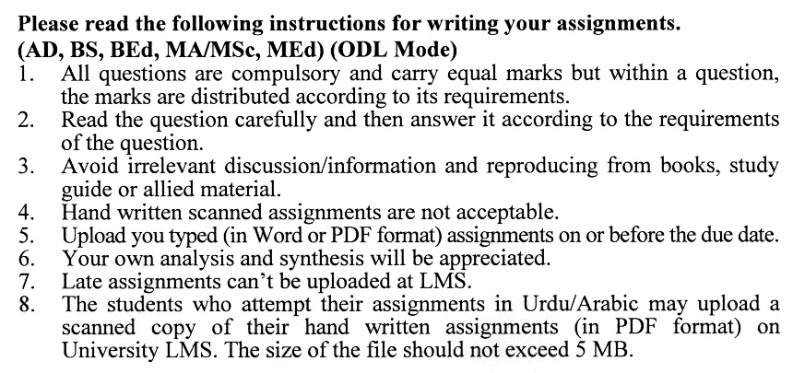

Total Marks: 100 Pass Marks: 50

**Assignment No. 1**

|  |  |  |
| --- | --- | --- |
| **Q1.** | Write a detail note on the concept of Risalah (Prophethood)in Islam. | **(20)** |
| **Q2.** | What are the reasons for the gradual revelation of the holy Quran? Also Write a brief note on social ethics in the light of Surah Al-Hujuraat. | **(20)** |
| **Q3.** | Define Iman. How does it differ from Islam?How do the Five Pillars of Islam contribute to the spiritual and social life of a Muslim? | **(20)** |
| **Q4.** | Write a detailed note on the cognitive foundations for Belief in Hereafter. Also Write down the Blessings of Belief in Aakhirah. | **(20)** |
| **Q5.** | Write a note on the importance of Hadith and Sunnah. | **(20)** |
| Total Marks: 100 Pass Marks: 50  **ASSIGNMENT No.2** | | |
| **Q1.** | What are the main characteristics of Islamic Culture and Civilization? Write a detailed note on the Muslim contribution to themedicine and mathematics. | **(20)** |
| **Q2.** | Discuss the life of the Holy Prophet SAWW, before and after migration. | **(20)** |
| **Q3.** | Discuss how the Holy Prophet (SAWW) established the State of Madinah. Include details about the Constitution of Madinah, the role of brotherhood between the Muhajirun and Ansar (R.A). | **(20)** |
| **Q4.** | *Discuss the importance of Ethics from an Islamic perspective. Alos Enlighten the importance of Piety (Taqwa) in Islam.* | **(20)** |
| **Q5.** | Which two parallel education systems are running in Pakistan?What revolutionary measures can be taken for comprehensive reform of the education system? | **(20)** |