# ALLAMA IQBAL OPEN UNIVERSITY, ISLAMABAD

**(Department of Business Administration)**

**WARNING**

1. **PLAGIARISM OR HIRING OF GHOST WRITER(S) FOR SOLVING THE ASSIGNMENT(S) WILL DEBAR THE STUDENT FROM AWARD OF DEGREE/CERTIFICATE, IF FOUND AT ANY STAGE.**
2. **SUBMITTING ASSIGNMENT(S) BORROWED OR STOLEN FROM OTHER(S) AS ONE’S OWN WILL BE PENALIZED AS DEFINED IN “AIOU PLAGIARISM POLICY”.**

**Course: Human Resource Management (5431//9504/8425/9471/9406)**

**Semester: Spring, 2025**

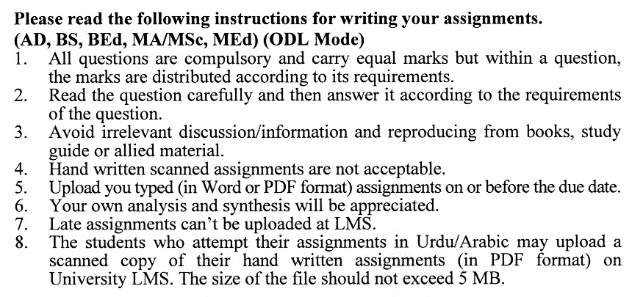

#### Instructions:

(a) All written assignments must be well organized, presented in an easy-to-read format, and neat. If your handwriting is not legible, type or compose the written assignment. Moreover, pay particularly close attention to grammar, spelling punctuation and understandability. Communication is extremely important in this course.

(b) Documentation is likewise very important. Un-supported statements or opinions are worthless to the reader who desires to verify your finding. Complete and specific documentation is mandatory. Also, your references should be to primary sources, except in rare unusual situations.

(c) Quoting should be kept to an absolute minimum.

**Guidelines for Doing Assignments:**

We expect you to answer each question as per instructions in the assignment. You will find it useful to keep the following points in mind:

1. **Planning:** Read the assignments carefully, and go through the Units on which they are based. Make some points regarding each question and then rearrange them in a logical order.
2. **Organization:** Be a little selective and analytical before drawing up a rough outline of your answer. Give adequate attention to the question’s introduction and conclusion.
3. The answer is logical and coherent,
4. It has clear connections between sentences and paragraphs,
5. The presentation is correct in your own expression and style.
6. **Presentation:** Once you are satisfied with your answer, you can write down the final version for submission. It is mandatory to write all assignments neatly. If you desire so, you may underline the points you wish to emphasize. Make sure that the answer is within the stipulated word limit.

## *Wishing you all the best*

## ASSIGNMENT No. 1

## Total Marks: 100 Pass Marks: 50

Q. 1 How can Human Resource Management (HRM) contribute to fostering a positive organizational culture, and what specific HR practices support this effort? **(20)**

Q. 2 What is the role of HR in aligning employee performance with organizational goals, and how can performance management systems be optimized to achieve this alignment? **(20)**

Q. 3 3 In what ways can HRM support diversity and inclusion in the workplace, and what are the potential benefits of a diverse workforce for the organization? **(20)**

Q. 4 How does HRM influence employee motivation and job satisfaction, and what are some effective strategies HR can implement to boost employee engagement? **(20)**

Q. 5 How can HR effectively manage talent acquisition and retention in competitive job markets, and what role does employer branding play in attracting top talent? **(20)**

**assignment No. 2**

**(Units 1–9)**

**Total Marks: 100 Pass Marks: 50**

This assignment is a research-oriented activity. You are required to submit a term paper and present the same in the classroom prior to the final examination. Presentation component is compulsory for all students. You will have to participate in the activity fully and prepare a paper of 6000 to 8000 words on the topic allotted to you. The students are required to prepare two copies of Assignment No. 2. Submit one copy to your teacher for evaluation and the second copy for presentation in the classrooms in the presence of your resource persons and classmates, which will be held at the end of the semester prior to the final examination.

Include the following main headings in your report: -

1. Introduction to the topic
2. Important sub-topics
3. Practical aspects with respect to the topic
4. Review of theoretical and practical situations
5. SWOC (Strengths, Weaknesses, Opportunities, and Challenges) Analysis of the organization with respect to your topic
6. Conclusions and recommendations
7. Annex, if any

You should also develop a PowerPoint Presentation. You are also required to select one of the following topics according to the last digit of your roll number. For example, if your roll number is D-3427185 then you will select topic No.5 (the last digit): -

**Topics:**

Here are 10 topics for classroom presentations on Human Resource Management (HRM):

1. **The Role of HRM in Shaping Organizational Culture**
   * Explore how HR practices influence and develop an organization's culture and values.
2. **Talent Acquisition and Recruitment Strategies in HRM**
   * Discuss effective recruitment methods, including sourcing, interviewing, and selecting the best candidates for an organization.
3. **Performance Management Systems: Enhancing Employee Performance**
   * Analyze how performance management systems are used to monitor, evaluate, and improve employee performance.
4. **Employee Motivation and Engagement Strategies in HRM**
   * Examine various HR practices aimed at motivating employees and fostering high levels of engagement.
5. **The Impact of HRM on Employee Retention**
   * Discuss strategies HR can implement to reduce turnover and retain top talent within an organization.
6. **Diversity and Inclusion in the Workplace: HR’s Role**
   * Discuss how HR can promote diversity, equity, and inclusion within the organization and the benefits of a diverse workforce.
7. **Training and Development in HRM**
   * Explore the importance of training and development programs and their role in improving employee skills and organizational performance.
8. **Compensation and Benefits: Strategic HRM Tools**
   * Discuss the role of compensation and benefits in attracting, retaining, and motivating employees.
9. **Labor Laws and Employee Relations: HR’s Legal Responsibilities**
   * Examine the role of HR in managing labor relations and ensuring compliance with employment laws and regulations.
10. **Change Management and HR’s Role in Organizational Transformation**

Explore how HR can support and manage organizational change, from culture shifts to process redesigns, during periods of transformation.

