ALLAMA IQBAL OPEN UNIVERSITY, ISLAMABAD

**(Department of Business Administration)**

**WARNING**

1. **PLAGIARISM OR HIRING OF GHOST WRITER(S) FOR SOLVING THE ASSIGNMENT(S) WILL DEBAR THE STUDENT FROM THE AWARD OF DEGREE/CERTIFICATE, IF FOUND AT ANY STAGE.**
2. **SUBMITTING ASSIGNMENT(S) BORROWED OR STOLEN FROM OTHER(S) AS ONE’S OWN WILL BE PENALIZED AS DEFINED IN “AIOU PLAGIARISM POLICY”.**

Course: Principles of Marketing (8407/9470) Semester: Spring, 2025

# Level: BBA (4 Years)

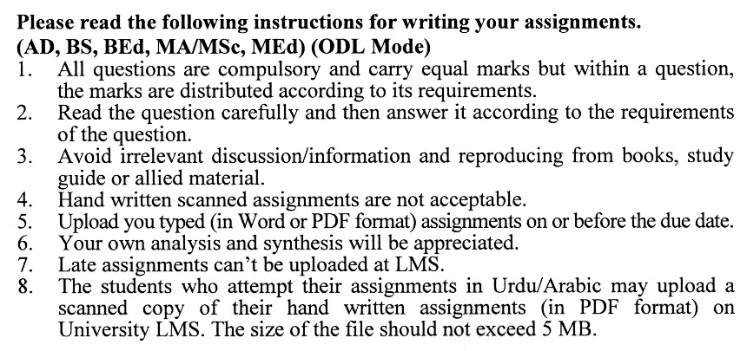

## ASSIGNMENT No. 1

# Total Marks: 100 Pass Marks: 50

***Instructions: You must answer the questions in your own words. (Copying from books is not permissible). Attempt all questions.***

Q. 1 How is strategic planning carried out at the corporate, division and business-unit levels? **(20)**

Q. 2 How marketing information system help organizations to compete in the contemporary scenario? Support your answer with a suitable example. **(20)**

Q. 3 Organizations focus on selling their product to different segments of the market and to cater for the requirements of the customers the whole market is divided into small segments. You are advised to identify and explain various approaches utilized for segregating the market to meet organizational objectives. **(20)**

Q. 4 Explain 05 stages of the product life cycle (Draw table). Also, draw a diagram of the product life cycle. Enlist 08 stages of the new product development process. **(20)**

Q. 5 How does PEST affect the organization’s products or services? What are the primary factors to consider? **(20)**

**ASSIGNMENT No. 2**

**Total Marks: 100 Pass Marks: 50**

This assignment is a research-oriented activity. You are required to obtain information from a business/commercial organization and prepare a report of about 1000 words on the topic allotted to you to be submitted to your teacher for evaluation.

You are required to select one of the following topics according to the last digit of your roll number. For example, if your roll number is P-3427180 then you will select topic # 10 (the last digit): -

**Topics:**

1. Application of TQM in Marketing Process
2. Determinants of Buying Behavior in Service Organizations
3. Factors Affecting pricing of Manufacturing Organizations in Pakistan
4. International Marketing Approaches
5. Marketing Decision Support Systems
6. Marketing Management and Its Evaluation
7. New Product Development Issues and their Measures
8. Selecting Best Channels of Distribution
9. Selection of Different Target Market
10. Societal Marketing Concept

**The report should follow the following format:**

1. Title page
2. Acknowledgements
3. An abstract (one-page summary of the paper)
4. Table of contents
5. Introduction to the topic (brief history & significance of topic assigned)
6. Practical study of the organization (for the topic)
7. Data collection methods
8. SWOT analysis (strengths, weaknesses, opportunities & threats) relevant to the topic assigned
9. Conclusion (one-page brief covering important aspects of your report)
10. Recommendations (specific recommendations relevant to the topic assigned)
11. References (as per APA format)
12. Annexes (if any)

**GUIDELINES FOR ASSIGNMENT # 2:**

* 1.5 line spacing
* Use headers and subheads throughout all sections
* Organization of ideas
* Writing skills (spelling, grammar, punctuation)
* Professionalism (readability and general appearance)
* Do more than repeat the text
* Express a point of view and defend it.

**Workshops**

The workshop presentations provide you with the opportunity to express your communication skills, knowledge & understanding of concepts learned during the practical study assigned in assignment # 2.

You should use transparencies and any other material for effective presentation. The transparencies are not the presentation, but only a tool; the presentation is the combination of the transparencies and your speech. Workshop presentation transparencies should only be in typed format.

