ALLAMA IQBAL OPEN UNIVERSITY, ISLAMABAD

**(Department of Educational Planning Policy Studies & Leadership)**

Warning

1. Plagiarism or hiring of ghost writer(s) for solving the assignment(s) will debar the student from award of degree/certificate, if found at any stage.
2. Submitting assignment(s) borrowed or stolen from other(s) as one’s own, will be penalized as defined in “AIOU Plagiarism Policy”.

## Course: Plan Implementation and Management-I (6561)

## Level: MA Semester: Spring, 2025

## 

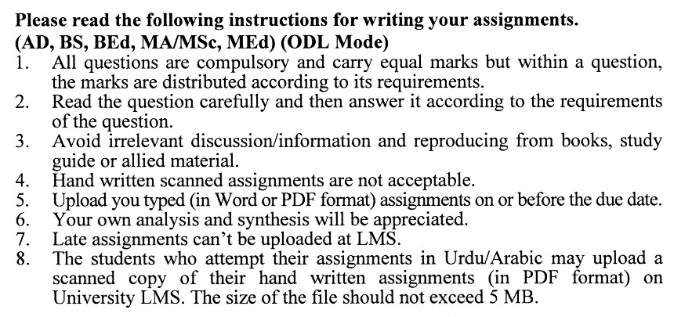

## Total Marks: 100 Pass Marks: 40

**ASSIGNMENT No. 1**

**(Units 1-5)**

|  |  |  |
| --- | --- | --- |
| Q.1 | What is feasibility testing, and why is it crucial in the educational planning process? | (20) |
| Q.2 | What are the key steps in formulating an effective education plan? | (20) |
| Q.3 | How does the elaboration of educational plans ensure the alignment of goals with national education policies? | (20) |
| Q.4 | What are the main stages involved in the educational planning process? | (20) |
| Q.5 | What are the key phases of the project cycle in educational planning? | (20) |

## Total Marks: 100 Pass Marks: 40

**ASSIGNMENT No. 2**

**(Units 6-9)**

|  |  |  |
| --- | --- | --- |
| Q.1 | How does project appraisal contribute to the effective utilization of educational resources? | (20) |
| Q.2 | What are the fundamental components of an educational project? | (20) |
| Q.3 | What are the key financial and economic concepts used in project appraisal? | (20) |
| Q.4 | Appraise a national education reform project based on financial, social, and educational indicators. | (20) |
| Q.5 | What are the distinctive features that differentiate an evaluation study from other types of research? | (20) |