ALLAMA IQBAL OPEN UNIVERSITY, ISLAMABAD

**(Department of Business Administration)**

|  |
| --- |
| **WARNING**   1. **PLAGIARISM OR HIRING OF GHOST WRITER(S) FOR SOLVING THE ASSIGNMENT(S) WILL DEBAR THE STUDENT FROM THE AWARD OF DEGREE/CERTIFICATE IF FOUND AT ANY STAGE.** 2. **SUBMITTING ASSIGNMENT(S) BORROWED OR STOLEN FROM OTHER(S) AS ONE’S OWN WILL BE PENALIZED AS DEFINED IN THE “AIOU PLAGIARISM POLICY”.** |

**Course: Business Communication (5002/9472) Semester: Spring, 2025**

**Level: MSc Administrative Sciences / BS**

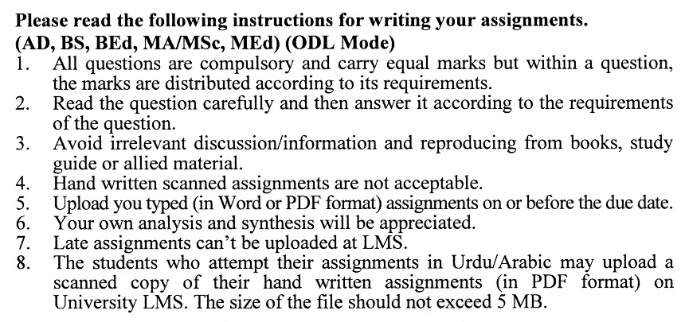

**Total Marks: 100 Pass Marks: 50**

**ASSIGNMENT No. 1**

Q. 1 What is the role of effective business communication in the success of an organization? **(20)**

Q. 2 How do verbal and non-verbal communication differ in a business setting? **(20)**

Q. 3 What are the key elements of effective written communication in business? **(20)**

Q. 4 How does communication flow in an organization, and what are its types? **(20)**

Q. 5 What is the impact of cultural diversity on business communication? **(20)**

**Guidelines FOR ASSIGNMENT No. 1:**

You should look upon the assignments as a test of knowledge, management skills, and communication skills. When you write an assignment answer, you are indicating your knowledge to the teacher:

* Your level of understanding of the subject.
* How do you think?
* How well you can reflect on your knowledge & experience?
* How well you can use your knowledge in solving problems, explaining situations, and describing organizations and management?
* How professional you are, and how much care and attention you give to what you do?

To answer a question effectively, address the question directly, bring important related issues into the discussion, refer to sources, and indicate how principles from the course materials apply. The student must also be able to identify important problems and implications arising from the answer.

For citing references, writing bibliographies, and formatting the assignment, APA format should be followed.

**ASSIGNMENT No. 2**

**Total Marks: 100 Pass Marks: 50**

You are also required to select one of the following topics according to the last digit of your roll number. For example, if your roll number is D-3427185 then you will select topic number 5 (the last digit):-

**Topics**

1. Principles of Effective Communication
2. Written communication: Short Reports
3. Effective Written Job Presentation
4. Strategies for Effective Intrapersonal Communication
5. Successful Listening Skills
6. Effective Proposal Writing
7. Process of Preparing Effective Business Messages
8. Persuasive Writing
9. Communication and Ethical Issues
10. Forms of Managing Information related to a company

****