**ALLAMA IQBALOPENUNIVERSITY, ISLAMABAD**

**(Department of Mass Communication)**

## Course: Media Ethics & Laws – I (6603) Semester: Spring, 2025

## Level: MSc Total Marks: 100

**Credit Hours: 03 (Units: 1–9) Pass Marks: 40**

### **INSTRUCTIONS:**

1. Assignments 1 and 2 cover units 1–4 and 5–9 respectively.

2. Each assignment carries 100 marks.

3. Write the assignments in your own words.

Since the nature of assignment questions requires you to be more analytical, therefore, supplement material from the study guides with information from other suggested readings could be incorporated into it. Some of the questions require including examples from a Pakistani perspective/setting. So do not simply rehash material from the study guide verbatim but rely on synthesizing materials from different units of the study guide in your language.

# **LIST OF CONTENTS:**

This package comprises the following material:

1. Study Guide (Available online)

2. Assignments 1 and 2

Best of Luck.

##### *(****Dr. Asad Munir****)*

##### *Course Coordinator*

ALLAMA IQBAL OPEN UNIVERSITY, ISLAMABAD

**(Department of Mass Communication)**

|  |
| --- |
| **WARNING**   1. **PLAGIARISM OR HIRING OF GHOST WRITER(S) FOR SOLVING THE ASSIGNMENT(S) WILL DEBAR THE STUDENT FROM THE AWARD OF DEGREE/CERTIFICATE IF FOUND AT ANY STAGE.** 2. **SUBMITTING ASSIGNMENT(S) BORROWED OR STOLEN FROM OTHER(S) AS ONE’S OWN WILL BE PENALIZED AS DEFINED IN THE “AIOU PLAGIARISM POLICY”.** |

**Course: Media Ethics & Laws – I (6603) Semester: Spring, 2025**

**Level: MSc**

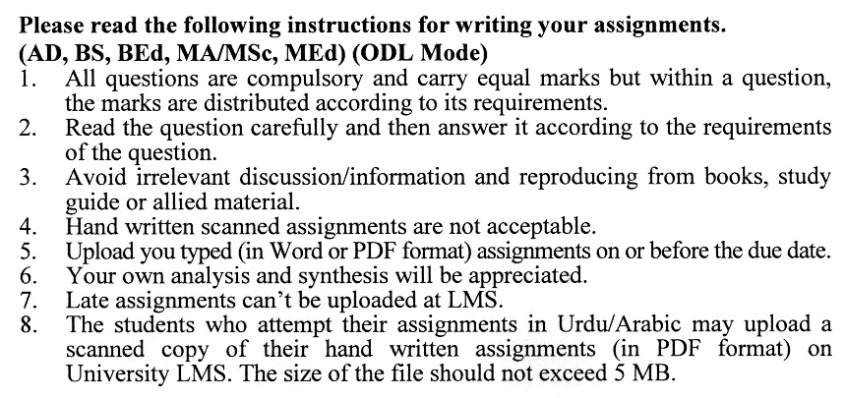

**Total Marks: 100 Pass Marks: 40**

**ASSIGNMENT No. 1**

**(Units: 1–4)**

Q. 1 What is the difference between constitution, law and ethics? Also, describe a brief history of press laws in Pakistan. **(20)**

Q. 2 What do you know about the coverage of politics and ethical issues? **(20)**

Q. 3 Explain the ethics and morality in perspectives of freedom of speech. **(20)**

Q. 4 Elaborate on universal press laws. **(20)**

Q. 5 Describe the international scenario on privacy rights. **(20)**

**Total Marks: 100 Pass Marks: 40**

**ASSIGNMENT No. 2**

**(Units: 5–9)**

Q. 1 How should privacy be managed while covering public interest issues? **(20)**

Q. 2 Write short notes on the following: **(5 x 4 = 20)**

1. Credibility
2. Social Responsibility
3. Privacy
4. Portrayal of Women

Q. 3 Elaborate the responsibilities of online journalism with suitable examples. **(20)**

Q. 4 Describe salient features of Islamic ethical guidelines for communication. **(20)**

Q. 5 Discuss unethical practices in photojournalism. **(20)**

