**ALLAMA IQBAL OPEN UNIVERSITY, ISLAMABAD**

***(Department of Islamic Thought, History and Culture)***

Warning

1. Plagiarism or hiring of ghost writer(s) for solving the assignment(s) will debar the student from award of degree/certificate, if found at any stage.
2. Submitting assignment(s) borrowed or stolen from other(s) as one’s own, will be penalized as defined in “AIOU Plagiarism Policy”.

**Course: Islamic Studies (5466/8221 English) Semester: Spring, 2025**

Level: BS

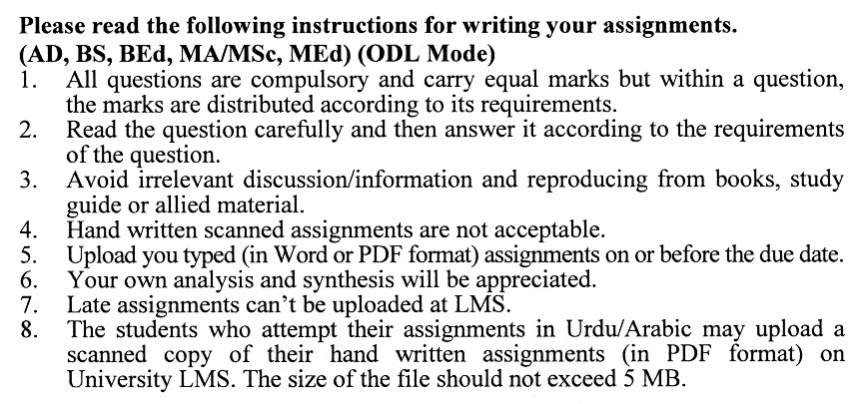

Total Marks: 100 Pass Marks: 50

**Assignment No. 1**

|  |  |  |
| --- | --- | --- |
| **Q1.** | Write a detail note on the concept of Risalah (Prophethood) and Akhira (life hereafter) in Islam. | **(20)** |
| **Q2.** | Discuss the qualities of special persons of the Al-Rehman (Ibad-ur-Rahman) in the context of Surah al-Furqan. | **(20)** |
| **Q3.** | Discuss the Islam, Iman and Ihsan with details as described in the Hadith. | **(20)** |
| **Q4.** | Write a detailed note on the concept of worships in Islam. Also write a note on the importance of prayer (Salah) in Islam. | **(20)** |
| **Q5.** | Write a note on the importance of Hadith and Sunnah. | **(20)** |
| Total Marks: 100 Pass Marks: 50  **ASSIGNMENT No.2** | | |
| **Q1.** | What are the main characteristics of Islamic Culture and Civilization? Write a detailed note on the Muslim contribution to themedicine and mathematics. | **(20)** |
| **Q2.** | Discuss the life of the Holy Prophet SAWW, before and after migration. | **(20)** |
| **Q3.** | Discuss how the Holy Prophet (SAWW) established the State of Madinah. Include details about the Constitution of Madinah, the role of brotherhood between the Muhajirun and Ansar (R.A). | **(20)** |
| **Q4.** | Write a brief note on the lives of the Companions (*Sahaba*) of the Prophet Muhammad (SAWW). Who were the Wives of the Holy Prophet (S.A.W.) (known as the *Mothers of the Believers* (*Ummahat al-Mu'mineen)*. | **(20)** |
| **Q5.** | Write the impacts of the belief of Tauheed? Also write a detailed note on the significance and Importance of the holy Quran. | **(20)** |