# ALLAMA IQBAL OPEN UNIVERSITY ISLAMABAD

**(Department of Business Administration)**

**WARNING**

1. **PLAGIARISM OR HIRING OF GHOST WRITER(S) FOR SOLVING THE ASSIGNMENT(S) WILL DEBAR THE STUDENT FROM THE AWARD OF DEGREE/CERTIFICATE IF FOUND AT ANY STAGE.**
2. **SUBMITTING ASSIGNMENT(S) BORROWED OR STOLEN FROM OTHER(S) AS ONE’S OWN WILL BE PENALIZED AS DEFINED IN “AIOU PLAGIARISM POLICY”.**

**Course: Organizational Behavior (9506) Semester: Spring, 2025**

Level: PGD (Human Resource Management)

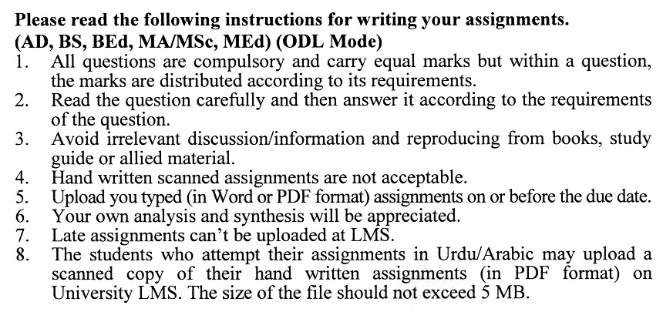

Total Marks: 100 Pass Marks: 50

ASSIGNMENT No. 1

(Units: 1–5)

Note: Attempt all questions.

Q. 1 Contrast the strengths and weaknesses of individual vs group decision-making. **(20)**

Q. 2 Does behaviour always follow from attitudes? Why or why not? Discuss the factors that affect whether behaviour follows from attitudes. **(20)**

Q. 3 What is the evidence for and against the existence of emotional intelligence? **(20)**

Q. 4 What is attribution theory? What are the three determinants of attribution? What are its implications for explaining organizational behaviour? **(20)**

Q. 5 Compare the effectiveness of different leadership styles. **(20)**

**assignment No. 2**

**(Units: 1–9)**

**Total Marks: 100 Pass Marks: 50**

This assignment is a research-oriented activity. You are required to obtain information from a business/commercial organization and prepare a report of about 1000 words on the issue allotted to you to be submitted to your teacher for evaluation.

You are required to select one of the following topics according to the last digit of your roll number. For example, if your roll number is P-3427180 then you will select issue # 0 (the last digit): -

**Topics:**

1. Employee engagement
2. Emotional intelligence
3. Global Diversity
4. Rational Decision Making
5. Centralization
6. Women in the International Workforce
7. Power and Control
8. Types of Managers
9. Leadership
10. Goal-Setting

**The report should follow the following format:**

1. Title page
2. Acknowledgements
3. An abstract (one-page summary of the paper)
4. Table of contents
5. Introduction to the issue (brief history & significance of issue assigned)
6. Practical study of the organization (for the issue)
7. Data collection methods
8. SWOT analysis (strengths, weaknesses, opportunities & threats) relevant to the issue assigned
9. Conclusion (one-page brief covering important aspects of your report)
10. Recommendations (specific recommendations relevant to the issue assigned)
11. References (as per APA format)
12. Annexes (if any)

**GUIDELINES FOR ASSIGNMENT # 2:**

* 1.5 line spacing
* Use headers and subheads throughout all sections
* Organization of ideas
* Writing skills (spelling, grammar, punctuation)
* Professionalism (readability and general appearance)
* Do more than repeat the text
* Express a point of view and defend it.

**Workshop:**

The workshop presentations provide you with an opportunity to express your communication skills, knowledge & understanding of concepts learned during the practical study assigned in assignment # 2.

You should use transparencies and any other material for effective presentation. The transparencies are not the presentation, but only a tool; the presentation is the combination of the transparencies and your speech. Workshop presentation transparencies should only be in typed format.

**The transparencies should follow the following format:**

1. Title page
2. An abstract (one-page summary of the paper)
3. Introduction to the issue (brief history & significance of issue assigned)
4. Practical study of the organization (for the issue)
5. Data collection methods
6. SWOT analysis (strengths, weaknesses, opportunities & threats) relevant to the issue assigned
7. Conclusion (one-page brief covering important aspects of your report)
8. Recommendations (specific recommendations relevant to the issue assigned)

**GUIDELINES FOR WORKSHOP PRESENTATION:**

* Make eye contact and react to the audience. Don't read from the transparencies or the report, and don't look too much at the transparencies (occasional glances are acceptable to help in recalling the topic to cover).
* A 15-minute presentation can be practised several times in advance, so do that until you are confident enough. Some people also use a mirror when rehearsing as a substitute for an audience.

**ORGANIZATION BEHAVIOUR (9506)**

**COURSE OUTLINE**

##### Unit 1 Overview of Organizational Behavior

* 1. Organizational Behavior: Theoretical Framework
     1. Defining Organizational Behavior
     2. Historical Background for Modern Organizational Behavior
     3. Challenges Faced by Management
     4. Organizational Behavior Model

1.2 Emerging Organizations

* + 1. Role of Information Technology
    2. Total Quality Management
    3. Learning Organizations

**Unit 2 Micro Perspective of OB–I**

##### Perception Process and Impression Management

##### Meaning and Significance of Perception

##### 2.1.2 Individual Perceptual Process

* + 1. Perceptual Selectivity
    2. Perceptual Organization
    3. Social Perception

##### Personality and Attitudes

* + 1. Meaning of Personality
    2. Development of Personality and Socialization
    3. Nature and Dimensions of Attitudes
    4. Job Satisfaction and Organizational Commitment

**Unit 3 Micro Perspective of OB–II**

##### Motivation: Needs, Content and Processes

* + 1. Meaning of Motivation
    2. Types of Motives
    3. Theories of Motivation
       1. Content Theories of Work Motivation
       2. Process Theories of Work Motivation
       3. Contemporary Theories of Work Motivation

##### Motivating Performance through Job Design and Goal Setting

##### Learning: processes, Reward System and Behavioral Management

##### Theoretical Processes of Learning

##### Principles of Learning: Reinforcement and Punishment

##### Organizational Rewards Systems

##### Behavioral Management

**Unit 4** **The Dynamics of OB–I**

###### Group Dynamics and Teams

* + 1. Nature of Groups
    2. Dynamics of Informal Groups
    3. Dynamics of Formal Work Groups
    4. Teams in Modern Workplace

###### Interactive Conflict and Negotiation Skills

###### Types of Conflict

* + - 1. Intra-Individual Conflict
      2. Interpersonal Conflict
      3. Intergroup Behavior and Conflict
      4. Organizational Conflict

4.2.2 Negotiation Skills

**Unit 5 The Dynamics of OB–II**

###### Occupational Stress

* + 1. Meaning of Stress
    2. Dynamics of Stress
    3. Effects of Occupational Stress
    4. Stress Management

###### Power and Politics

* + 1. Meaning and Types of Power
    2. Distinctions Between Power, Authority and Influence
    3. Meaning and Nature of Organizational Politics
    4. Political Implications of Power

###### Unit 6 Leadership

###### Defining Leadership

###### Background and Classic Studies on Leadership

###### Established Theories of Leadership

###### Emerging Theoretical Frameworks for Leadership

6.5 Leadership Styles

6.6 Roles and Activities of Leadership

6.7 Leadership Skills

###### Unit 7 A Macro Perspective of OB–I

###### Communication Technology and Interpersonal Processes

7.1.1 Historical Background of Communication

7.1.2 Communication Technology

7.1.3 Nonverbal Communication

7.1.4 Interpersonal Communication

7.1.5 Downward Communication

7.1.6 Upward Communication

###### Interactive Communication in Organizations

* + 1. Decision Making
    2. Nature of Decision Making
    3. Behavioral Decision Making
    4. Behavioral Oriented Decision-Making Techniques
    5. Creativity and Group Decision Making

###### Unit 8 A Macro Perspective of OB–II

###### Organizational Theory and Design

###### Classical Organization Theory and Design

* + 1. Modification of Bureaucratic Structuring
    2. Modern Organization Theory
    3. Modern Organization Design

###### Organizational Culture

###### Nature of Organizational Culture

###### Creating and Maintaining a Culture

###### Unit 9: Horizons for Organizational Behavior

###### International Organizational Behavior

###### Impact of Culture on International Organizational Behavior

###### Communication in an International Environment

###### Motivation across Cultures

###### Managerial Leadership Across Culture

###### Organizational Change and Development

###### Changes Facing Organizations

* + 1. Organizational Development Approaches and Techniques
    2. Future of Organizational Behavior

**Recommended Books:**

Robbins, S. P. **(2009). *Organizational Behaviour* (10th ed.).Hoboken New Jersey**: John Wiley & Sons Inc.

Luthen, F. **(2006). *Organizational Behaviour*.Mc Graw-Hill**

Griffin, R. W., & Moorhead, G. **(2011). *Organizational Behaviour* (10th ed.).Canada: Nelson Education Ltd.**

