# ALLAMA IQBAL OPEN UNIVERSITY, ISLAMABAD

**(Department of Business Administration)**

Warning

1. Plagiarism or hiring of ghost writer(s) for solving the assignment(s) will debar the student from award of degree/certificate, if found at any stage.
2. Submitting assignment(s) borrowed or stolen from other(s) as one’s own, will be penalized as defined in “AIOU Plagiarism Policy”.

**Course: Total Quality Management (5011/8224) Semester: Spring, 2025**

**Level: BBA/MSc Administrative Sciences**

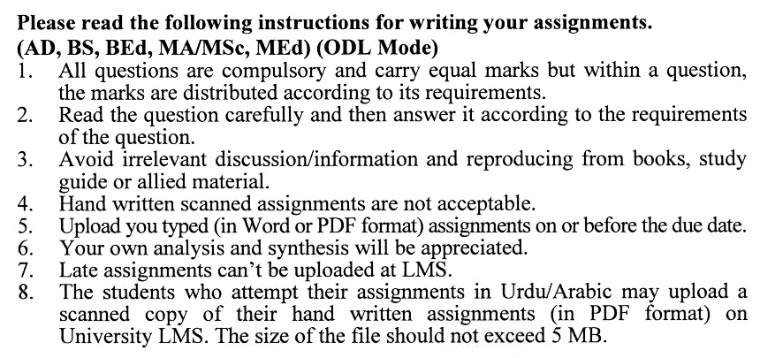

**Instructions:**

1. All written assignments must be well organized, presented in an easy-to-read format and neat. Moreover, pay particularly close attention to grammar, spelling, and punctuation understandability. Communication is extremely important in this course.
2. Documentation is likewise very important. Un-supported statements or opinions are worth less to the reader, who desires to verify your finding. Complete specific documentation is mandatory. Also, your references should be to prima sources, except in rare unusual situations.
3. Quoting should be kept to an absolute minimum.

**Guidelines for Doing Assignments**

We expect you to answer each question as per instructions in the assignment. You will find it useful to keep the following points in mind:

1) Planning: Read the assignments carefully, and go through the Units on which they are based. Make some points regarding each question and then rearrange them in logical order.

2) Organization: Be a little selective and analytical before drawing up a rough outline of your answer. Give adequate attention to the question's introduction and conclusion.

**Make sure that:**

1. The answer is logical and coherent,
2. It has clear connections between sentences and paragraphs,
3. The presentation is correct in your own expression and style.

3) Presentation: Once you are satisfied with your answer, you can write down the final version for submission. It is mandatory to write all assignments neatly. If you desire so, you may underline the points you wish to emphasize. Make sure that the answer is within the stipulated word limit.

**Total Marks: 100 Pass Marks: 50**

##### Assignment No. 1

Q. 1 Describe the basic approaches used in Total Quality Management and how they contribute to overall quality improvement. **(20)**

Q. 2 Discuss the various benefits that an organization can reap from successfully implementing Total Quality Management and the impact on its performance and competitiveness. **(20)**

Q. 3 Describe the different leadership styles and their potential impact on Total Quality Management. **(20)**

Q. 4 Explain the "Seven Habits of Highly Effective People" by Stephen Covey and their relevance to leadership in the context of Total Quality Management. **(20)**

Q. 5 What role does the perception of quality play in customer satisfaction, and how can businesses manage and improve this perception? **(20)**

**Total Marks: 100 Pass Marks: 50**

**ASSIGNMENT No. 2**

Q. 1 How does employee involvement contribute to improving the quality of products or services, and what are the key strategies for fostering a culture of employee engagement in quality initiatives? **(20)**

Q. 2 Discuss the role of performance appraisal in evaluating and rewarding employee contributions to quality improvement. **(20)**

Q. 3 Explore the adoption and implementation of ISO standards in Pakistan. What industries and sectors in Pakistan have benefited from ISO certification, and what are the specific challenges faced in this context? **(20)**

Q. 4 What is the fundamental concept underlying the continuous process of improvement, and how does it differ from one-time improvements in an organization's   
operations? **(20)**

Q. 5 Define the concept of quality costs and provide examples of prevention, appraisal, internal failure, and external failure costs. How do these costs relate to the overall quality of products and services? **(20)**

**COURSE OUTLINE**

**Unit–1: Introduction to Total Quality Management**

1.1 Defining Total Quality Management

1.2 Basic Approaches of Total Quality Management

1.3 Gurus of Total Quality Management

1.4 TQM Framework

1.5 Awareness of the Improved Quality

1.6 Historical Review

1.7 Obstacles in Implementing TQM

1.8 Benefits of TQM

**Unit–2: Leadership and Total Quality Management**

2.1 Leadership

2.2 Characteristics of Quality Leaders

2.3 Concepts

2.4 Habits of Highly Effective People

2.5 Ethics and Quality

2.6 Deming Philosophy

2.7 Role of Leaders in TQM

2.8 Quality Control

2.9 Core Values, Concepts and Framework

2.10 Strategic Planning and Communication

**Unit–3: Customer Satisfaction and Employee Involvement**

3.1 Customer Satisfaction (An Overview)

3.2 Perception of Quality and Feedback from Customer

3.3 Effectively using Customer Complaints

3.4 Transforming Needs into Requirement of Customers and the Importance of Customer Retention

3.5 Employee Involvement in Improving Quality

3.6 Motivational Theories and Empowerment

3.7 Teams and Their Effectiveness

3.8 Rewards, Recognition and Performance Appraisal

3.9 Union and Employee Involvement

**Unit–4: Continuous Process of Improvement and Performance Measures**

4.1 Perfection through Continuous Improving Process

4.2 Approach to Continuous Improvement Process

4.3 Improvement Strategies

4.4 Problems: Types and Solving Method

4.5 Objectives of Performance Measures

4.6 Presentation of Performance Measures

4.7 Quality Costs

4.8 Malcolm Baldrige National Quality Award.

**Unit–5: Benchmarking**

5.1 Benchmarking: Concept and Significance

5.2 Reasons for Benchmarking

5.3 Benchmark Planning

5.4 Process of Benchmarking

5.5 Actions to close the Gap between Benchmark

5.6 Pitfalls and Criticisms of Benchmarking

**Unit–6: Quality Management System**

6.1 ISO: Concept and Significance

6.2 ISO 9000 Series: Standards and Requirements

6.3 Implementation of Quality Management System (ISO)

6.4 Internal Audits

6.5 ISO Certification for Service Organizations

6.6 ISO Vs Baldrige Award

6.7 ISO Standards in Pakistan

**Unit–7: Environmental Management System**

7.1 Introduction to Environmental Management Standards

7.2 Concept of ISO 14001

7.3 ISO 14000 Series Standards

7.4 Requirements of ISO 14001

7.5 Benefits of Environmental Management System

7.6 Integrating ISO 14000 with ISO 9000

7.7 Relationship of Standards with Health and Safety

**Unit–8: Quality Function Deployment and Quality by Design**

8.1 Concept of Quality Function Deployment

8.2 Role of team in QFD

8.3 Benefits of QFD

8.4 House of Quality

8.5 Quality Function Deployment Process

8.6 Quality by Design: Concept and Significance

8.7 Rational for Implementing Quality by Design

8.8 Communication Models

8.9 Tools used for Implementing Quality by Design

**Unit–9: Management and Technical Tools for Improving**

9.1 Introduction of Management Tools and their Importance

9.2 Forced Field Analysis

9.3 Nominal Group Technique

9.4 Affinity Diagram, Tree Diagram and Matrix Diagram

9.5 Process Decision Program chart

9.6 Activity Network Diagram

9.7 Just in Time and Just in Case

9.8 Concept of Statistical Process Control

