# ALLAMA IQBAL OPEN UNIVERSITY, ISLAMABAD

**(Department of Business Administration)**

Warning

1. Plagiarism or hiring of ghost writer(s) for solving the assignment(s) will debar the student from award of degree/certificate, if found at any stage.
2. Submitting assignment(s) borrowed or stolen from other(s) as one’s own, will be penalized as defined in “AIOU Plagiarism Policy”.

**Course: Corporate Governance (5017/8225) Semester: Spring, 2025**

**Level: BBA/MSc Administrative Sciences**

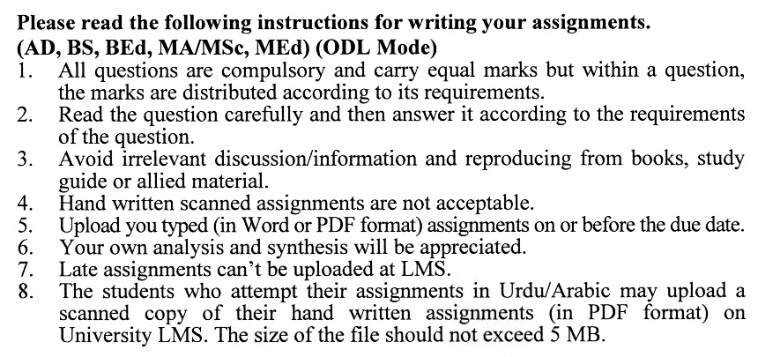

**Instructions:**

1. All written assignments must be well organized, presented in an easy-to-read format and neat. Moreover, pay particularly close attention to grammar, spelling, and punctuation understandability. Communication is extremely important in this course.
2. Documentation is likewise very important. Un-supported statements or opinions are worth less to the reader, who desires to verify your finding. Complete a specific documentation is mandatory. Also, your references should be to prima sources, except in rare unusual situations.
3. Quoting should be kept to an absolute minimum.

**Guidelines for Doing Assignments**

We expect you to answer each question as per instructions in the assignment. You will find it useful to keep the following points in mind:

1) Planning: Read the assignments carefully, go through the Units on which they are   
based. Make some points regarding each question and then rearrange them in logical order.

2) Organization: Be a little selective and analytical before drawing up a rough outline of your answer. Give adequate attention to the question's introduction and conclusion.

Make sure that:

1. The answer is logical and coherent,
2. It has clear connections between sentences and paragraphs,
3. The presentation is correct in your own expression and style.

3) Presentation: Once you are satisfied with your answer, you can write down the final version for submission. It is mandatory to write all assignments neatly. If you desire so, you may underline the points you wish to emphasize. Make sure that the answer is within the stipulated word limit.

**Total Marks: 100 Pass Marks: 50**

##### Assignment No. 1

***Note: Attempt all questions.***

Q. 1 Explain the role of leadership and the board of directors in implementing effective corporate governance. How do their decisions impact the company's overall governance structure? **(20)**

Q. 2 Illustrate the role of corporate governance ethics in preventing corporate scandals and controversies. How can transparent and ethical decision-making contribute to the prevention of legal and reputational risks? **(20)**

Q. 3 Highlight the important monitoring role that institutional investors play in Pakistan's corporate governance. **(20)**

Q. 4 In today's dynamic business environment, where companies often diversify their sources of resources, how might resource dependency theory's original assumptions be challenged? **(20)**

Q. 5 Discuss the significance of protecting minority shareholders' rights. What measures can companies take to ensure that minority shareholders' interests are not marginalized? **(20)**

**Total Marks: 100 Pass Marks: 50**

**ASSIGNMENT No. 2**

**(Units: 1–9)**

**Instructions:**

1. This assignment is a research-oriented activity. You are required to develop a term paper and submit it to the tutor for evaluation prior to the final examination. The last date of this assignment will be notified separately by our directorate of regional services and the same will be communicated to you directly as well as through approved study centers assigned to you.
2. You will have to participate in the activity fully, actively, and practically to be able to pass the final examination of the course.
3. For the preparation of this assignment, you should first thoroughly review the literature on the topic and develop a scholarly material of the same giving references, quotations, and extracts of various scholars and experts. Then study the relevant practical aspects. Combining the theoretical and practical aspects, develop a comprehensive paper consisting of at least 20 to 25 typed pages to be submitted to your tutor.
4. Introduction to the topic
5. Important sub-topics
6. Practical study of the with respect to the topic
7. Review of theoretical and practical situations, merits, de-merits deficiencies and strengths of the organization with respect to the topic under study.
8. Conclusion and recommendation
9. Annex, if any

4. Prepare a copy of this assignment and submit it to your tutor for your evaluation.

5. You should add any illustrative material/data/tables/analysis for effective submission

6. A number of topics given below are the general aspects of the course and you are required to select one of the topics according to the last digit of your roll number for example, if the roll number is N-9337241, you will select topic number 1, and if the roll number is 0-3427185 then you will select topic number 5 (the last digit).

**List of Topics:**

1. Board committees
2. Disclosures and Reporting
3. Global best practices of audit committees
4. Indemnity Agreement (Corporate)
5. Recommendations for enhancing financial institution`s transparency
6. Responsibilities and duties of the board
7. Selection, remuneration and evaluation of the board
8. Supervisors and transparency
9. The audit committee of the board of directors
10. The role of public disclosure

**CORPORATE GOVERNANCE (5017/8225)**

**COURSE OUTLINE**

**Block-1: Introduction to Governance**

* Introduction
* Corporate governance
* Definitions and importance of corporate governance
* Reputation, competition and corporate governance
* Corporate ethics
* The pillars of corporate governance
* Corporate governance and corporate responsibility
* Transparency
* Equal treatment of stakeholders
* Protection of minority shareholders
* Accountability
* Globalization and corporate governance

**Block-2: Employment Laws**

* Wages and holidays
* Workplace safety and protection
* Human rights
* Harassment

**Block-3: Models & Mechanisms**

* Objectives
* Introduction
* Models of corporate governance
* Mechanisms of corporate governance

**Block-4: Shareholders & Stakeholders**

* Introduction
* Shareholder rights
* Equitable treatment
* Responsibilities of shareholders
* Minority shareholders’ protection
* Stakeholder protection

**Block-5: Board of Directors**

* Introduction
* Structure and independence of the board
* Responsibilities and duties of the board
* Selection, remuneration and evaluation of the board
* Board committees
* The board and the management

**Block-6: Audit Committee**

* Introduction
* Organization of audit committee
* Responsibilities of the audit committee
* Working with auditors and management
* Disclosures and reporting
* The audit committee of the board of directors
* Global best practices of audit committees
* Implementing best practices

**Financial Institutions - Corporate Governance**

* Introduction
* Sound corporate governance practices in financial institutions
* The role of public disclosure
* Supervisors and transparency
* Recommendations for enhancing financial institution`s transparency
* Supportive environment for corporate governance

**Block-7: Corporate Scandals, & Best Practices**

* Introduction
* General Motors
* American Express
* Enron
* WorldCom
* Infosys Technologies
* Sony
* Bad corporate practices
* Best corporate practices

**Block-8: Reducing the Risks**

* Before appointment
* Avoiding liability
* Indemnification
* Indemnity Agreement (Corporate)
* Indemnity Agreement (Third Party)
* Indemnity Bylaw
* Insurance
* Directors and Officers Liability Policy
* Company Reimbursement Policy

**Commerce**

* Overview
* Web sites
* E-mail
* E-business
* Secured transactions
* Copyright

**Block-9: Environmental Laws**

* Overview
* Environmental laws
* Environmental assessment
* Environmental audits

**RECOMMENDED BOOKS:**

# Governance Networks in Public Administration and Public Policy / Edition-I by Christopher Koliba, Jack W. Meek, Asim Zia, Publisher: Taylor & Francis, latest edition

1. Corporate Governance: International Edition, John R. Nofsinger, Kenneth A. Kim, ISBN: 013128732X, Publisher: Prentice Hall, latest edition
2. Corporate Governance by Robert A. G. Monks and Nell Minow, ISBN 10: 1405171065, Publisher: Prentice Hall, latest edition
3. Blair, Margaret M., Ownership and Control: Rethinking Corporate Governance for the Twenty-first Century. Publisher: McGraw Hill, latest edition

5) Charkham, Jonathan, Keeping Good Company: A Study of Corporate Governance in Five Countries. Publisher: Prentice Hall, latest edition.

