# **ALLAMA IQBAL OPEN UNIVERSITY, ISLAMABAD**

**(Department of Business Administration)**

**WARNING**

1. **PLAGIARISM OR HIRING OF GHOST WRITER(S) FOR SOLVING THE ASSIGNMENT(S) WILL DEBAR THE STUDENT FROM THE AWARD OF DEGREE/CERTIFICATE IF FOUND AT ANY STAGE.**
2. **SUBMITTING ASSIGNMENT(S) BORROWED OR STOLEN FROM OTHER(S) AS ONE’S OWN WILL BE PENALIZED AS DEFINED IN THE “AIOU PLAGIARISM POLICY”.**

**Course: Performance Management (9508) Semester: Spring, 2025**

**Level: PGD (Human Resource Management)**

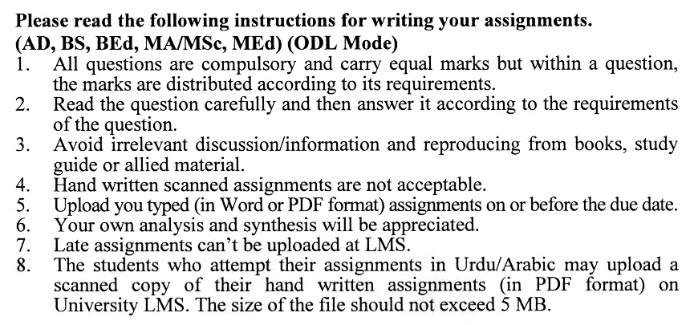

**Guidelines FOR ASSIGNMENT No. 1 & 2:**

You should look upon the assignments as a test of knowledge, management skills, and communication skills. When you write an assignment answer, you are indicating your knowledge to the teacher:

* Your level of understanding of the subject;
* How do you think?
* How well you can reflect on your knowledge & experience?
* How well you can use your knowledge in solving problems, explaining situations, and describing organizations and management?
* How professional you are, and how much care and attention you give to what you do?

To answer a question effectively, address the question directly, bring important related issues into the discussion, refer to sources, and indicate how principles from the course materials apply. You must also be able to identify important problems and implications arising from the answer.

For citing references, writing bibliographies, and formatting the assignment, APA format should be followed.

## ASSIGNMENT No. 1

## (Units: 1–5)

## Total Marks: 100 Pass Marks: 50

Q. 1 How does an effective performance management system integrate with human resources and development activities to improve overall organizational performance? **(20)**

Q. 2 What are the key challenges in aligning performance management systems with strategic planning, and how can organizations overcome them? **(20)**

Q. 3 What are the advantages and disadvantages of using a 360-degree feedback system in performance management, particularly for employee development? **(20)**

Q. 4 How can organizations ensure that performance measurement approaches are fair and objective, preventing distortions in employee appraisals? **(20)**

Q. 5 What role does coaching play in performance management, and how can different coaching styles influence the outcomes of performance reviews and employee development? **(20)**

## ASSIGNMENT No. 2

## (Units: 1–9)

## Total Marks: 100 Pass Marks: 50

This assignment is a research-oriented activity. You are required to submit a term paper and present the same in the classroom prior to the final examination. Presentation component is compulsory for all students. You will have to participate in the activity fully and prepare a paper of 6000 to 8000 words on the topic allotted to you. The students are required to prepare two copies of Assignment No. 2. Submit one copy to your teacher for evaluation and the second copy for presentation in the classrooms in the presence of your resource persons and classmates, which will be held at the end of the semester prior to the final examination.

Include the following main headings in your report: -

1. Introduction to the topic
2. Important sub-topics
3. Practical aspects with respect to the topic
4. Review of theoretical and practical situations
5. SWOC (Strengths, Weaknesses, Opportunities, and Challenges) Analysis of the organization with respect to your topic
6. Conclusions and recommendations
7. Annex, if any

You should also develop a PowerPoint Presentation. You are also required to select one of the following topics according to the last digit of your roll number. For example, if your roll number is D-3427185 then you will select topic No.5 (the last digit): -

**Topics:**

1. The Role of Performance Management Systems in Enhancing Organizational Effectiveness
2. Defining Performance: Key Determinants and Dimensions in Performance Management
3. Linking Performance Management Systems to Strategic Planning for Organizational Success
4. Performance Appraisal: Best Practices for Measuring Results and Behaviors
5. The Significance of Feedback Systems in Performance Management: Focus on 360-Degree Feedback
6. Challenges in Implementing a Performance Management System and How to Overcome Them
7. Developing Personal Development Plans: A Tool for Employee Growth and Organizational Success
8. The Impact of Coaching in Performance Management and Employee Development
9. Managing Team Performance: Strategies for Improving Collaboration and Effectiveness
10. Rewarding Performance: Creating a Reward System That Motivates Employees and Drives Performance

**WorkshoPS:**

The workshop presentations provide you the opportunity to express your communication skills, knowledge & understanding of concepts learned during the practical study assigned in assignment # 2.

**PERFORMANCE MANAGEMENT (9508)**

Course Outline

**Unit 1 Performance Management and Reward System**

* 1. Definition of Performance Management
  2. Advantages of Performance Management System
  3. Definition of Reward System
  4. Aims and Role of Performance Management Systems
  5. Characteristics of an Ideal Performance Management System
  6. Integration with Human Resources and Development Activities

**Unit 2 Performance Management Process**

* 1. Performance Planning
  2. Performance Execution
  3. Performance Assessment
  4. Performance Review
  5. Performance Renewal and Re-contracting

**Unit 3 Performance Management and Strategic Planning**

* 1. Definition and Purposes of Strategic Planning
  2. Process of Linking Performance Management to Strategic Plan
  3. Building Support

**Unit 4 Defining Performance and Choosing a Measurement Approach**

* 1. Defining Performance
  2. Determinants of Performance
  3. Performance Dimensions
  4. Approaches to Measuring Performance

**Unit 5 Measuring Results and Gathering Performance Information**

* 1. Measuring Results
  2. Measuring Behaviors
  3. Characteristics of Appraisal Forms
  4. Determining Overall Rating and Appraisal Period
  5. A Model of Rater Motivation
  6. Preventing Rating Distortion Through Rater Training

**Unit 6 Implementing Performance Management System**

* 1. Communication Plan
  2. Appeals Process
  3. Training Programs for Acquisition of Required Skills
  4. Pilot Testing
  5. On Going Monitoring and Evaluation

**Unit 7 Performance Management and Employee Development**

* 1. Personal Development Plans
  2. Direct Supervisor’s Role
  3. 360-Degree Feed Back System

**Unit 8 Performance Management Skills**

* 1. Coaching
  2. Coaching Styles
  3. Coaching Process
  4. Performance Review Meetings

**Unit 9 Managing Team Performance**

* 1. Definition and Importance of Teams
  2. Types of Teams and Implications of Performance Management
  3. Purpose and Challenges of Team Performance Management
  4. Including Team Performance in Performance Management System
  5. Rewarding Team Performance

**Recommended Books:**

* Aguinis, H. (2012). Performance Management. U.P India: Dorling Kindersley.
* Michael, A., & Angela, B. (2005). Performance Management. London: CIPD.
* Dipak, K. B. (2011). Performance Management System and Strategies. U.P India: Dorling Kindersley.

