ALLAMA IQBAL OPEN UNIVERSITY, ISLAMABAD

**(Department of Business Administration)**

|  |
| --- |
| **WARNING**   1. **PLAGIARISM OR HIRING OF GHOST WRITER(S) FOR SOLVING THE ASSIGNMENT(S) WILL DEBAR THE STUDENT FROM THE AWARD OF DEGREE/CERTIFICATE IF FOUND AT ANY STAGE.** 2. **SUBMITTING ASSIGNMENT(S) BORROWED OR STOLEN FROM OTHER(S) AS ONE’S OWN WILL BE PENALIZED AS DEFINED IN THE “AIOU PLAGIARISM POLICY”.** |

**Course: Fundamental of Accounting (8401) Semester: Spring, 2025**

**Level: BBA**

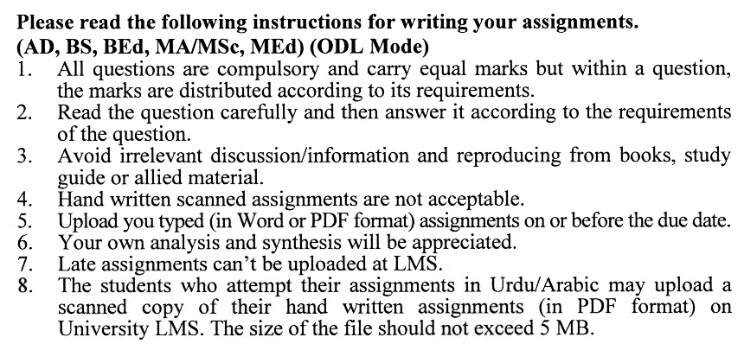

**Total Marks: 100 Pass Marks: 50**

**ASSIGNMENT No. 1**

**Instructions**: (*You must answer the questions in your own words. Copying from books is not permissible. Give supporting calculations where necessary)*

Q. 1What are the various types of financial statements? Explain the purpose of each of them as well. **(20)**

Q. 2 Community TV was organized in February 1994 to operate at a local television station. The transactions for February were as follows: **(20)**

Feb 1. James Ward deposited Rs. 400,000 cash in a bank checking account in the name of the business, community TV.

Feb 3. Community TV purchased the land, building and telecasting equipment previously used by a local television station which had gone bankrupt. The total purchase price was Rs. 300,000, of which Rs. 100,000 was attributable to the land, Rs. 90,000 to the building, and the remainder to the telecasting equipment. The terms of the purchase required a cash payment of Rs. 200,000 and the issuance of a note payable for the balance.

Feb 5. Purchased a transmitter for Rs. 225,000 from AC Manufacturing Company, making a cash down payment of Rs. 75,000. The balance, in the form of a note payable, was to be paid in monthly installments of Rs. 12,500, beginning Feb 15. (ignore interest expense)

Feb 9. Purchased a film library at a cost of Rs. 40,000 from Modern Film Productions, making a down payment of Rs. 15,000 cash, with the balance on account payable in 30 days.

Feb 12. Bought supplies costing Rs. 3,500, paying cash.

Feb 15 Paid Rs. 12,500 to AC Manufacturing as the first monthly payment on the note payable created on Feb 5. (ignore interest expense)

Feb 25. Sold part of the film library to City College; the cost was Rs. 9,000 and the selling price was also Rs. 9,000. City College agreed to pay the full amount in 30 days.

**Required:**

Journal Ledger Trial Balance Balance Sheet

Q. 3 Explain the following with the help of examples: **(20)**

Entity concept cost concept

Accruals concept Realization concept

Accounting equation

Q. 4 Following is the Trial Balance of affirm. From this, you are required to prepare a worksheet for the year ending on 31st December 1991. **(20)**

**Dr. (Rs)** **Cr. (Rs**)

Cash at bank 80,000

Accounts receivable 35,200

Store supplies 5,000

Prepaid rent 11,240

Furniture and fixtures 7,600

Acc. Dep furniture and fixture 1,520

Prepaid insurance 8,500

Plant and machinery 45,000

Acc. Dep plant and machinery 9,000

Capital 165,000

Accounts payable 8,500

Drawings 31,000

Sales revenue 212,980

Salaries expense 9,500

Advertising Expense 7,000

Purchases 95,000

Wages 10,000

Purchase return 6,500

Sales return 3,000

Merchandise inventory on 1.1.1991 45,000

Travelling expenses 5,460

Miscellaneous expense 5000

403,500 403,500

**Adjustments:**

1. Merchandise inventory on 31.12.91 was valued at Rs.35,000.
2. Store supplies on hand 31.12.91 Rs. 1,500
3. prepaid rent expired Rs. 9240
4. prepaid insurance expired Rs. 6000
5. Depreciate furniture and fixtures and plant and machinery by 10 %.
6. accrued salaries Rs, 3000
7. write off bad debts from accounts receivable Rs. 1500

Q. 5 (a) Key Imports sold merchandise to Marine Systems for Rs.7,500, offering terms of 2/10,n/30. Marine Systems paid for the merchandise within the discount period. Both companies use perpetual inventory systems. **(20)**

1. Prepare journal entries in the accounting records of key Imports to account for this sale and the subsequent collection. Assume the original cost of the merchandise to Key Imports had been Rs.4,100.
2. Prepare journal entries in the accounting records of Marine Systems to account for the purchase and subsequent payment. Marine Systems records purchases of merchandise at net cost.
3. Assume that because of a change in personnel, Marine Systems could not pay for this merchandise within the discount period. Prepare journal entries in the accounting records of Marine Systems to record payment after the discount period.

(b) Distinguish cash discount from trade discount and what is their accounting treatment?

**Total Marks: 100 Pass Marks: 50**

**ASSIGNMENT No. 2**

Q. 1 (a)On November 30, ABC Cleaners made available the following data concerning its bank checking account: **(20)**

1. On November 30, cash per the bank statement was Rs. 37,758; per the accounting records Rs. 42,500.
2. The cash receipts of Rs. 6,244 on November 30 were deposited on December 1.
3. Included in the bank statement was a credit for Rs.167 interest earned on this checking account during November.
4. Two checks were outstanding on November 30: no. 921 for Rs.964 and No. 925 for Rs. 1,085.
5. Enclosed with the bank statement were two debit memoranda for the following items: service charges for November, Rs.14; and a Rs.700 check of customer Tanya Miller, marked “NSF”.

Prepare a bank reconciliation on November 30.

(b) Define temporary investments.

Q. 2 (a) The income statement approach to estimating uncollectible accounts expense is used by Burgess Wholesale. On March 31 the firm had accounts receivable in the amount of Rs. 630,000. The allowance for doubtful accounts had a credit balance of Rs. 3,950. The controller estimated that uncollectible account expense would amount to one-half of 1% of the net sales made during March. This estimate was entered in the accounts by an adjusting entry on March 31. **(20)**

On April 12, an account receivable from Conrad Stern of Rs. 3,110 was determined to be worthless and was written off. However, on April 24, Stern won several thousand dollars on a TV game show and immediately paid the Rs. 3,110 past due account.

Prepare journal entries to record the above events.

(b) Explain the concept of “lower of cost or market”

Q. 3 (a) Define specific identification method. How it is different from cost flow assumptions. Illustrate with examples. **(20)**

(b) On September 1, a six-month, 15 % note receivable is acquired from Shaun Young, a customer, in settlement of his Rs. 12,000 account receivable.

Prepare journal entries to record:

1. The receipt of note on September 1
2. The adjustment to record accrued interest revenue on December 31.
3. Collection of the principal and interest on February 28

Q. 4 What is the difference between “Receipt and payment account” and an “Income and expenditure account”? Discuss in detail. **(20)**

Q. 5 Make a comparative study of the Single entry system and Double entry system. Which of the systems, in your opinion, is more appropriate and why? **(20)**

****