**ALLAMA IQBAL OPEN UNIVERSITY, ISLAMABAD**

**(Department of Business Administration)**

**WARNING**

1. **PLAGIARISM OR HIRING OF GHOST WRITER(S) FOR SOLVING THE ASSIGNMENT(S) WILL DEBAR THE STUDENT FROM AWARD OF DEGREE/CERTIFICATE, IF FOUND AT ANY STAGE.**
2. **SUBMITTING ASSIGNMENT(S) BORROWED OR STOLEN FROM OTHER(S) AS ONE’S OWN WILL BE PENALIZED AS DEFINED IN “AIOU PLAGIARISM POLICY”.**

**Course: Fundamental of Computers (8403) Semester: Spring, 2025**

**Level: BBA (4 Years)**

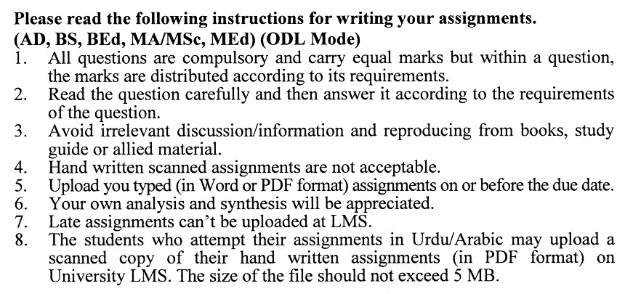

**Total Marks:100 Pass Marks: 50**

**ASSIGNMENT No. 1**

***Note: All questions are compulsory. Each question carries equal marks.***

Q. 1 Explain the **Information Processing Cycle** and describe how the essential hardware and software components play a role in this cycle. **(20)**

Q. 2 Explain how the **processing speed of a computer system** is affected by factors such as the bus, memory, and microprocessors. **(20)**

Q. 3 Compare and contrast **magnetic storage devices** and **optical storage devices** in terms of storage capacity, speed, and reliability. **(20)**

Q. 4 Explain the **basic components of a network** and discuss the role of network hardware in ensuring data communication. **(20)**

Q. 5 Explain the **major services of the internet**, such as email, online shopping, and online banking, and their impact on daily life. **(20)**

**ASSIGNMENT No. 2**

**Total Marks: 100 Pass Marks: 50**

This assignment is a research-oriented activity. You are required to prepare a detailed report of about 3000 words on the topic allotted to you to be submitted to your teacher for **evaluation**.

You are required to select one of the following topics according to the last digit of your roll number. For example, if your registration number is 18-IDM-3427183 then you will select topic # 3(the last digit): -

**List of Topics:**

1. Mobile App Development Basics
2. Artificial Intelligence Fundamentals
3. Human-Computer Interaction (HCI)
4. Computer Graphics
5. Software Engineering Concepts
6. Computer Ethics and Professionalism
7. Introduction to Linux
8. Cloud Computing Basics
9. Software Testing and Quality Assurance
10. Introduction to Machine Learning

**GUIDELINES FOR ASSIGNMENT No. 2:**

* 1.5 line spacing
* Use headers and subheads throughout all sections
* Organization of ideas
* Writing skills (spelling, grammar, punctuation)
* Professionalism (readability and general appearance)
* Do more than repeat the text
* Express a point of view and defend it.

**LAB WORK**

Develop a database system of a hospital in MS Access. Develop data tables, and relationship diagrams and generate reports. Follow the Database management system unit from your course book.

**ALLAMA IQBAL OPEN UNIVERSITY, ISLAMABAD**

**(Department of Business Administration)**

Course: **Fundamental of Computers**  Course Code: **8403**

Level: **BBA (4 Years)** Credit Hours: **04**

**Unit–1: Introduction to Computer Systems & Interacting with Computer**

* Computer for Individual
* Computer for organization
* Uses of computer
* Parts of Computer System
* Information Processing Cycle
* Essential Hardware & Software
* Memory Devices
* Input & Output Devices
* Inputting data in other ways

**Unit–2: Seeing, Hearing, Printing and Processing Data**

* CRT Monitors
* Flat-panel and Other types of Monitors
* Comparing Monitors
* Video Cards
* Ergonomics and Monitors
* Sound system
* Sound card
* Printers and Comparing Printers
* How Computer Processes data
* Factors Affecting Processing Speed.
* Memory and Computing Power
* Bus and its types
* Micro Processors
* Extending Processing Power to other devices
* Specialized Expansion Ports

**Unit–3: Storing Data, Using Operating System**

* Magnetic Storage Devices
* Optical Storage Devices
* Optimizing Disk Performance
* Operating Systems and Types
* PC Operating System
* Network Operating System
* Providing User Interface
* Managing Hardware
* Enhancing Operating system with Utility Software

**Unit–4: Networks**

* Network Basic
* Common Types of Networks
* Network Structuring
* Network Hardware
* Data Communications with standard telephone lines and modems
* Broadband & Wireless Network

**Unit–5: Presenting the Internet, Working in the online world**

* Internet and its major services
* Email and Other internet services
* Connecting to the Internet through wires
* Doing Business in the online world
* Online Shopping
* Online Banking and Finance
* E-commerce at Business Level

**Unit–6: Working with Application Software**

* Acquiring Software
* Word Processing Programs
* Spreadsheet Programs
* Understanding Graphing File Formats
* Graphic Software

**Unit–7: Software Programming**

* Creating Computer Programs
* Hardware and Software Interaction
* How Program Solve Problems
* Programming Languages
* World Wide Web Development Languages
* Programming Processes

**Unit–8: Protecting Your Privacy**

* Basic Security Concepts
* Threats to Users
* Threats to Hardware
* Threats to Data
* Taking Proactive Measures
* Avoiding Identity Theft
* Understand the need for security measures
* Protect your computer and your data

**Unit–9: Database Management**

* Database
* Database Management Systems
* Working with a Database
* Database at Work
* Common Corporate Database Management systems

**Recommended Book:**

Introduction to Computers 6th International Edition, Peter, N. McGraw-Hill (2008)

**Reference Books:**

* Computer Fundamentals by PK Sinha, 4th Edition, BPB Publications (2004)

Using Information Technology: A Practical Introduction to Computer & Communications, 10th Edition. Williams, S. McGraw-Hills (2012)

****