ALLAMA IQBAL OPEN UNIVERSITY, ISLAMABAD

**(Department of Business Administration)**

|  |
| --- |
| **WARNING**   1. **PLAGIARISM OR HIRING OF GHOST WRITER(S) FOR SOLVING THE ASSIGNMENT(S) WILL DEBAR THE STUDENT FROM THE AWARD OF DEGREE/CERTIFICATE IF FOUND AT ANY STAGE.** 2. **SUBMITTING ASSIGNMENT(S) BORROWED OR STOLEN FROM OTHER(S) AS ONE’S OWN WILL BE PENALIZED AS DEFINED IN THE “AIOU PLAGIARISM POLICY”.** |

**Course: Fundamentals of Business (8402/9501) Semester: Spring, 2025**

**Level: BBA/PGD**

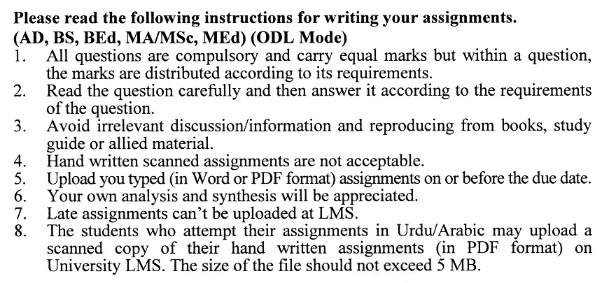

**Total Marks: 100 Pass Marks: 50**

**ASSIGNMENT No. 1**

***Note:*** *Attempt all the questions. Examples with special reference to Pakistan will carry more credit.*

Q. 1 What are the primary functions of a business, and how do they contribute to its success? **(20)**

Q. 2 What is the importance of understanding the difference between profit and revenue in business operations? **(20)**

Q. 3 Discuss the characteristics of small businesses, corporations, partnerships, and various industry sectors. **(20)**

Q. 4 Describe how economic conditions, competition, customer needs, and technological changes impact decisions. **(20)**

Q. 5 How do businesses create value for their customers, employees, and stakeholders? **(20)**

**Total Marks: 100 Pass Marks: 50**

**ASSIGNMENT No. 2**

This assignment is a research-oriented activity. You are required to submit a term paper

**Include the following main headings in your report: -**

1. Introduction to the topic
2. Important sub-topics
3. Practical aspects for the topic
4. Review of theoretical and practical situations
5. SWOT analysis of the organization concerning your topic
6. Conclusions and recommendations
7. Annex, if any

You must use transparencies, charts or any other material for effective presentation. You are also required to select one of the following topics according to the last digit of your roll number. For example, if your roll number is D-3427185 then you will select topic No.5 (the last digit):-

**Topics:**

1. Business decisions
2. Joint-stock company
3. Departmentalization
4. Determinants of market price
5. Quality standards
6. Capital structure
7. Risk management
8. Life insurance
9. Business environment
10. Employees Output

****