**ALLAMA IQBAL OPEN UNIVERSITY, ISLAMABAD**

**(Department of Business Administration)**

**WARNING**

1. **PLAGIARISM OR HIRING OF GHOST WRITER(S) FOR SOLVING THE ASSIGNMENT(S) WILL DEBAR THE STUDENT FROM AWARD OF DEGREE/CERTIFICATE, IF FOUND AT ANY STAGE.**
2. **SUBMITTING ASSIGNMENT(S) BORROWED OR STOLEN FROM OTHER(S) AS ONE’S OWN WILL BE PENALIZED AS DEFINED IN “AIOU PLAGIARISM POLICY”.**

**Course: Micro Economics (8406) Semester: Spring, 2025**

**Level: BBA (4 Years)**

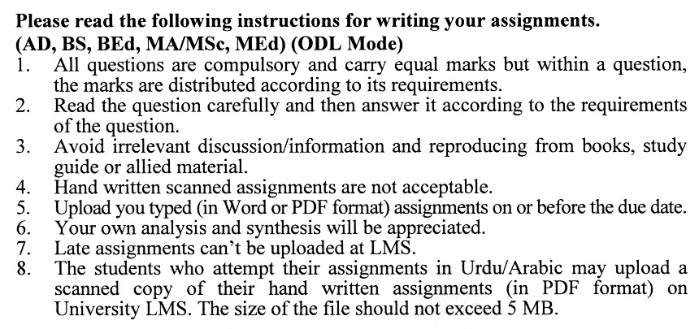

**Total Marks:100 Pass Marks: 50**

**ASSIGNMENT No. 1**

***Note: All questions are compulsory. Each question carries equal marks.***

Q. 1 Discuss the difference between **Macroeconomics and Microeconomics**, providing examples of how each is applied in real-world economic analysis. **(20)**

Q. 2 Compare and contrast the **Command Economy, Market Economy, and Mixed Economy**, highlighting their characteristics, advantages, and disadvantages. **(20)**

Q. 3 Discuss how the **Law of Demand** and the **Law of Supply** interact to determine the **Market Equilibrium Price and Quantity**. **(20)**

Q. 4 Explain the concepts of **price elasticity of demand** and **price elasticity of supply**, and analyze their importance for businesses and policymakers. **(20)**

Q. 5 Analyze the **law of diminishing marginal utility** and its role in the theory of consumer behaviour, with examples of its practical applications. **(20)**

**ASSIGNMENT No. 2**

**Total Marks: 100 Pass Marks: 50**

This assignment is a research-oriented activity. You are required to prepare a detailed report of about 3000 words on the topic allotted to you to be submitted to your teacher for **evaluation**.

You are required to select one of the following topics according to the last digit of your roll number. For example, if your registration number is 18-IDM-3427183 then you will select topic # 3(the last digit): -

**List of Topics:**

1. Consumer Behavior and Utility
2. Pricing Strategies
3. Game Theory in Microeconomics
4. Externalities and Public Goods
5. Labor Markets and Wage Determination
6. Market Failures and Government Intervention
7. Utility Maximization and Consumer Choice
8. Marginal Analysis
9. Price Discrimination
10. Behavioral Economics

**The report should follow the following format**

1. Title page
2. Acknowledgements
3. An abstract (one-page summary of the paper)
4. Table of contents
5. Introduction to the issue (brief history & significance of issue assigned)
6. Elaborate the issue
7. Practical examples (for the issue)
8. References (as per APA format) and Annexes (if any)

**GUIDELINES FOR ASSIGNMENT No. 2**

* 1.5 line spacing
* Use headers and subheads throughout all sections
* Organization of ideas
* Writing skills (spelling, grammar, punctuation)
* Professionalism (readability and general appearance)
* Do more than repeat the text
* Express a point of view and defend it.

**ALLAMA IQBAL OPEN UNIVERSITY**

**Department of Business Administration**

**MICRO ECONOMICS (8406)**

**Unit 1: Introduction to Economics and Economy**

* Economic Perspective
* Macroeconomic & Microeconomics
* Positive & Normative Economics
* Individual Economize Problem
* Society Economize Problem

**Unit 2: Market System & Circular Flow**

* Command Economy
* Market Economy
* Mixed Economy
* Characteristics of the Market System

**Unit 3: Demand, Supply**

* Market Demand
* Law of Demand
* Demand Curve
* Market Demand
* Change in Demand
* Changes in Quantity Demanded
* Supply
* Law of Supply
* Supply Curve
* Market Supply
* Determinants of Supply
* Changes in Supply
* Changes in Quantity Supplied
* Market Equilibrium
* Equilibrium Price & Quantity
* Rationing Function of Price
* Efficient Allocation
* Changes in Supply, Demand and Equilibrium.
* Government Set Prices

**Unit 4: Extension of Demand & Supply**

* Price Elasticity of Demand
* Price Elasticity of Supply
* Cross Elasticity & Income Elasticity of Demand
* Consumer Surplus
* Producer Surplus

**Unit 5: Consumer Behavior & Utility Maximization**

* Law of Diminishing Marginal Utility
* Theory of Consumer Behavior
* Utility Maximization and Demand Curve
* Indifference curves
* Properties of indifference curve
* Marginal rate of substitution
* Applications and uses of the indifference curve technique

**Unit 6: Cost of Production**

* Economic Cost
* Short Run Production Relationships
* Short Run Production Cost
* Long Run Production Cost

**Unit 7: Pure Competition**

* Four Market Model
* Pure Competition: Characteristics & Occurrences
* Profit Maximization in the short run: Total Revenue- Total Cost Approach
* Profit Maximization in the short run: Marginal Revenue- Marginal Cost Approach
* Pure Competition & Efficiency
* Profit Maximization in Short Run

**Unit 8: Pure Monopoly**

* Introduction to Monopoly
* Barriers to Entry
* Monopoly Demand
* Output and Price Determination
* Economic Effect of Monopoly

**Unit 9: Monopolistic Competition & Oligopoly**

* Monopolistic Competition
  + Price & Output in Monopolistic Competition
  + Monopolistic Competition & Efficiency
* Oligopoly
  + Oligopoly Three Models
  + Advertising, Efficiency & Oligopoly

**Book: Economics Principles, Problem & Policies by**

**McConnel Brue 17th Edition**

****