ALLAMA IQBAL OPEN UNIVERSITY, ISLAMABAD

**(Department of Business Administration)**

|  |
| --- |
| **WARNING**   1. **PLAGIARISM OR HIRING OF GHOST WRITER(S) FOR SOLVING THE ASSIGNMENT(S) WILL DEBAR THE STUDENT FROM THE AWARD OF DEGREE/CERTIFICATE IF FOUND AT ANY STAGE.** 2. **SUBMITTING ASSIGNMENT(S) BORROWED OR STOLEN FROM OTHER(S) AS ONE’S OWN WILL BE PENALIZED AS DEFINED IN THE “AIOU PLAGIARISM POLICY”.** |

**Course: Cost Accounting (8408) Semester: Spring, 2025**

**Level: BBA**

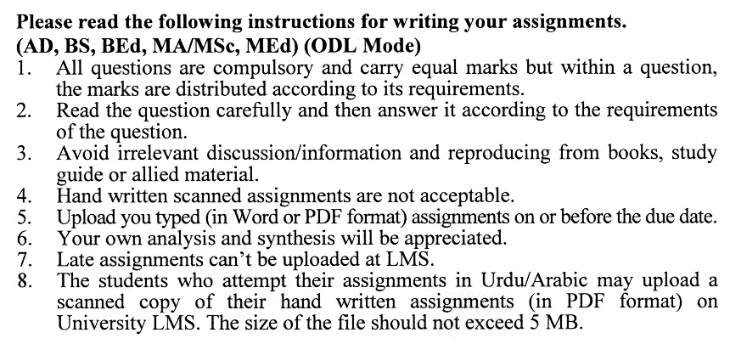

**Total Marks: 100 Pass Marks: 50**

**ASSIGNMENT No. 1**

**Instructions**: (*You must answer the questions in your own words. Copying from books is not permissible. Give supporting calculations where necessary)*

Q. 1 (a) What are the objectives of cost accounting? What are its advantages and limitations?

(b) Describe the various techniques of costing in detail.

(c) Enlist the various classifications of costs and describe them. **(6+7+7)**

Q. 2 The following data is extracted from the books of Usman & Brothers Corporation for the period ended on 31st December 2023. You are required to **(a)** Prepare cost of goods manufactured and sold statement and **(b)** Income statement. **(20)**

|  |  |  |  |
| --- | --- | --- | --- |
| Sales | 1,075,400 | **Factory Overheads:** |  |
| Direct Labour | 180,400 | Factory Insurance | 18,000 |
| Purchases | 288,000 | Heat & Light Costs | 9,600 |
| Office Expenses | 60,000 | Depreciation on Machinery | 13,200 |
| Advertisement Expenses | 72,000 | Factory Rent | 34,000 |
| **Inventories on 1 January 2023:** |  | **Inventories at 31 Dec 2023:** |  |
| Raw Materials | 76,800 | Raw materials | 67,200 |
| Work in Process | 60,000 | Work in Process | 57,600 |
| Finished Goods | 125,200 | Finished goods | 144,800 |

Q. 3 Roshan Milling Corporation manufactures a product requiring processing in three departments, with all materials put into process in the first department. During December 220,000 units were completed in Department 1 at a total cost of Rs. 352,000 and were transferred to the next department. From this lot, department 2 completed and transferred out 170,000 units incurring a direct labour cost of Rs. 52,360 and a factory overhead cost of Rs. 26,180. The December 31. work in process inventory of department 2 is 44,000 units which were 25% complete as to direct labour and factory overhead cost. The spoilage occurs at the end of the process and is considered a normal loss.

**Required: -** Prepare a cost of production report for department 2. **(20)**

Q. 4 (a) Describe the Job Order costing system and the nature of industries which can make use of it.

**(**b) Dell Company uses the Job Order Cost System. The manufacturing operations for the year ended December 31, 2022 were as follows:

i. Purchased raw materials on account Rs. 140,000.

ii. Materials issued to the factory of Rs. 120,000 of which Rs 20,000 was indirect materials.

iii. Direct labour cost incurred Rs. 90,000 and Rs. 10,000 indirect labour.

iv. Factory overhead application rate was 90% on direct labour cost.

v. Factory overhead cost incurred on account Rs. 80,000

vi. Cost of jobs completed Rs 250,000.

vii. Cost of goods sold Rs. 180,000

vii. Sales on account Rs 230,000.

**Required:**

Record all the above transactions in the General Journal & give an entry to close the factory overhead account. **(20)**

Q. 5 Yale Manufacturing Industries is considering setting up some suitable inventory procurement yardsticks to ensure continuous availability of materials but at least costs. The following data of Material "A" was gathered from the records. **(20)**

A) The monthly requirement of material "A" is 1850 units for Rs. 10 each.

B) The ordering cost is Rs. 200 per order.

C) Carrying cost is 15% of the average inventory investment

**Required:**

1) Calculate the Economic Order Quantity.

2) Compute the number of orders needed per year.

3) Frequency of order placement in days.

4) Annual Ordering Cost.

5) Annual Carrying Cost.

6) Annual Inventory Cost.

**Total Marks: 100 Pass Marks: 50**

**ASSIGNMENT No. 2**

Q. 1 The following information is available regarding the procurement and issuance of material inventory for October 2023 of a manufacturing company:

01.10.2023 Opening inventory of 800 units at Rs. 65 each.

06.10.2023 Purchases 200 units at Rs. 75 each.

09.10.2023 Issued 400 units to production.

12.10.2023 Issued 150 units to production.

16.10.2023 Purchased 300 units at Rs. 80 each.

24.10.2023 Issued 400 units to production.

27.10.2023 Issued 250 units to production.

**Required:** Compute the cost of materials issued to production and the value of the 31 October 2023 inventory using a perpetual inventory system under each of the following methods: -

A) First in First Out method

B) Moving Average method. **(20)**

Q. 2 Gujrat Fan Manufacturing Industry has received a special order for manufacturing and supply of 250 specially designed bracket fans of A Grade. The following costs were incurred by the company for execution of the order: **(20)**

Direct material cost Rs. 50,000

Direct labour costs Rs. 150,000

Factory Overhead is applied at 60% of direct labour cost.

After completion of the production, it was noticed during testing by the Quality Control Department that 30 fans were found technically defective for which the following additional costs were incurred to remove the defects: -

Direct material cost Rs. 2,400

Direct labour costs Rs. 6,000

Factory overhead is applied at 60% of direct labour cost.

**Required:** Prepare necessary general journal entries to record the execution of the special order in the following prospects: -

a) When relevant job is charged with the additional cost of defective works.

b) When the relevant Job is not charged with the additional cost of defective works.

Q. 3 (a) Describe the functions of a Timekeeping department and various methods used for controlling the attendance of workers in a factory.

(b) A pharmaceutical company is considering introducing Halsey Premium or Rowan Plan of incentives scheme for their employees. The standard time of production is 10 hours and the Hourly rate is Rs. 100. In order to carry out a comparative study to determine which of the two incentive plans is cost-effective for the payment of wages to workers, the company estimates that the time taken for production of a Batch maybe 9 Hours, 8 Hours and 7 Hours.

**Required:** Advise the company to adopt a suitable incentive plan supported by workings and total labor cost per Hour under each incentive plan of Halsey Premium and Rowan. **(20)**

Q. 4 The following data has been extracted from the record of Basharat Production Industries for the year 2014: - **(20)**

a) Budgeted factory overheads Rs 500,000

b) Actual factory overheads Rs.455,000

c) Budgeted machine hours 12,500 hours

d) Actual machine hours 12,000 hours

**Required**:

Work out the following: -

a) Predetermined overhead absorption rate per machine hour.

b) Applied overhead cost.

c) Over or under-absorbed factory overhead cost.

Q. 5 Wilson Pharmaceutical Company uses the direct method of allocating servicing ' overhead costs to the producing departments. The following data is available concerning the activities: - **(20)**

|  |  |  |  |  |
| --- | --- | --- | --- | --- |
| **Particulars** | **Producing Department** | | **Servicing Department** | |
| **Mixing** | **Finishing** | **Procurement** | **Factory Admin** |
| Budget FOH cost | Rs. 410,000 | Rs. 304,000 | Rs. 100,000 | Rs. 50,000 |
| Number of Employees | 90 | 210 | 20 | 28 |
| Machine Hours | 64,000 | 16,000 | — | — |
| Direct Labour Hours | 35,000 | 100,000 | — | — |

The costs of the Procurement Department are allocated on the basis of the number of employees while the costs of the Factory Administration are prorated on the basis of machine hours.

**Required:**

1) Prepare a statement of overhead cost allocation.

2) Calculate predetermined overhead rates for each of the producing departments based on machine hours for the mixing department while direct labour hours for the finishing department.

