**ALLAMA IQBAL OPEN UNIVERSITY, ISLAMABAD**

**(Department of Business Administration)**

**WARNING**

1. **PLAGIARISM OR HIRING OF GHOST WRITER(S) FOR SOLVING THE ASSIGNMENT(S) WILL DEBAR THE STUDENT FROM AWARD OF DEGREE/CERTIFICATE, IF FOUND AT ANY STAGE.**
2. **SUBMITTING ASSIGNMENT(S) BORROWED OR STOLEN FROM OTHER(S) AS ONE’S OWN WILL BE PENALIZED AS DEFINED IN “AIOU PLAGIARISM POLICY”.**

**Course: Statistics for Management (8409) Semester: Spring, 2025**

**Level: BBA (4 Years)**

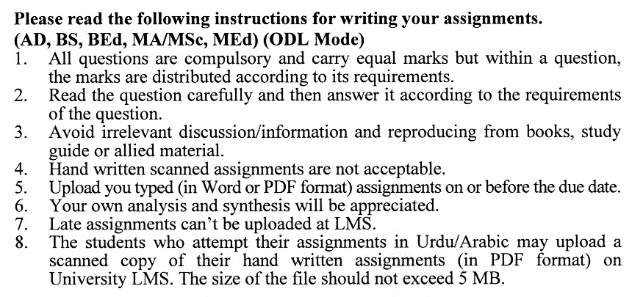

**Total Marks:100 Pass Marks: 50**

**ASSIGNMENT No. 1**

***Note: All questions are compulsory. Each question carries equal marks.***

Q. 1 Using the data below, create an **ogive** to represent cumulative frequency:

|  |  |
| --- | --- |
| **Class Interval** | **Frequency** |
| 10-20 | 5 |
| 20-30 | 10 |
| 30-40 | 15 |
| 40-50 | 20 |
| 50-60 | 25 |

Define **Statistics** and explain the difference between **Descriptive** and **Inferential Statistics**, highlighting their role in business decision-making. **(20)**

Q. 2 Calculate the **arithmetic mean**, **median**, and **mode** for the following data set:

12, 15, 20, 25, 30, 15, 20, 25, 15. **(20)**

Q. 3 A bag contains 3 red balls, 4 green balls, and 5 blue balls. What is the probability of drawing: **(20)**

* a red ball?
* a green or blue ball?
* two red balls in succession without replacement?

Discuss **Bayes’s Rule** and its application in decision-making under uncertainty.

Q. 4 A coin is tossed 10 times. What is the probability of getting exactly 6 heads using the **binomial distribution** formula?

Explain the difference between **discrete** and **continuous probability distributions**, providing examples of each. **(20)**

Q. 5 Explain the **importance of sampling** in statistics and describe the differences between **random sampling** and **stratified sampling** with examples.

A random sample of 50 students has a mean test score of 75 with a standard deviation of 10. Construct a **95% confidence interval** for the population mean. **(20)**

**ASSIGNMENT No. 2**

**Total Marks: 100 Pass Marks: 50**

This assignment is a research-oriented activity. You are required to prepare a detailed report of about 3000 words on the topic allotted to you to be submitted to your teacher for **evaluation**.

You are required to select one of the following topics according to the last digit of your roll number. For example, if your registration number is 18-IDM-3427183 then you will select topic # 3(the last digit): -

**List of Topics:**

1. Descriptive Statistics in Business Decision-Making
2. Role of Inferential Statistics in Business Analytics
3. Application of Frequency Distributions in Management
4. Statistical Graphs and Charts for Data Visualization
5. Sampling Techniques in Business Research
6. Hypothesis Testing for Managerial Decision-Making
7. Regression and Correlation Analysis in Business Forecasting
8. Time Series Analysis for Predictive Management
9. Index Numbers for Performance Measurement
10. Quality Control and Statistical Process Control in Management

**GUIDELINES FOR ASSIGNMENT # 2:**

* 1.5 line spacing
* Use headers and subheads throughout all sections
* Organization of ideas
* Writing skills (spelling, grammar, punctuation)
* Professionalism (readability and general appearance)
* Do more than repeat the text
* Express a point of view and defend it.

**STATISTICS FOR MANAGEMENT (8409)**

## **UNIT 1: INTRODUCTION TO STATISTICS**

* Definition of Statistics
* Descriptive and inferential Statistics
* Role of Statistics in Business
* Constructing a Frequency Distribution
* Graphing Frequency Distribution

- Line Chart

- Bar Chart

- Multiple Bar Charts

- Pie Chart

* Frequency Distribution for Qualitative Data
* Graphical Display of Data
* Graphic Display of Qualitative Frequency Distributions
* Grouped Frequency Distribution
* Cumulative Frequency Distribution
* The Ogive
* Distribution Shapes

## **UNIT 2: DESCRIPTIVE STATISTICS**

- Measures of Central Tendency

- Mean (arithmetic, weighted and geometric means)

- Median

- Mode

* Choosing Measures of Central Tendency
* Percentiles, Deciles, and Quartiles
* Measures of Dispersion

- Range and Semi-Interquartile Range

* Variance
* Standard Deviation
* The Coefficient of Variation
* Interpretations
* Skewness and Kurtosis
* Measures of Skewness and Peakedness

## **UNIT 3: PROBABILITY I**

* Set theory
* Sample Spaces and Events
* Elementary Principles of Probability
* Types of Probability
* Probability Rules
* The calculation of Probabilities
* Bayes’s Rules
* Combinations and Permutations

## **UNIT 4: PROBABILITY II**

* Introduction to Probability Distribution
* Random Variables
* Discrete Probability Distribution
* Use of Expected Value in Decision Making
* Continuous Probability Distribution
* The Binomial Distribution
* Hypergeometric Distribution
* The Poisson Distribution
* The Normal distribution
* The Central Limit Theorem

## **UNIT 5: SAMPLING AND SAMPLING DISTRIBUTION**

* Population and Samples
* Parameters and Estimates
* Introduction to Statistical Inference
* Introduction to Sampling
* Importance of Sampling in Statistics
* Random Sampling
* Stratified and Proportional Stratified Sampling
* Other Sampling Procedures
* Errors in Sampling
* Sampling Distribution
* Point and Interval Estimation
* Using Sampling Distribution to make Inferences
* The relationship between sample size and Standard Error

## **UNIT 6: ESTIMATION**

* Point Estimation
* Methods of obtaining Point Estimator
* Interval Estimation and Confidence Intervals
* Estimation of Means
* Estimation of Differences Between Means
* Estimation of Proportions
* Estimation of Variances
* Estimating the required Sample Size

## **UNIT 7: TEST OF HYPOTHESIS**

* Role of Statistical Hypothesis
* Formulating Hypothesis
* The Null Hypothesis and Error Type
* One Sided and Two-sided Tests
* Testing Hypothesis about Single Sample Means
* Testing Hypothesis about two independent Sample Means
* Hypothesis Testing of Proportions- Large Samples
* Testing for differences between Means and Proportions
* The importance of Sampling Distribution as Probability Distribution
* Probability Distributions; z, t, x2 and F distribution
* Interpretations Based on Tests of Hypothesis
* Goodness of Fit

## **UNIT 8: REGRESSION AND CORRELATION ANALYSIS**

* The Functional Relationship between Two Variables
* The Error Component and the Principle of Least Squares
* The Linear Regression Equation: Line of Best Fit
* Calculating the Regression Equation
* Evaluating a Regression Equation
* Linear Correlation
* Inferences Concerning Correlation coefficients
* Factors affecting the Correlation Coefficient
* Multiple Regression and Correlation Analysis

## **UNIT 9: TIME SERIES AND INDEX NUMBERS**

* Introduction to Time Series
* Variations in Time Series
* Trend Analysis
* Cyclical Variation
* Seasonal Variation
* Irregular Variation
* Time Series Analysis in Forecasting
* Defining an Index Number
* Un-weighted Aggregate Index
* Weighted Aggregate Index
* Quantity and Value indices

Levin, R. I., & Rubin, D. S. (2009). *Statistics for Management* (7th ed.). Delhi, India: Dorling Kindersley Ltd (under the license of Pearson Education).

Lind, D. A., Marchal, W. G., & Wathen, S. A. (2005). *Statistical Techniques in Business and Economics* (12th ed.). USA: McGraw-Hill Irwin

Holcomb, Jr. (2010). *Mathematics with Applications in Management, Natural, and Social Sciences* (10th ed.). USA: Adison Wesley Publishers.

James, T. M., Benson, P. G., & Sincich, T. (2010). *Statistics for Business and Economics*(11th ed.). USA: Prentice Hall.

****