# **ALLAMA IQBAL OPEN UNIVERSITY ISLAMABAD**

**(Department of Business Administration)**

**WARNING**

1. **PLAGIARISM OR HIRING OF GHOST WRITER(S) FOR SOLVING THE ASSIGNMENT(S) WILL DEBAR THE STUDENT FROM THE AWARD OF DEGREE/CERTIFICATE IF FOUND AT ANY STAGE.**
2. **SUBMITTING ASSIGNMENTS BORROWED OR STOLEN FROM OTHER(S) AS ONE’S OWN WILL BE PENALIZED AS DEFINED IN “AIOU PLAGIARISM POLICY”.**

**Course: Macro Economics (8412) Semester: Spring, 2025**

**Level: BBA**

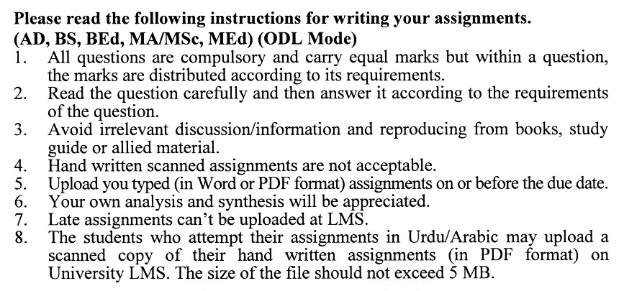

**Guidelines FOR ASSIGNMENT # 1:**

You should look upon the assignments as a test of knowledge, management skills, and communication skills. When you write an assignment answer, you are indicating your knowledge to the teacher:

* Your level of understanding of the subject;
* How clearly do you think?
* How well you can reflect on your knowledge & experience?
* How well you can use your knowledge in solving problems, explaining situations, and describing organizations and management?
* How professional you are, and how much care and attention you give to what you do?

To answer a question effectively, address the question directly, bring important related issues into the discussion, refer to sources, and indicate how principles from the course materials apply. You must also be able to identify important problems and implications arising from the answer.

For citing references, writing bibliographies, and formatting the assignment, APA format should be followed.

**Total Marks: 100 Passing Marks: 50**

**ASSIGNMENT No. 1**

Q. 1 A country experiences a sudden increase in consumer spending and exports. How would this impact the country’s nominal and real GDP? Explain the difference between the two. **(20)**

Q. 2A nation has been experiencing rapid job losses and declining production over the last six months. Based on the business cycle, which phase is the country in, and what are its key characteristics? **(20)**

Q. 3A government report shows that when household incomes rise, people tend to spend more but also save a portion of their earnings. How does this relate to the concept of marginal propensity to consume (MPC) and marginal propensity to save (MPS)? **(20)**

Q. 4 A country implements a stimulus package that increases government spending significantly. How would this affect aggregate demand (AD), and what potential economic changes might occur? **(20)**

Q. 5 Due to technological advancements, more people are using digital transactions instead of cash. How does this trend align with the primary functions of money? **(20)**

**Total Marks: 100 Passing Marks: 50**

**ASSIGNMENT No. 2**

This assignment is a research-oriented activity. You are required to obtain practical information and prepare a report of about 1000 words on the issue allotted to you to be submitted to your teacher for evaluation.

You are required to select one of the following issues according to the last digit of your roll number. For example, if your roll number is P-3427180 then you will select issue # 0 (the last digit): -

**Issues:**

1. Expenditure vs. Income Approach: Two Ways to Measure GDP
2. Unemployment Types and Their Impact on Economic Stability
3. The Multiplier Effect: How Small Changes Create Big Economic Impact
4. Factors Affecting Aggregate Demand and Supply: A Macroeconomic Perspective
5. Functions of Money: The Backbone of Modern Economies
6. How Banks Create Money: The Fractional Reserve System Explained
7. Tools of Monetary Policy: How Central Banks Influence the Economy
8. Understanding Risk and Return in Financial Markets
9. Balance of Payments: Causes and Consequences of Disequilibrium
10. Inflation, Interest Rates, and Economic Stability: How Are They Connected?

**The report should follow the following format:**

1. Title page
2. Acknowledgements
3. An abstract (one page summary of the paper)
4. Table of contents
5. Introduction to the issue (brief history & significance of issue assigned)
6. Practical study (with respect to the issue)
7. Data collection methods
8. SWOT analysis (strengths, weaknesses, opportunities & threats) relevant to the issue assigned
9. Conclusion (one page brief covering important aspects of your report)
10. Recommendations (specific recommendations relevant to the issue assigned)
11. References (as per APA format)
12. Annexes (if any)

**GUIDELINES FOR ASSIGNMENT # 2:**

* 1.5 line spacing
* Use headers and subheads throughout all sections
* Organization of ideas
* Writing skills (spelling, grammar, punctuation)
* Professionalism (readability and general appearance)
* Do more than repeat the text
* Express a point of view and defend it.

**ALLAMA IQBAL OPEN UNIVERSITY, ISLAMABAD**

**(Department of Business Administration)**

**Course: Macro Economics Course Code: 8412**

**Level: BBA Credit hours: 03**

## Unit 1: The Measurement of Domestic Output & National Income

* Gross Domestic Product
* Expenditure Approach
* Income Approach
* Other National Income Accounts
* Nominal v/s Real GDP
* Short Coming of GDP

## Unit 2: Introduction to Economic Growth and Instability

* Economic Growth
* Business Cycle
* Unemployment
* Inflation
* Redistribution Effect of Inflation

## Unit 3: Basic Macroeconomic Relationships

* Interest Rate & Income & Consumption Relationship
* Income & Saving Relationship
* Investment Relationship
* Multiplier Effect

## Unit 4: Aggregate Demand & Aggregate Supply

* Aggregate Demand
* Changes in Aggregate Demand
* Aggregate Supply
* Changes in Aggregate Supply
* Equilibrium and Changes
* Fiscal Policy
* AD-AS Model
* Built In Stability
* Evaluating Fiscal Policy
* Problem Criticism & Complications
* Public Debt

## Unit 5: Money

* Money: definition and functions of money
* Functions of central bank and commercial banks
* Money demand, money supply and the determination of interest rate

## Unit 6: Money Creation

* Fractional Reserve System
* Single Commercial Bank
* Money Creating Transactions of Commercial Banks
* The Banking System: Multiple Deposit Expansion

## Unit 7: Interest Rate and Monetary Policy

* Interest Rate
* Tools of Monetary Policy
* Explanatory Monetary Policy
* Restrictive Monetary Policy
* Monetary Policy Real GDP & Price Level

## Unit 8: Financial Economics

* Financial Economics
* Present Value
* Some Popular Investments
* Arbitrage
* Risk
* Security Market Line

## Unit 9: Balance of Payments & International Trade

* International Trade
* Role of Banks in International Trade
* Balance of Payments
* Equilibrium in the balance of payments
* Causes and consequences of balance of payments disequilibrium
* Methods of controlling balance of payments disequilibrium

**Books:**

* Macroeconomics: Principles, Problems & Policies By Campbell R. McConnell & Stanley L. Brue
* Macroeconomics by Paul Samulson

