**ALLAMA IQBAL OPEN UNIVERSITY, ISLAMABAD**

**(Department of Business Administration)**

**WARNING**

1. **PLAGIARISM OR HIRING OF GHOST WRITER(S) FOR SOLVING THE ASSIGNMENT(S) WILL DEBAR THE STUDENT FROM AWARD OF DEGREE/CERTIFICATE, IF FOUND AT ANY STAGE.**
2. **SUBMITTING ASSIGNMENT(S) BORROWED OR STOLEN FROM OTHER(S) AS ONE’S OWN WILL BE PENALIZED AS DEFINED IN “AIOU PLAGIARISM POLICY”.**

**Course: Introduction to Business Finance (8414) Semester: Spring, 2025**

**Level: BBA (4 Years)**

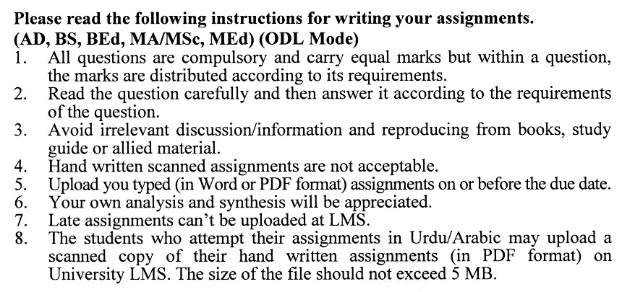

**Total Marks:100 Pass Marks: 50**

**ASSIGNMENT No. 1**

Q. 1 You have a portfolio with two assets:

* Asset A: Expected return = 12%, Standard deviation = 15%,   
  Portfolio weight = 40%
* Asset B: Expected return = 8%, Standard deviation = 10 %,   
  Portfolio weight = 60%
* Correlation coefficient between Asset A and Asset B = 0.7
* Make separate calculations if the correlation coefficient is -0.7

Calculate the **expected portfolio risk and return**. **(20)**

Q. 2 Define **business** and explain the various types of businesses with examples.

A firm’s revenue is $500,000, operating expenses are $300,000, and taxes amount to 25% of the net profit. Calculate the net profit and explain its significance. **(20)**

Q. 3 Discuss the components of the **business environment** and their impact on financial decision-making. **(20)**

Q. 4 A loan of $50,000 is amortized over 10 years with an annual interest rate of 8%. Calculate the annual payment using the amortization formula. **(20)**

Q. 5 Differentiate between the **valuation of bonds**, **preferred stock**, and **common stock**, highlighting the unique factors influencing each.

A bond has a face value of $1,000, a coupon rate of 5%, and matures in 10 years. If the required rate of return is 6%, calculate the bond’s present value. **(20)**

**ASSIGNMENT No. 2**

**Total Marks: 100 Pass Marks: 50**

This assignment is a research-oriented activity. You are required to prepare a detailed report of about 3000 words on the topic allotted to you to be submitted to your teacher for **evaluation**.

You are required to select one of the following topics according to the last digit of your registration number. For example, if your registration number is 18-IDM-3427183 then you will select topic # 3(the last digit): -

**List of Topics:**

1. Sustainable Finance: Integrating Environmental, Social, and Governance (ESG) Factors
2. The Rise of FinTech: Disrupting Traditional Business Finance Models
3. COVID-19 and Business Finance: Challenges and Strategies for Recovery
4. Impact Investing: Aligning Financial Goals with Social and Environmental Impact
5. Economic Stimulus Packages: Evaluating Their Effectiveness in Business Finance
6. Digital Transformation in Financial Management: Opportunities and Risks
7. Artificial Intelligence in Financial Decision-Making: Enhancing Efficiency and Accuracy
8. The Role of Central Banks in Shaping Business Finance Policies
9. Inclusive Finance: Bridging the Gap for Small and Medium Enterprises (SMEs)
10. Cryptocurrency and Blockchain Technology: Implications for Business Finance

**GUIDELINES FOR ASSIGNMENT # 2:**

* 1.5 line spacing
* Use headers and subheads throughout all sections
* Organization of ideas
* Writing skills (spelling, grammar, punctuation)
* Professionalism (readability and general appearance)
* Do more than repeat the text
* Express a point of view and defend it.

**ALLAMA IQBAL OPEN UNIVERSITY, ISLAMABAD**

**(Department of Business Administration)**

# **Course: Introduction to Business Finance Course Code: 8414**

**Level: BBA (4 years) Credit Hours: 03**

**Unit 1. Business & Finance**

* 1. Business, Types of Businesses
  2. Finance, Key Financial Decisions

1.3 Goals of the Firm

**Unit 2. Business & Financial Environment**

2.1 Business Environment

2.2 Financial Environment

2.3 Financial Markets

**Unit 3. Time Value of Money**

3.1 Concepts of Time Value of Money

3.2 Significance of Time Value of Money

3.3 Amortizing Loans

**Unit 4. Valuation of Long-Term Securities**

4.1 Distinctions among Valuation Concepts

4.2 Bond Valuation

4.3 Preferred Stock Valuation

4.4 Common Stock Valuation

**Unit 5: Risk and Return**

5.1 Defining Risk and Return

5.2 Using Probability Distributions to Measure Risk

5.3 Attitudes Towards Risk

5.4 Portfolio Theory

**Unit 6. Funds Analysis**

6.1 Flow of Fund

6.2 Accounting Statement of Cash Flows

6.3 Cash-Flow Forecasting

6.4 Range of Cash-Flow Estimates

6.5 Forecasting Financial Statements

**Unit 7. Working Capital Management**

7.1 Working Capital: Concept and Classification

7.2 Working Capital Issues

7.3 Financing Current Assets: Short-term and Long-term Mix

7.4 Combining Liability Structure

**Unit 8. Capital Budgeting & Estimating Cash Flows**

8.1 Capital Budgeting

8.2 Capital Budgeting Process

8.3 Generating Investment Project Proposal

8.4 Estimating Project After-Tax Incremental Operating Cash Flows

**Unit 9. Mergers & Other Forms of Corporate Restructuring**

9.1 Sources of Value

9.2 Strategic Acquisitions Involving Common Stock

9.3 Acquisitions and Capital Budgeting

9.4 Closing the Deal

9.5 Takeovers, Tender Offers & Defenses

9.6 Strategic Alliances

9.7 Divestiture

9.8 Ownership Restructuring

9.9 Leverage Buyouts

**Recommended Book:**

Van Horn, C., J. and Jr., W., M., J. (2008). *Fundamentals of Financial Management*.

13th Edition. Edinburgh: Pearson Publications Limited.

**Additional Books:**

Khan, M., Y. and Jains K., P. (2007). *Financial Management*. New York: McGraw Hills Companies.

Shin, K., J. and Siegel, G., J. (2008). *Financial Management.* New York: Barrens Business Library.

****