**ALLAMA IQBAL OPEN UNIVERSITY, ISLAMABAD**

**(Department of Business Administration)**

**WARNING**

1. **PLAGIARISM OR HIRING OF GHOST WRITER(S) FOR SOLVING THE ASSIGNMENT(S) WILL DEBAR THE STUDENT FROM AWARD OF DEGREE/CERTIFICATE, IF FOUND AT ANY STAGE.**
2. **SUBMITTING ASSIGNMENT(S) BORROWED OR STOLEN FROM OTHER(S) AS ONE’S OWN WILL BE PENALIZED AS DEFINED IN “AIOU PLAGIARISM POLICY”.**

**Course: Introduction to Logic (8413) Semester: Spring, 2025**

**Level: BBA / BS**

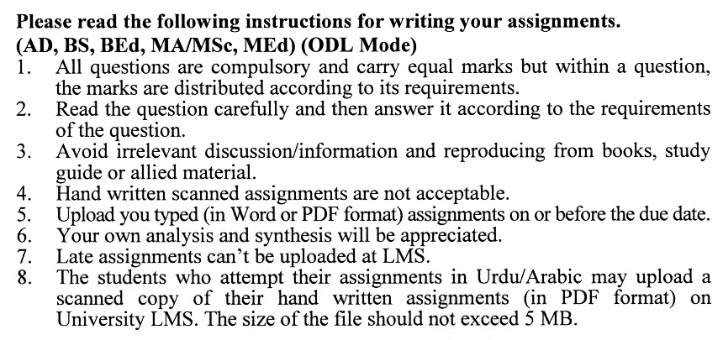

**Total Marks: 100 Pass Marks: 50**

**ASSIGNMENT No. 1**

**(Units: 1–4)**

***Note: Attempt all questions. All questions carry equal marks.***

Q. 1 How can two premises be incorporated into a single sentence in an argument? Provide examples. **(20)**

Q. 2 Explain how the fallacy of begging the question occurs in in-advocate promise situations with examples. **(20)**

## Q. 3 Discuss the role of logical connectives in constructing complex arguments with examples. (20)

Q. 4 How can the truth value components of a compound proposition be determined? Discuss with examples. **(20)**

Q. 5 Critically analyze the applications of the Traditional Square of Opposition in business organizations with examples. **(20)**

**ASSIGNMENT No. 2**

**Total Marks: 100 Unit: (5–9) Pass Marks: 50**

**Note: Attempt all questions. All questions carry equal marks**

Q. 1 How can indirect proof be applied to confirm the truth of a logical statement? Illustrate with an example. **(20)**

Q. 2 As a business manager, how would you differentiate science from superstition logically? Provide examples. **(20)**

Q. 3 How can the method of concomitant variation be applied to solve real-life problems? Provide examples. **(20)**

Q. 4 In what ways can a manager use standard deviation to inform business decisions? Provide examples. **(20)**

Q. 5 How can the finite universe method be used to disprove the validity of an argument involving a single variable? Provide an example. **(20)**

INTRODUCTION TO LOGIC (8413)

COURSE OUTLINE

Unit 1: Basic Concepts

* 1. Arguments
  2. Premises, and Conclusions
  3. Recognizing Arguments
  4. Deduction and Induction
  5. Truth and Soundness

Unit 2: Informal Fallacies

2.1 Fallacies in General  
2.2 Fallacies of Relevance  
2.3 Fallacies of Weak Induction  
2.4 Fallacies of Presumption  
2.5 Illicit Transference

Unit 3: Categorical Propositions

3.1 Components of Categorical Propositions  
3.2 Quality, Quantity  
3.3 Venn Diagrams  
3.4 Modern Square of Opposition  
3.5 Traditional Square of Opposition

Unit 4: Propositional Logic

4.1 Truth Functions  
4.2 Symbols and Translation  
4.3 Truth Tables for Propositions  
4.4 Indirect Truth Tables  
4.5 Argument Forms and Fallacies

Unit 5: Natural Deduction in Propositional Logic.

5.1 Natural Deduction

5.2 Rules of Implication- I

5.3 Rules of Implication II

5.4 Conditional Proof and Indirect Proof

Unit 6: Predicate Logic

6.1 Symbols and Translation  
6.2 Using the Rules of Inference  
6.3 Proving Invalidity  
6.4 Relational Predicates  
6.5 Overlapping Quantifiers

Unit 7: Inductive Logic

7.1 Analogy  
7.2 Legal Reasoning  
7.3 Reasoning  
7.4 "Cause" and Necessary  
7.5 Causality and Mill's Methods

Unit 8: Probability and Statistical Reasoning

8.1 Theories of Probability  
8.2 Evaluating Statistics  
8.3 Average  
8.4 Calculus  
8.5 Samples

Unit 9: Hypothetical/Scientific Reasoning

9.1 Hypothetical Method

9.2 Hypothetical Reasoning  
9.3 Proof of Hypotheses  
9.4 Tentative Acceptance of Hypotheses  
9.5 Distinguishing Between Science and Superstition

Recommended Book:Hurley, P. (the latest edition). A concise introduction to logic: Cengage Learning.

