ALLAMA IQBAL OPEN UNIVERSITY, ISLAMABAD

**(Department of Business Administration)**

|  |
| --- |
| **WARNING**   1. **PLAGIARISM OR HIRING OF GHOST WRITER(S) FOR SOLVING THE ASSIGNMENT(S) WILL DEBAR THE STUDENT FROM THE AWARD OF DEGREE/CERTIFICATE IF FOUND AT ANY STAGE.** 2. **SUBMITTING ASSIGNMENT(S) BORROWED OR STOLEN FROM OTHER(S) AS ONE’S OWN WILL BE PENALIZED AS DEFINED IN THE “AIOU PLAGIARISM POLICY”.** |

**Course: Business Communications II (8415) Semester: Spring, 2025**

**Level: BBA**

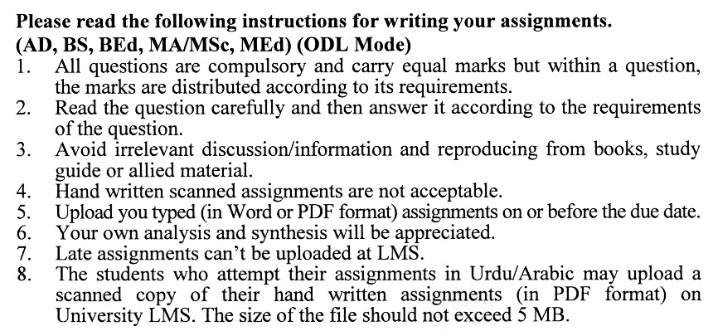

**Total Marks: 100 Pass Marks: 50**

**ASSIGNMENT No. 1**

***Note: Attempt all the questions.***

Q. 1 Describe the role of emails, video conferencing, instant messaging, and collaborative tools. **(20)**

Q. 2 Identify physical, emotional, and semantic barriers and propose solutions to address them. **(20)**

Q. 3 Explain how feedback enhances understanding, accountability, and performance in organizations. **(20)**

Q. 4 Discuss how transparency, trust, and professional communication impact relationships. **(20)**

Q. 5 Describe the contexts, tone, and purpose of formal communication compared to informal exchanges. **(20)**

**Total Marks: 100 Pass Marks: 50**

**ASSIGNMENT No. 2**

This assignment is a research-oriented activity. You are required to obtain information from a banking/financial organization and prepare a report of about 1000 words on the issue allotted to you to be submitted to your teacher for evaluation. Discuss your topic by giving examples of organizations and markets etc. in Pakistan.

You are required to select one of the following issues according to the last digit of your roll number. For example, if your roll number is P-3427182 then you will select issue No.2 (the last digit). All the issues carry equal marks.

**List of Issues:**

1. Letter or Memorandum of Transmittal
2. Executive Summary, Abstract, Synopsis
3. Strategies for an Effective Nonverbal Delivery
4. Strategies for Successful Business and Group Meetings
5. Organizational Communication Strategies
6. Getting a Job
7. Progress & Periodic Reports
8. Writing Memos, Emails & Letters
9. Presentations and Meetings
10. Technology in the Workplace

****