# **ALLAMA IQBAL OPEN UNIVERSITY, ISLAMABAD**

**(Department of Business Administration)**

**WARNING**

1. **PLAGIARISM OR HIRING OF GHOST WRITER(S) FOR SOLVING THE ASSIGNMENT(S) WILL DEBAR THE STUDENT FROM AWARD OF DEGREE/CERTIFICATE, IF FOUND AT ANY STAGE.**
2. **SUBMITTING ASSIGNMENT(S) BORROWED OR STOLEN FROM OTHER(S) AS ONE’S OWN WILL BE PENALIZED AS DEFINED IN “AIOU PLAGIARISM POLICY”.**

**Course: Strategic Human Resource Management (9510) Semester: Spring, 2025**

**Level: PGD (Human Resource Management)**

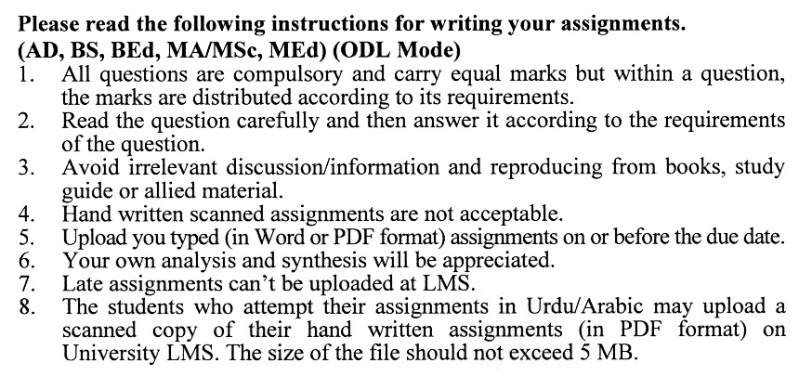

**Guidelines FOR ASSIGNMENT No. 1 & 2:**

You should look upon the assignments as a test of knowledge, management skills, and communication skills. When you write an assignment answer, you are indicating your knowledge to the teacher:

* Your level of understanding of the subject;
* How clearly you think?
* How well you can reflect on your knowledge & experience?
* How well you can use your knowledge in solving problems, explaining situations, and describing organizations and management?
* How professional you are, and how much care and attention you give to what you do?

To answer a question effectively, address the question directly, bring important related issues into the discussion, refer to sources, and indicate how principles from the course materials apply. You must also be able to identify important problems and implications arising from the answer.

For citing references, writing bibliographies, and formatting the assignment, APA format should be followed.

## ASSIGNMENT No. 1

**Total Marks: 100 Pass Marks: 50**

Q. 1 How can investments in training and development be considered a strategic approach to improving employee retention and organizational performance? **(20)**

Q. 2 What are the key challenges in aligning HR practices with the strategic goals of an organization, particularly in a rapidly changing business environment? **(20)**

Q. 3 How does the evolving legal environment impact HR strategies, and what steps should HR managers take to ensure compliance with labor laws? **(20)**

Q. 4 What role do technology and organizational structure play in shaping HR practices, and how can HR adapt to these changes? **(20)**

Q. 5 How do strategically oriented performance management and compensation systems contribute to employee motivation and organizational success? (**20)**

## ASSIGNMENT No. 2

**Total Marks: 100 Pass Marks: 50**

This assignment is a research-oriented activity. You are required to submit a term paper and present the same in the classroom prior to the final examination. Presentation component is compulsory for all students. You will have to participate in the activity fully and prepare a paper of 6000 to 8000 words on the topic allotted to you. The students are required to prepare two copies of Assignment No. 2. Submit one copy to your teacher for evaluation and the second copy for presentation in the classrooms in the presence of your resource persons and classmates, which will be held at the end of the semester prior to the final examination.

Include the following main headings in your report: -

1. Introduction to the topic
2. Important sub-topics
3. Practical aspects with respect to the topic
4. Review of theoretical and practical situations
5. SWOC (Strengths, Weaknesses, Opportunities, and Challenges) Analysis of the organization with respect to your topic
6. Conclusions and recommendations
7. Annex, if any

You should also develop a PowerPoint Presentation. You are also required to select one of the following topics according to the last digit of your roll number. For example, if your roll number is D-3427185 then you will select topic No.5 (the last digit): -

**Topics:**

1. HR Investment Considerations: Balancing Short-term and Long-term Returns
2. The Role of Training and Development Investments in Enhancing Workforce Capability
3. Global Trends in Worker Values and Their Impact on HR Practices
4. Strategic HRM: Aligning HR Practices with Organizational Goals
5. Legal Considerations in HR: Equal Employment Opportunity and Employee Relations
6. The Strategic Impact of Compensation and Reward Systems on Employee Performance
7. Forecasting and Planning for HR: Selecting the Right Techniques for Strategic Success
8. Managing Employee Surpluses and Shortages: Strategic Solutions for Workforce Utilization
9. The Evolution of High-Performance HR Practices: Universal Practices vs. Contingency Perspectives
10. Evaluating the Strategic Contributions of HR: Approaches and Techniques for Effective HR Evaluation

**WORKSHOPS:**

The workshop presentations provide you the opportunity to express your communication skills, knowledge & understanding of concepts learned during the practical study assigned in assignment # 2.

STRATEGIC HUMAN RESOURCE MANAGEMENT

COURSE OUTLINE (9510)

**Unit–1: Investment Perspective of Human Resources**

* 1. HR Investment Considerations
  2. Investments in Training and Development
  3. Investments Practices for Improved Retention
  4. Investments in Job-Secure Workforces
  5. Nontraditional Investment Approaches

**Unit–2: Human Resource Environment**

* 1. Technology and Organization Structure
  2. Worker Values and Attitudinal Trends
  3. Management Trends
  4. Trends in Utilization of HR
  5. International Developments

**Unit–3: HR Legal Environment**

* 1. Equal Employment Opportunity
  2. Compensation
  3. Employee Relations
  4. Labor Relations and Collective Bargaining
  5. Strategic Impact of Legal Environment

**Unit–4: Strategy Formulation**

* 1. Importance of HR to Strategy
  2. International Strategy
  3. HR Contributions to Strategy
  4. Strategy Driven Roles Behaviors and Practices
  5. Strategic HR Activity Topology
  6. Integration of Strategy and HR Planning
  7. HR Manger and Strategic Planning

**Unit–5: Strategic Role of HR Planning**

* 1. Developmental Planning For Strategic Leadership
  2. Assessment of Strategic Alternatives
  3. Contribution to Strategic HRM
  4. Strategic Salary Planning
  5. Selecting Forecasting Techniques

**Unit–6: Strategy Implementation: Workforce Utilization and Employment Practices**

* 1. Efficient Utilization of HR
  2. Dealing with Employee Shortages
  3. Selection of Employees
  4. Dealing with Employee Surplus
  5. Special Implementation Challenges
     1. Career Path for Technical professionals
     2. Dual Career Couples

**Unit–7: Strategy Implementation: Reward and Development Systems**

* 1. Strategically Oriented Performance Management Systems
  2. Strategically Oriented Compensation Systems
  3. Employee Development

**Unit–8: Performance Impact of HR Practices**

* 1. Individual High Performance Practices
  2. Limitations of Individual Practices
  3. Evolution of Practices
  4. Systems of High Performance HR Practices
  5. Universal Practices Vs. Contingency Perspectives

**Unit–9: Human Resource Evaluation**

* 1. Overview of Evaluation
  2. Approaches to Evaluation
  3. Prevalence of Evaluation
  4. Evaluating Strategic Contributions of Traditional Areas

**Recommended Books:**

Armstrong M., & Baron A. **(2002). *Strategic Human Resource Management***, *The Key to Improve Business Performance.* **London: CIPD**

Armstrong M., & Baron A. **(2008). *Strategic Human Resource Management****, a Guide to Action* (**8th ed.). USA: Kogan Page Ltd.**

**Greer C. R. (2008). *Strategic Human Resource Management, a General Managerial Approach* (2nd ed.). Delhi: Dowling Kindersley.**

