**ALLAMA IQBAL OPEN UNIVERSITY, ISLAMABAD**

**(Department of Business Administration)**

**WARNING**

1. **PLAGIARISM OR HIRING OF GHOST WRITER(S) FOR SOLVING THE ASSIGNMENT(S) WILL DEBAR THE STUDENT FROM AWARD OF DEGREE/CERTIFICATE, IF FOUND AT ANY STAGE.**
2. **SUBMITTING ASSIGNMENT(S) BORROWED OR STOLEN FROM OTHER(S) AS ONE’S OWN WILL BE PENALIZED AS DEFINED IN “AIOU PLAGIARISM POLICY”.**

**Course: Statistical Inference (8417) Semester: Spring, 2025**

**Level: BBA (4 Years)**

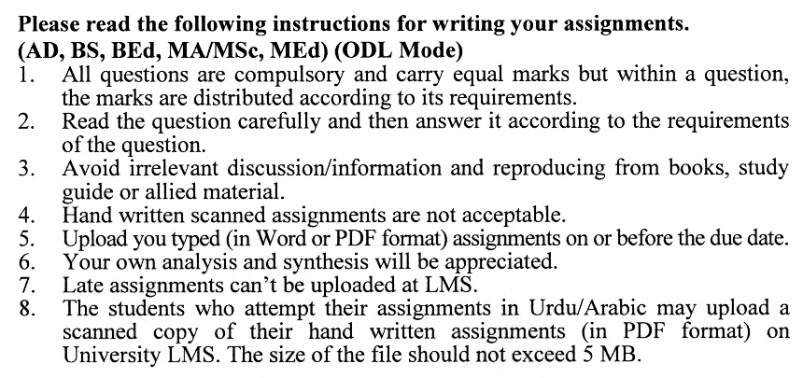

**Total Marks:100 Pass Marks: 50**

**ASSIGNMENT No. 1**

Q. 1 Discuss the importance of **measures of central tendency** in summarizing data and describe how to choose the most appropriate measure for different datasets.

For the datasets 5, 8, 12, 15, and 20, calculate the **range**, **interquartile range**, and **coefficient of variation** **(20)**

Q. 2 A survey sample of 150 people has a mean age of 35 years with a standard deviation of 5 years. Construct a **95% confidence interval** for the mean age of the population.

Explain the **importance of sampling in statistics** and discuss the advantages of **stratified sampling** over random sampling. **(20)**

Q. 3 Differentiate between **point estimation** and **interval estimation**, and explain the role of confidence intervals in decision-making.

Estimate the required **sample size** needed to achieve a margin of error of 2% with a confidence level of 95%, given a population standard deviation of 10. **(20)**

Q. 4 Explain the role of **null and alternative hypotheses** in hypothesis testing and describe the possible errors in hypothesis testing.

A company claims that the average lifespan of their product is 5 years. A sample of 30 products has an average lifespan of 4.8 years with a standard deviation of 0.5 years. Test the hypothesis at a 5% significance level. **(20)**

Q. 5 Two factories produce light bulbs. A sample of 50 bulbs from Factory A has an average lifespan of 1,200 hours with a standard deviation of 100 hours. A sample of 50 bulbs from Factory B has an average lifespan of 1,180 hours with a standard deviation of 120 hours. Test whether there is a significant difference in the average lifespans of the bulbs at a 5% significance level.

Compare and contrast **independent sample t-tests** and **paired sample   
t-tests**, and discuss when each should be used. **(20)**

**ASSIGNMENT No. 2**

**Total Marks: 100 Pass Marks: 50**

This assignment is a research-oriented activity. You are required to prepare a detailed report of about 3000 words on the topic allotted to you to be submitted to your teacher for **evaluation**.

You are required to select one of the following topics according to the last digit of your registration number. For example, if your registration number is 18-IDM-3427183 then you will select topic # 3(the last digit): -

**List of Topics:**

1. Descriptive Statistics
2. Probability
3. Probability Sampling Distribution
4. ANOVA
5. Non-Probability Sampling Distribution
6. Hypothesis Testing: One Sample Test
7. Hypothesis Testing: Two-Sample Test
8. Chi-Square
9. Non-parametric Methods
10. Time Series Forecasting

**GUIDELINES FOR ASSIGNMENT # 2:**

* 1.5 line spacing
* Use headers and subheads throughout all sections
* Organization of ideas
* Writing skills (spelling, grammar, punctuation)
* Professionalism (readability and general appearance)
* Do more than repeat the text
* Express a point of view and defend it.

**STATISTICAL INFERENCE**

**(OUTLINES)**

## UNIT 1: DESCRIPTIVE STATISTICS

- Measures of Central Tendency

- Mean (arithmetic, weighted and geometric means)

- Median

- Mode

* Choosing Measures of Central Tendency
* Percentiles, Deciles, and Quartiles
* Measures of Dispersion

- Range and Semi-Interquartile Range

* Variance
* Standard Deviation
* The Coefficient of Variation
* Interpretations
* Skewness and Kurtosis
* Measures of Skewness and Peakedness

## UNIT 2: SAMPLING AND SAMPLING DISTRIBUTION

* Population and Samples
* Parameters and Estimates
* Introduction to Statistical Inference
* Introduction to Sampling
* Importance of Sampling in Statistics
* Random Sampling
* Stratified and Proportional Stratified Sampling
* Other Sampling Procedures
* Errors in Sampling
* Sampling Distribution
* Point and Interval Estimation
* Using Sampling Distribution to make Inferences
* The relationship between sample size and Standard Error

## UNIT 3: ESTIMATION

* Point Estimation
* Methods of obtaining Point Estimator
* Interval Estimation and Confidence Intervals
* Estimation of Means
* Estimation of Differences Between Means
* Estimation of Proportions
* Estimation of Variances
* Estimating the required Sample Size

## UNIT 4: TESTING HYPOTHESES: ONE SAMPLE TESTS

* Role of Statistical Hypothesis
* Formulating Hypothesis
* The Null Hypothesis and Error Type
* Testing Hypothesis of means when population standard deviation is known.
* Measuring Power of Hypothesis Test
* Hypothesis Testing of Proportions- Large Samples
* Testing Hypothesis of means when population standard deviation is not known.

## UNIT 5: TESTING HYPOTHESES: TWO SAMPLE TESTS

* Testing for differences between Means and Proportions
* Testing for differences between Means: Large Sample Size
* Testing for differences between Means: Small Sample Size
* Testing for differences between Means with Dependent Samples
* Testing for differences between Proportions: Large Sample Size
* Probability Value: Another way of looking at testing hypotheses

## UNIT 6: Chi-Square and Analysis of Variance

* Chi-Square as a Test of Independence
* Chi-Square as Test of Goodness of Fit
* Analysis of Variance
* Inference about a Population Variance
* Inference about Two Population Variances

## UNIT 7: REGRESSION AND CORRELATION ANALYSIS

* Estimation Using the Regression Line
* Correlation Analysis
* Inferences about Population Parameters
* Limitations, Errors, Caveats of Regression and Correlation
* Multiples Regression and Correlation Analysis
* Finding the Multiple Regression Equation
* Making Inferences about Population Parameters
* Modeling Techniques

## UNIT 8: NONPARAMETRIC METHODS

* Introduction to nonparametric statistics
* The sign test for paired data
* Rank Sum Tests: The Mann-Whitney U Test and The Kruskal-Wallis Test
* One Sample Run Test
* Rank Correlation Test
* The Kolmogorov-Smirnov Test
* Factors affecting the Correlation

## UNIT 9: TIME SERIES & FORECASTING

* Introduction to Time Series
* Variations in Time Series
* Trend Analysis
* Cyclical Variation
* Seasonal Variation
* Irregular Variation
* Time Series Analysis in Forecasting

Levin, R. I., & Rubin, D. S. (2009). *Statistics for Management* (7th ed.). Delhi, India: Dorling Kindersley Ltd (under the license of Pearson Education).

Lind, D. A., Marchal, W. G., & Wathen, S. A. (2005). *Statistical Techniques in Business and Economics* (12th ed.). USA: McGraw-Hill Irwin

Holcomb, Jr. (2010). *Mathematics with Applications in Management, Natural, and Social Sciences* (10th ed.). USA: Adison Wesley Publishers.

James, T. M., Benson, P. G., & Sincich, T. (2010). *Statistics for Business and Economics* (11th ed.). USA: Prentice Hall.

****