**ALLAMA IQBALOPEN UNIVERSITY, ISLAMABAD**

**(Department of Business Administration)**

**WARNING**

1. **PLAGIARISM OR HIRING OF GHOST WRITER(S) FOR SOLVING THE ASSIGNMENT(S) WILL DEBAR THE STUDENT FROM THE AWARD OF DEGREE/CERTIFICATE IF FOUND AT ANY STAGE.**
2. **SUBMITTING ASSIGNMENT(S) BORROWED OR STOLEN FROM OTHER(S) AS ONE’S OWN WILL BE PENALIZED AS DEFINED IN “AIOU PLAGIARISM POLICY”.**

**Course: Management Theory and Practice (8419/5003/9503) Semester: Spring, 2025**

**Level: BBA (4 Years)/ MSc/PGD**

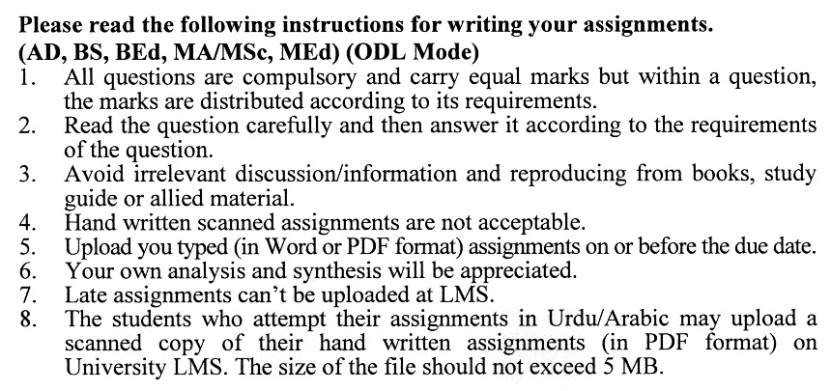

**Total Marks: 100 Pass Marks: 50**

## **ASSIGNMENT No. 1**

**(Units: 1–5)**

**Note: Attempt all questions.**

Q.1 As a newly appointed manager of a growing startup, you notice inefficiencies in how your team handles projects. Drawing on the concept of the **Management Process**, outline the steps you would take to improve efficiency and ensure successful project outcomes. **(20)**

Q. 2  You are leading a team tasked with launching a new product in a highly competitive market. Given the uncertainty in consumer preferences, how would you apply **decision-making tools**, such as probability theory or decision trees, to make informed choices? **(20)**

Q. 3  Your company is expanding into a new region. As part of the strategic planning team, identify the **steps in the planning process** you would follow to ensure a seamless transition and mitigate risks. **(20)**

Q. 4  As a manager in a mid-sized organization undergoing downsizing, how would you restructure the **organizational structure** to maintain productivity while supporting employees during the transition? **(20)**

Q. 5  You are leading a cross-functional team working on a tight deadline. Team conflicts arise due to differing working styles. How would you use **leadership styles** and team management strategies to resolve conflicts and improve team performance? (**20)**

**Total Marks: 100 Pass Marks: 50**

**assignment No. 2**

**(Units: 6–9)**

**Note: Attempt all questions.**

Q.1 Your organization faces a challenge with declining employee engagement. Based on **need theory**, design a strategy to motivate employees and improve their performance. **(20)**

Q. 2  A high-performing employee is considering leaving due to a perceived lack of recognition. How would you apply **equity theory** to address their concerns and retain them? **(20)**

Q. 3  During a critical negotiation with a key supplier, you encounter resistance on pricing terms. How would you use **negotiation skills** to find a mutually beneficial agreement while maintaining a strong working relationship? **(20)**

Q. 4  Your team consistently misses project deadlines, causing budget overruns. Which **control tools** would you implement to monitor progress effectively and ensure timely project completion? **(20)**

Q. 5  Your company is preparing managers for a globalized work environment. How would you design a training program to enhance **situational analysis skills** and **cultural competence** for future managers? **(20)**

**MANAGEMENT THEORY AND PRACTICE (8419)**

**(COURSE OUTLINE)**

**Unit 1: Introduction**

1.1 Concept of Management

1.1.1 The Importance of Management

1.1.2 The Management Process

1.1.3 Types of Managers

1.1.4 The Challenge of Management

1.2 Evolution of Management Theory

1.2.1 Scientific Management School

1.2.2 Relations Theory

1.2.3 Quantitative Approach

1.2.4 Systems Approach

1.2.5 Modified Process Management

1.2.6 Contingency Approach

**Unit 2: Decision Making**

2.1 Time and Human Relationships in Decision-Making

2.1.1 The Problem-Finding Process

2.1.2 Opportunity Finding

2.1.3 Fundamentals of Decisions

2.2 The Nature of Managerial Decision Making

2.2.1 Programmed and un-programmed Decisions

2.2.2 Certainty, Risk and Uncertainty

2.2.3 Decision-Making Tools

2.2.3.1 Probability Theory

2.2.3.2 Decision Trees

2.3 Rational Model of Decision Making

**Unit 3: Planning**

3.1 Organizational Objectives

3.1.1 Importance of Organizational Objectives

3.1.2 Types of Objectives

3.1.3 Management by Objectives

3.2 Planning

3.2.1 Characteristics and Purposes of Planning

3.2.2 Advantages and Limitations of Planning

3.2.3 Types of Planning

3.2.4 Steps in Planning Process

3.2.5 Approaches to Planning

* 1. Plans and Planning Tools

3.3.1 Dimensions and Types of Plans

3.3.2 Planning Tools

3.3.3 Forecasting

3.3.4 Scheduling

3.4 Implementing the Plans

3.5 Planning and Strategic Management

**Unit 4: Organizing**

4.1 Fundamentals of Organizing

4.1.1 The Organizing Process

4.1.2 The Importance of Organizing

4.1.3 Downsizing

4.1.4 Types of Organizational Structures

4.2 Organizing the Activity of Individuals

4.2.1 Responsibility

4.2.2 Authority

4.2.2.1 Types of Authority

4.2.2.2 Accountability

4.2.3 Delegation

4.2.3.1 Steps in the Delegation Process

4.2.3.2 Obstacles to the Delegation Process

4.2.3.3 Centralization and Decentralization

4.3 Organizational Change and Development

**Unit 5: Leading and Managing Groups**

5.1 Defining Leadership

5.2 The Trait Approach to Leadership

5.3 The Behavioral Approach to Leadership

5.3.1 Leadership Functions

5.3.2 Leadership Styles

5.3.3 The Managerial Grid

5.4 Contingency Approach to Leadership

5.5 Leadership Situations and Decisions

5.6 Personal Characteristics of Employees

5.6.1 Environmental Pressures and Workplace Demands

5.6.2 Deciding when to involve subordinates

5.7 The Future of Leadership Theory

5.8 Types of Teams

5.9 Characteristics of Teams

5.10 Making Teams Effective

5.10.1 Guidelines for Committees

5.10.2 Focusing Teams on Performance

5.10.3 Conflict within Teams

**Unit 6: Motivating**

6.1 Concept and Importance of Motivation

6.1.1 The Motivation Process

6.1.2 Basic Assumptions about Motivation and Motivating

6.1.3 The Importance of Motivation

6.2 Theories of Motivation

6.3 Contemporary Views of Motivation

6.3.1 Need Theory

6.3.2 Equity Theory

6.3.3 Expectancy Theory

6.3.4 Reinforcement Theory

6.3.5 Goal-setting Theory

6.4 Strategies for Motivating

**Unit 7: Communicating and Negotiation**

7.1 The Importance of Effective Communication

7.2 Interpersonal Communication

7.3 Improving Communication Processes

7.4 Communication in Organizations

7.4.1 Factors Influencing Organizational Communication

7.4.2 Types of Organizational Communication

7.4.3 Lateral and Informal Communication

7.5 Using Communication Skills: Negotiating to Manage Conflicts

7.6 Stability of Negotiations Outcomes

7.7 Relations between Labour and Management

**Unit 8: Controlling**

8.1 Fundamentals of Controlling

8.1.1 Defining Control

8.1.2 Types of Control

8.2 Power and Control

8.3 Control Tools

8.3.1 Management by Exception

8.3.2 Break-Even Analysis

8.3.3 Ratio Analysis

8.3.4 Budgets

8.3.5 Human Asset Accounting

8.4 Use of Control Tools

8.5 Operations Management

8.5.1 Designing Operations Systems

8.5.2 Operational Planning and Control Decisions

8.6 Information Systems

8.6.1 Management Information Systems

8.6.2 user-end-user computing

**Unit 9: Management: The Futuristic View**

9.1 Essential Skills for Future Managers

9.1.1 Systems Skills in the Future

9.1.2 Functional Skills in the Future

9.1.3 Situational Analysis Skill in the Future

9.2 Training Managers for the Future

9.3 Globalization and Competitiveness

9.4 The Changing International Scene

9.5 The Role of Multinational Enterprises

9.6 Global Business Practice

9.6.1 How Companies Go International?

9.6.2 Globalization Across Different Cultures

9.6.3 Managers and Prejudice

9.6.4 Women in the International Workforce

9.7 Inventing and Reinventing Organizations

9.7.1 The Meaning and Importance of Entrepreneurship

9.7.2 Small Business

* + 1. Reinventing Organizations

##### Recommended Books:

Management by Stephen P. Robbins & Mary Coulter (latest edition)

Management by Griffin, R. W. (latest edition), Houghton Mifflin & Company, New York.

Management by Hitt, M. A. Black; J. S. & Porter; International edition, Pearson Prentice Hall.

