**ALLAMA IQBAL OPEN UNIVERSITY, ISLAMABAD**

**(Department of Business Administration)**

**WARNING**

1. **PLAGIARISM OR HIRING OF GHOST WRITER(S) FOR SOLVING THE ASSIGNMENT(S) WILL DEBAR THE STUDENT FROM AWARD OF DEGREE/CERTIFICATE, IF FOUND AT ANY STAGE.**
2. **SUBMITTING ASSIGNMENT(S) BORROWED OR STOLEN FROM OTHER(S) AS ONE’S OWN WILL BE PENALIZED AS DEFINED IN “AIOU PLAGIARISM POLICY”.**

**Course: Business Ethics (8420) Semester: Spring, 2025**

**Level: BBA (4 Years)**

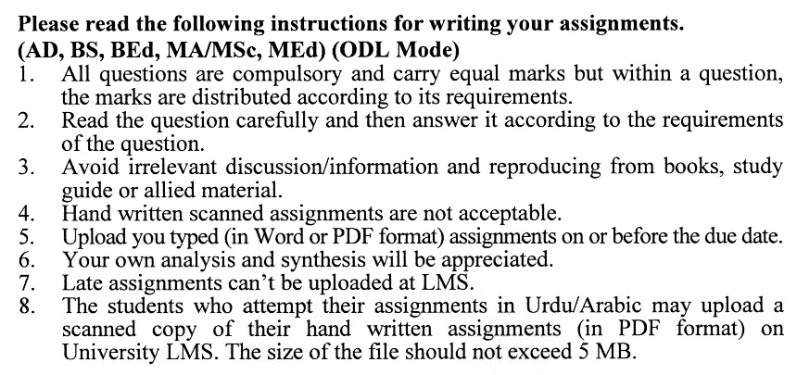

**Total Marks:100 Pass Marks: 50**

**ASSIGNMENT No. 1**

Q. 1 Explain the relationship between **individual integrity** and personal responsibility in the context of ethical decision-making. Provide real-life examples to support your argument.  **(20)**

Q. 2 Compare and contrast **Consequentialist** and **Non-Consequentialist** theories of ethics. How can these theories influence decision-making in professional settings? **(20)**

Q. 3 Analyze **Rawls's Theory of Justice** in addressing economic inequalities. How does this theory contribute to discussions on wealth redistribution and fairness? **(20)**

Q. 4 Evaluate the concept of **Corporate Moral Agency**. Should corporations be held morally accountable for the actions of their employees? Justify your response. **(20)**

Q. 5 Examine the ethical responsibilities of businesses in ensuring **product safety**. Provide examples of cases where lack of product safety led to public harm and legal consequences. **(20)**

**ASSIGNMENT No. 2**

**Total Marks: 100 Pass Marks: 50**

This assignment is a research-oriented activity. You are required to prepare a detailed report of about 3000 words on the topic allotted to you to be submitted to your teacher for **evaluation**.

You are required to select one of the following topics according to the last digit of your registration number. For example, if your registration number is 18-IDM-3427183 then you will select topic # 3(the last digit): -

**List of Topics:**

1. Utilitarian View and Libertarian Approach to Economic Justice
2. Assessing Rawls’s Theory of Justice in Modern Societies
3. Current Debates on Capitalism: Concepts and Arguments
4. Criticisms and Reforms in Modern Capitalistic Systems
5. Corporate Moral Agency in the Age of Globalization
6. Diverse Views on Corporate Responsibility in the 21st Century
7. Ongoing Debates on Corporate Responsibility in Public Discourse
8. Institutionalizing Ethics within Modern Corporations
9. Ethical Considerations in Product Safety Today
10. Emerging Issues in Business Responsibility Beyond Product Safety

**GUIDELINES FOR ASSIGNMENT # 2:**

* 1.5 line spacing
* Use headers and subheads throughout all sections
* Organization of ideas
* Writing skills (spelling, grammar, punctuation)
* Professionalism (readability and general appearance)
* Do more than repeat the text
* Express a point of view and defend it.

**Business ethics (8420)**

**Unit–1: INTRODUCTION**

* 1. Nature of Ethics
  2. Moral versus Non-Moral Standards
  3. Religion and Morality
  4. Morality and Personal Values
  5. Individual Integrity and Responsibility

**Unit–2: NORMATIVE THEORIES OF ETHICS**

* 1. Consequentialist Theories
  2. Non-consequentialist Theories
  3. Egoism and Utilitarianism
  4. Kant’s Ethics
  5. Moral Decision Making

**Unit–3: ECONOMIC JUSTICE AND CAPITALISM**

* 1. Utilitarian View and Libertarian Approach
  2. Rawls’s Theory of Justice
  3. Capitalism: Concepts and Arguments
  4. Criticisms of Capitalism

**Unit–4: ETHICS INCORPORATIONS**

* 1. Corporate Moral Agency
  2. Rival Views of Corporate Responsibility
  3. Debating Corporate Responsibility
  4. Institutionalizing Ethics within Corporations

**Unit–5: ETHICS FOR CONSUMERS**

* 1. Product Safety
  2. Other Areas of Business Responsibility
  3. Deception and Unfairness in Advertising
  4. Debate over Advertising

**Unit–6: THE ENVIRONMENT**

* 1. Business and Ecology
  2. The Ethics of Environmental Protection
  3. Achieving Our Environmental Goals
  4. Delving Deeper into Environmental Ethics

**Unit–7: THE WORKPLACE**

* 1. Civil Liberties in the Workplace
  2. Hiring and Promotions
  3. Discipline and Discharge
  4. Wages and Labor Unions

**Unit–8: MORAL CHOICES FACING EMPLOYEES**

* 1. Obligations to the Firm
  2. Abuse of Official Position
  3. Bribes and Kickbacks
  4. Gifts and Entertainment
  5. Conflicting Obligations
  6. Whistle-Blowing
  7. Self-Interest and Moral Obligation

**Unit–9: GLOBALIZATION OF ETHICAL DECISION MAKING**

* 1. Capitalism, Economics and Business Ethics
  2. Global Business Practices
  3. Sustainable Development
  4. International Monetary Fund (IMF)
  5. World Trade Organization (WTO)
  6. The Multinational Corporation (MNC)

**Recommended Book:**

Business Ethics: A Textbook with Casesby William H. Shaw.

****