**ALLAMA IQBAL OPEN UNIVERSITY, ISLAMABAD**

**(Department of Business Administration)**

**WARNING**

1. **PLAGIARISM OR HIRING OF GHOST WRITER(S) FOR SOLVING THE ASSIGNMENT(S) WILL DEBAR THE STUDENT FROM AWARD OF DEGREE/CERTIFICATE, IF FOUND AT ANY STAGE.**
2. **SUBMITTING ASSIGNMENT(S) BORROWED OR STOLEN FROM OTHER(S) AS ONE’S OWN WILL BE PENALIZED AS DEFINED IN “AIOU PLAGIARISM POLICY”.**

**Course: Financial Management (8422, 5040) Semester: Spring, 2025**

**Level: M. Com/BBA)**

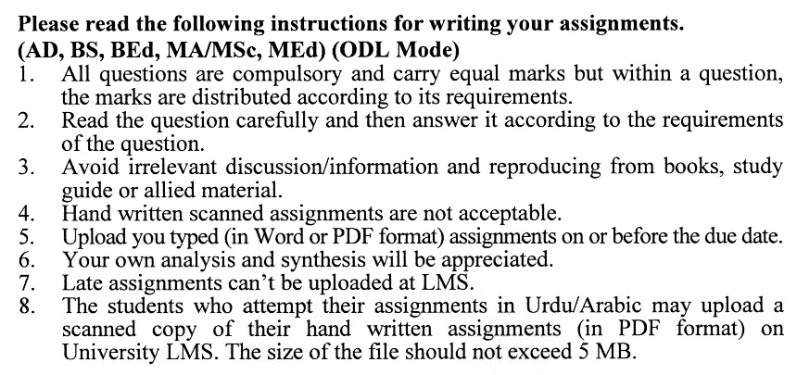

**Total Marks:100 Pass Marks: 50**

**ASSIGNMENT No. 1**

Q. 1 Define **financial management** and explain its key functions, highlighting their importance in achieving the goals of a firm.

A company’s net income is $120,000, and its total equity is $800,000. Calculate the **return on equity (ROE)** and explain its significance in financial decision-making. **(20)**

Q. 2 Discuss the importance of **financial statement analysis** and explain how trend analysis and common-size analysis can aid in decision-making.

From the following data, calculate the **current ratio** and **debt-to-equity ratio**:

* Current Assets: $100,000
* Current Liabilities: $60,000
* Total Debt: $120,000
* Total Equity: $180,000. **(20)**

Q. 3 Explain the concepts of **simple and compound interest**, providing examples of their application in financial decision-making.

A loan of $50,000 is amortized over 10 years with an annual interest rate of 8%. Calculate the **annual payment** using the amortization formula. **(20)**

Q. 4 Discuss the concept of **rates of return (or yields)** and explain their importance in evaluating long-term securities.

A preferred stock pays an annual dividend of $5, and the required rate of return is 8%. Calculate the **value of the preferred stock**. **(20)**

Q. 5 Define **risk and return** and discuss their relationship in the context of portfolio theory.

A portfolio consists of two assets:

* Asset A: Expected return = 12%,

Portfolio weight = 40%,

Standard deviation = 10%

* Asset B: Expected return = 8%,

Portfolio weight = 60%,

Standard deviation = 6%

The correlation coefficient between the two assets is 0.3. Calculate the **expected return** and **portfolio standard deviation**. **(20)**

**ASSIGNMENT No. 2**

**Total Marks: 100 Pass Marks: 50**

This assignment is a research-oriented activity. You are required to prepare a detailed report of about 3000 words on the topic allotted to you to be submitted to your teacher for **evaluation**.

You are required to select one of the following topics according to the last digit of your registration number. For example, if your registration number is 18-IDM-3427183 then you will select topic # 3(the last digit): -

**List of Topics:**

1. Inclusive Finance: Bridging the Gap for Small and Medium Enterprises (SMEs)
2. Evolving Trends in Venture Capital: Navigating the Startup Financing Landscape
3. Big Data Analytics in Business Finance: Leveraging Data for Strategic Insights
4. Financial Inclusion and Access to Capital: Global Perspectives
5. E-commerce and Business Finance: Funding Strategies for Online Ventures
6. Regulatory Changes in Business Finance: Compliance Challenges & Opportunities
7. The Gig Economy and Personal Finance: Managing Income and Expenses
8. Corporate Social Responsibility (CSR) Reporting: Impact on Financial Decision-Making
9. Real Options Analysis: Incorporating Flexibility into Capital Budgeting
10. The Role of Central Banks in Shaping Business Finance Policies

**GUIDELINES FOR THE PREPARATION OF ASSIGNMENT # 2**

* 1.5 line spacing
* Use headers and subheads throughout all sections
* Organization of ideas
* Writing skills (spelling, grammar, punctuation)
* Professionalism (readability and general appearance)
* Do more than repeat the text
* Express a point of view and defend it.

**FINANCIAL MANAGEMENT (**8422,8513,5040,5042,9521**)**

**Unit 1: Introduction to Financial Management**

1.1 The Role of Financial Management

1.1.1 Defining Financial Management

1.1.2 Goals of firm

1.1.3 Functions of Financial Management

1.1.4 Corporate Social Responsibility (CSR)

### 1.2 The Business, Tax and Financial Environments

1.2.1 Business environment

1.2.2 Tax environment

1.2.3 Financial environment

**Unit 2: Tools of Financial Analysis and Planning**

###### 2.1 Financial Statement Analysis

* + 1. Financial statements
    2. Balance sheet ratios
    3. Income statement and income statement/balance sheet ratios
    4. Trend analysis
    5. Common-size and index analysis
  1. Cash-flow Analysis and Financial Planning
     1. Accounting statement of cash flows
     2. Cash-Flow forecasting
     3. Range of cash-flow estimates
     4. Forecasting financial statements

## **Unit 3: Time Value of Money**

##### 3.1 Time Value of Money

* + 1. Simple and compound interest
    2. Annuities
    3. Compounding more than once a year
    4. Amortizing a loan

## **Unit 4: Time Value of Money**

### Valuation of Long-Term Securities

4.1 Distinctions among valuation concepts

4.2 Bond valuation

4.3 Preferred stock valuation

4.4 Common stock valuation

4.4 Rates of return (or Yields)

#### Unit 5: Risk and Return

5.1 Defining Risk and Return

5.2 Using Probability Distribution to Measure Risk

5.3 Attitudes Toward Risk

5.4 Risk and Return in a Portfolio Context

5.5 Diversification

5.6 Capital Asset Pricing Model (CAPM)

5.6 Arbitrage P: ricing Theory (APT)

**Unit 6: Working Capital Management-I**

##### 6**.1 Overview of Working Capital Management**

6.1.1 Working capital

6.1.2 Financing current assets: Short-term and long-term mix

6.1.3 Optimal Mix

6.1.4 Uncertainty and the margin of safety

6.1.5 Motives for holding cash

6.1.6 Balancing Risk and Profitability

**Unit 7: Working Capital Management-II**

### Accounts Receivable Management

### Credit Standards

### Inventory Management

### ABC Costing Method

### Economic Order Quantity

**Unit 8: Investment in Capital Assets**

# 8.1 Overview of Capital Budgeting Process

# 8.2 Estimating Project “After-Tex Incremental Operating Cash Flows”

# 8.3 Capital Budgeting Process

# 8.4 Capital Budgeting Techniques

## **Unit 9: Cost of Capital**

9.1 the Cost of Capital

9.2 Weighted Average Cost of Capital (WACC)

9.3 Operating Leverage, Financial Leverage, and Total Leverage

9.4 Cash-Flow Ability to Service Debt

9.5 Dividend policy

9.6 Stock Dividend and Stock Splits

**Recommended Books:**

Horne, J. C. V. & Wachowicz, J. R. (2005). *Fundamentals of Financial Management* (12th ed.) U.S.A.: Pearson Education Ltd.

Khan, M. Y. & Jains, P. K. (2007). *Financial Management* (2nd ed.) New Delhi, India: Tata McGraw-Hill/Irwin.

Brigham, E. F. & Ehrhardt, M. C. (2001). *Financial Management* (10th ed.) Ohio, U.S.A.: South-Western Pub.

****