# **ALLAMA IQBAL OPEN UNIVERSITY, ISLAMABAD**

**(Department of Business Administration)**

**WARNING**

1. **PLAGIARISM OR HIRING OF GHOST WRITER(S) FOR SOLVING THE ASSIGNMENT(S) WILL DEBAR THE STUDENT FROM THE AWARD OF DEGREE/CERTIFICATE IF FOUND AT ANY STAGE.**
2. **SUBMITTING ASSIGNMENT(S) BORROWED OR STOLEN FROM OTHER(S) AS ONE’S OWN WILL BE PENALIZED AS DEFINED IN THE “AIOU PLAGIARISM POLICY”.**

**Course: Marketing Management. (5434/8423/447) Semester: Spring: 2025**

**Level: ADB**

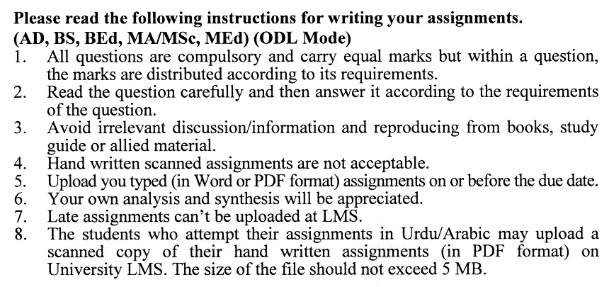

**Total Marks: 100 Pass Marks: 50**

**ASSIGNMENT No. 1**

Q.1 What are the seven P’s of marketing? Describe each with examples **(20)**

Q.2 Discuss the marketing planning process. Which step do you think is most important, and why? **(20)**

Q.3 Describe the steps involved in an effective marketing research process. **(20)**

Q.4 Discuss how Institutional and Government buyers make their buying decisions**.(20)**

Q.5 What are the elements of control and requirements that are essential for establishing control? Explain. **(20)**

**Total Marks: 100 Pass Marks: 50**

**ASSIGNMENT No. 2**

This assignment is a research activity. You are required to visit any business/commercial organization which has an international presence and study their marketing activities and practices as the whole of marketing of product and prepare a research report of about 15 to 20 pages on one of the topics given below. To avoid the duplication, you are required to select the topic according to the last digit of your roll number. For example, if your roll number is I-342718 then you will select topic # 8 from the list given below (last digit).

**Topics:**

1. Understanding Consumers.
2. Marketing Vs Sales
3. Marketing Strategy
4. Segmentation & Targeting
5. Positioning the Products
6. Complaint Handling in Service Delivery
7. Buyer Decision Process
8. Marketing Mix
9. Branding a Product
10. Market Orientation

**The assignment should be developed on the following format:**

• Introduction

• Review of literature

• The data collection

• Data analysis

• Conclusion and recommendations

• References

• Annexes

**Guidelines for submission of assignments**

You are required to prepare two copies of 2nd assignment. Submit one copy to your tutor/teacher for evaluation and the second copy for presentations in the workshop in the presence of the resource persons and classmates, which will be held at the end of the semester prior to the final examination.

**MARKETING MANAGEMENT (5434/8423/447)**

**UNIT–1: MARKETING FUNDAMENTALS**

Overview of the key concepts, Customers and Consumers, Business Marketing, Marketing vs. Sales, The marketing cycle, Marketing’s relationships to other functions, managing the marketing process, Marketing Mix

**UNIT–2: MARKETING STRATEGIES AND PARADIGMS**

Marketing Strategy & Planning Framework, Strategy formulation basics for marketing, Establishing company or divisional benchmarks, Understanding external market drivers and internal business issues, Marketing Orientation/Customer Focus Marketing myopia, Market segment and niches Target market, Product positioning, Market and Market share, The Marketing Plan (framework), Environmental scanning, Industry dynamics, Understanding the competition, Competitive Intelligence, Customer research project structure

**UNIT–3: SERVICES MARKETING**

An overview of the Service Sector and the Foundation of Services Marketing, Various Types of Services as Products, Borderless, Selling Quality, Gaps Analysis; Management of Services, Marketing Handling of Complaints’, Consumer Behavior, Factors affecting Consumer Buying Behavior, Buyer decision processes, Maslow’s hierarchy of needs

**UNIT–4: MARKETING RESEARCH**

An overview of Marketing Research Qualitative Marketing Research, Quantitative Marketing Research, Scales and Sampling, Techniques for Data Collection, Industry or Market Research—SWOT Analysis; Competitors Analysis; , Porter 5 Forces Analysis and Benchmarking, Data Analysis techniques used in Marketing Research

**UNIT–5: PRODUCT MANAGEMENT**

Defining and describing the product, Determining value and benefits, Product and its attributes, Product Differentiation, Product Marketing mix effectiveness, Relating the mix to market segments, Positioning, Understanding life cycle phases, Describing the product development process, Branding basics, Corporate Branding; family Branding; Individual Branding; and Trademark, Packaging and design, Product portfolio considerations

**UNIT–6: PRODUCT PRICING**

Pricing and Price, Price Points---Psychological Pricing and odd Pricing -Pricing Objectives, Discounts and Allowances -Penetration Pricing, Variable Pricing and Real Time Pricing-Profit Maximization, Price Discrimination -Price Elasticity of Demand, Geographical Pricing and Price Zoning-Cost-Plus Pricing, Rate of Return Pricing, Joint Product Pricing -Transfer Pricing

**UNIT–7: DISTRIBUTION**

The Concept of channels of Distribution, Retail—shopping malls; Department stores; convenience stores; Supermarket; Franchising, Wholesaler, Supply Chain and Supply Chain Management, Drop Shipping, Door to Door Shipping, Database Marketing, Multi-level Marketing

**UNIT–8: PROMOTION**

Marketing Communications, Marketing Communications Planning Framework, Integrated Marketing communications, Sales Promotion, Advertising, Personal Selling, Publicity, Public Relations

**UNIT–9: INTERNATIONAL MARKETING**

Environmental Forces to consider in international marketing, Adaptations of marketing mixes, Ways to enter foreign markets, Some risks to consider in international marketing: Nationalization, Changing value of currencies, Imposition of tariffs, quotas, and embargoes

**Recommended Books:**

1. Kotler, P., Keller, K. L., Ang, S. H., Tan, C. T., & Leong, S. M. (2021). Marketing management: An Asian perspective.
2. Kotler, P., & Keller, K. L. (2016). *A framework for marketing management* (p. 352). Boston, MA: Pearson.