**ALLAMA IQBAL OPEN UNIVERSITY, ISLAMABAD**

**(Department of Business Administration)**

**WARNING**

1. **PLAGIARISM OR HIRING OF GHOST WRITER(S) FOR SOLVING THE ASSIGNMENT(S) WILL DEBAR THE STUDENT FROM AWARD OF DEGREE/CERTIFICATE, IF FOUND AT ANY STAGE.**
2. **SUBMITTING ASSIGNMENT(S) BORROWED OR STOLEN FROM OTHER(S) AS ONE’S OWN WILL BE PENALIZED AS DEFINED IN “AIOU PLAGIARISM POLICY”.**

**Course: Entrepreneurship (8424) Semester: Spring, 2025**

**Level: BBA (4 Years)**

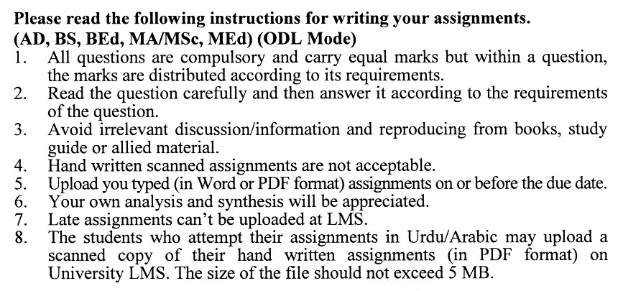

**Total Marks:100 Pass Marks: 50**

**ASSIGNMENT No. 1**

Q. 1 Discuss the role of **personal attributes, environmental factors, and sociological factors** in starting a new enterprise. Provide examples of how these factors influence the entrepreneurial process.  **(20)**

Q. 2 Explain the process of **opportunity recognition, shaping, and reshaping** in entrepreneurship. How do passion and idea multiplication contribute to the development of a business idea? **(20)**

Q. 3 Critically assess the importance of a **revenue model and cost model** in the development of a business model. How do these models contribute to entrepreneurial success? **(20)**

Q. 4 Discuss the components of a comprehensive **business plan**. How does the business planning process aid in achieving entrepreneurial objectives? **(20)**

Q. 5 Explain the process of creating a **Pro-Forma Financial Statement**. Discuss the importance of revenue projections, cost of goods sold, and operating expenses in this context. **(20)**

**ASSIGNMENT No. 2**

**Total Marks: 100 Pass Marks: 50**

This assignment is a research-oriented activity. You are required to prepare a detailed report of about 3000 words on the topic allotted to you to be submitted to your teacher for **evaluation**.

You are required to select one of the following topic according to the last digit of your registration number. For example, if your registration number is 18-IDM-3427183 then you will select topic # 3(the last digit): -

**List of Topics:**

1. Bootstrapping and Team Development at Different Venture Stages
2. Role and Impact of External Team Members in Entrepreneurial Projects
3. Addressing Challenges to Keep the Entrepreneurial Team Together
4. Understanding the Business Model: Revenue and Cost Perspectives
5. Dispelling the First Mover Myth in Entrepreneurship
6. Crafting a Winning Strategy: People-Centric, Entry, and Growth Strategies
7. Marketing's Role in Entrepreneurship: Strategies and Skills
8. The Story Model in Business Planning
9. Types of Business Plans and Components
10. Overview of Financial Statements in Entrepreneurial Ventures

**GUIDELINES FOR ASSIGNMENT # 2:**

* 1.5 line spacing
* Use headers and subheads throughout all sections
* Organization of ideas
* Writing skills (spelling, grammar, punctuation)
* Professionalism (readability and general appearance)
* Do more than repeat the text
* Express a point of view and defend it.

**ENTREPRENEURSHIP**

**Course Code (5026/8424)**

**Unit–1: Entrepreneurial Process**

1. Entrepreneurship in Global Perspective
2. Factors for Starting a New Enterprises
3. Personal Attributes
4. Environmental Factors
5. Other Sociological Factors
6. Evaluating Opportunities for New Businesses
7. Ingredients of a Successful Business

**Unit–2: Initial Steps to Set Up an Entrepreneurial Project**

1. Opportunity Recognition, Shaping and Reshaping
2. From Glimmer to Action: How Do I Come Up with a Good Idea
3. Finding Passion
4. Idea Multiplication
5. Ideas and Opportunities
6. Selection of the Founding Team
7. Bootstrapping: Building Team Based on Stage-of-Venture Life
8. External Team Members
9. Keeping the Team Together
10. Burnout
11. Family Pressure
12. Interpersonal Conflict

**Unit–3: Understanding the Business Model and Developing Strategy**

1. Business Model
2. Revenue Model
3. Cost Model
4. First Mover Myth
5. Formulating a Winning Strategy
6. People Centric Strategy
7. Entry Strategy
8. Growth Strategy
9. Marketing and Entrepreneurship
10. Marketing Strategies for Entrepreneurs
11. Marketing Skills for Managing Growth

**Unit–4: Business Planning Process**

1. Planning Process
2. Story Model
3. Business Plan
4. Types of Business Plans and its Components

**Unit–5: Building Pro-Forma Financial Statement**

1. Overview of Financial Statements
2. Building Pro-Forma Financial Statement
3. Expected Revenue and Expenditure
4. Revenue Projections
5. Cost of Goods Sold
6. Operating Expenses
7. Preliminary Income Statement
8. Building Integrated Financial Statements
9. Income Statement
10. Balance Sheet
11. Cash Flow Statement

**Unit–6: Financial Entrepreneurial Ventures Worldwide**

1. Microfinance and Entrepreneurship
2. Entrepreneurs and Informal Investors
3. Venture Capital
4. Factors Affecting Availability of Financing
5. Bootstrapping New Ventures Valuation
6. Financing New Venture
7. Informal Investors
8. Business Angels
9. Venture Capitalists
10. Harvesting Investment
11. Initial Public Offering
12. Selling the Company
13. A Strategic Acquisition

**Unit–7: Equity and Debt Financing**

1. Equity Financing
2. Common Stock
3. Deferred Stock
4. Debt Financing
   * 1. Bonds
     2. Debentures

**Unit–8: Legal and Tax Issues**

1. Choosing a Name of Entrepreneurial Venture
2. Legal and Tax Issues in Hiring Employees
3. Insurance
4. Raising Money and Legal Issues

**Unit–9: Entrepreneurial Growth**

1. Making the Transition from Startup to Growth
2. Driving Forces of Growth
3. Growth Process
4. Exit Strategy

**Recommended Books:**

Bygrave D.W., & Zacharakis A. (2010). *Entrepreneurship* (2nd ed.). U.S.A.: John Wiley & Sons.

Hisrich D.R., Peters P.M., & Shepherd A. D. (2009). *Entrepreneurship* (8th ed.). Illinois, U.S.A.: McGraw-Hill/Irwin

Kuratko F.D., & Hodgetts M. R. (2008). *Entrepreneurship: Theory, Process, and Practice* (8th ed.). Ohio, U.S.A.: South-Western Pub.

****