**ALLAMA IQBAL OPEN UNIVERSITY, ISLAMABAD   
(Department of Business Administration)**

**WARNING**

1. **PLAGIARISM OR HIRING OF GHOST WRITER(S) FOR SOLVING THE ASSIGNMENT(S) WILL DEBAR THE STUDENT FROM THE AWARD OF DEGREE/CERTIFICATE IF FOUND AT ANY STAGE.**
2. **SUBMITTING ASSIGNMENT(S) BORROWED OR STOLEN FROM OTHER(S) AS ONE’S OWN WILL BE PENALIZED AS DEFINED IN THE “AIOU PLAGIARISM POLICY”.**

**Course: Management Information Systems (8429) Semester: Spring, 2025**

**Level: BBA (4 Years)**

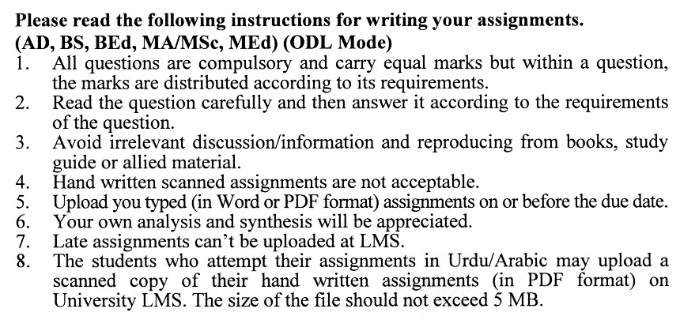

**Guidelines FOR ASSIGNMENT # 1:**

You should look upon the assignments as a test of knowledge, management skills, and communication skills. When you write an assignment answer, you are indicating your knowledge to the teacher:

* Your level of understanding of the subject;
* How do you think?
* How well you can reflect on your knowledge & experience?
* How well you can use your knowledge in solving problems, explaining situations, and describing organizations and management?
* How professional you are, and how much care and attention you give to what you do?

To answer a question effectively, address the question directly, bring important related issues into the discussion, refer to sources, and indicate how principles from the course materials apply. You must also be able to identify important problems and implications arising from the answer.

For citing references, writing bibliographies, and formatting the assignment, APA format should be followed.

## ASSIGNMENT No. 1

**Total Marks: 100 Pass Marks: 50**

Q. 1 How do contemporary businesses manage the complexities associated with Information Technology (IT), including cybersecurity risks, digital transformation demands, IT governance frameworks, and talent management, to ensure the effective use and alignment of IT resources with organizational goals? (**20)**

Q. 2 In what ways can the strategic implementation of application software drive improved efficiency and productivity within a business setting? Illustrate with examples of essential application software types, explaining their roles and influence on organizational operations, decision-making processes, and customer engagement strategies. (**20)**

Q. 3 How has the Internet revolutionized various aspects of society, business, and communication? Explore the transformative impact of the Internet on global connectivity, information dissemination, e-commerce, and social interactions, and discuss both the opportunities and challenges presented by this revolutionary technological advancement. **(20)**

Q. 4 How has the evolution of electronic commerce (e-commerce) influenced the nature of business interactions and market dynamics? Discuss the critical drivers behind its expansion, as well as the advantages and obstacles organizations encounter in adopting e-commerce strategies. **(20)**

Q. 5 In what ways do business information systems support the optimization of organizational operations, strategic decision-making, and performance outcomes? Explain the essential elements and functions that drive their effectiveness. **(20)**

**ASSIGNMENT No. 2**

**Total Marks: 100 Pass Marks: 50**

This assignment is a research-oriented activity. You are required to submit a term paper. You will have to participate in the activity fully and prepare a paper of above 15 to 20 pages on the topic allotted to you.

**Include the following main headings in your report:**

1. Introduction to the topic
2. Important sub-topics
3. Practical study of the organization for the topic
4. Review of theoretical and practical situations
5. Merits, demerits, deficiencies or strengths of the organization for the topic under study
6. Conclusions and recommendations
7. Annex, if any

You are required to select one of the following topics according to the last digit of your roll number. For example, if your roll number is D-3427185 then you will select the topic number. 5 (the last digit).

**List of Topics:**

1. Data Resource Management
2. Electronic Commerce
3. Executive Information System
4. Managing IT Functions
5. Role and Importance of Intranet
6. Role of IT in Organization Planning
7. Security Management and Security Measures
8. Strategic use of IT
9. System Approach to Problem Solving
10. Transaction Processing System

**MANAGEMENT INFORMATION SYSTEMS**

**COURSE OUTLINE (8429)**

# **Unit–1: Information Systems and Strategic Information Technology**

* 1. Importance and Fundamental Roles of Information Systems
  2. Fundamental Concepts, Components, Resources, and Activities of Information Systems
  3. Trends and Types of Information Systems
  4. Role of E-Business and IT
  5. Managerial Challenges of Information Technology
  6. Information Technology, Strategy, and Strategic Advantage
  7. Strategic Uses of IT
  8. Value Chain and Strategic IS
  9. Reengineering Business Processes
  10. Becoming an Agile, Virtual, or Knowledge-Creating Company

**Unit–2:** **Information Technology- I**

* 1. Trends and Generations of Computer Systems
  2. Concepts and Components of Computer System
  3. Computer Peripherals: Input, Output, and Storage Technologies
  4. Introduction to Application Software
  5. Software Suites and Integrated Packages
  6. Web Browsers and Electronic Mail
  7. Word Processing, Desktop Publishing, Electronic Spreadsheets, Database Management, Presentation Graphics and Multimedia, Personal Information Managers, GroupWare etc.
  8. Introduction to System Software
  9. Operating Systems, Network Management Programs, Database Management Systems, and Other System Management Software Programs
  10. Programming Language and Programming Packages

**Unit–3:** **Information Technology-II**

* 1. Telecommunication Technologies and Internetworked Enterprises
  2. Internet Revolution and Information Superhighway
  3. Telecommunication Network Model
  4. Types of Telecommunications Networks
  5. Telecommunications Alternatives, Telecommunications Media, Telecommunications Processors, Telecommunications Software, Telecommunications Network Topologies, and Network Architectures & Protocols
  6. Bandwidth Alternatives, Switching Alternatives, and Access Alternatives
  7. Introduction to Databases and Database Management Approach
  8. Database Management Software
  9. Types of Databases and Database Structures
  10. Managerial Considerations for Data Resource Management
  11. Object Technology

**Unit–4: Internet & Electronic Commerce**

* 1. Role and Importance of the Internet in Businesses
  2. Interactive Marketing
  3. Customers and the Internet
  4. Electronic Commerce: Fundamental Concepts and Scope
  5. Essential Processes of Electronic Commerce
  6. Electronic Payments and Security
  7. Electronic Commerce Applications
  8. Electronic Commerce Issues and Challenges
  9. Role and Importance of Intranet in Businesses
  10. Applications & Future of Intranets
  11. Role & Future of Extranets

**Unit–5: Enterprise Collaboration and IS for Business Operations**

* 1. Introduction to Enterprise Collaboration
  2. Groupware for Enterprise Collaboration
  3. Electronic Communications, Electronic Conferencing, and Collaborative Work Management Tools
  4. Business Information Systems
  5. Cross-Functional Information Systems
  6. Enterprise Application Integration
  7. Marketing Information Systems, Manufacturing Information Systems, Human Resource Information Systems, Accounting Information Systems, Financial Information Systems
  8. Transaction Processing Systems, Data Entry Process, Batch Processing, Real-Time Processing, Database Maintenance, Document & Report Generation, and Inquiry Processing
  9. Customer Relationship Management: Introduction, Trends, Benefits, Issues etc.
  10. Enterprise Resource Planning: Introduction, Trends, Benefits, and Challenges etc.
  11. Supply Chain Management: Introduction, Trends, Benefits, Issues, etc.

**Unit–6: Management Information Systems and Decision Support Systems**

* 1. Decision Support Systems (DSSs) Applications and Trends
  2. Management Information Systems (MISs)
  3. Online Analytical Processing (OLAP)
  4. Executive Information Systems (EISs)
  5. Knowledge Management Systems (KMSs)
  6. Artificial Intelligence (AI)
  7. Neural Networks
  8. Fuzzy Logic Systems
  9. Genetic Algorithms
  10. Virtual Reality
  11. Intelligent Agents
  12. Expert Systems: Components, Applications, Developing Expert Systems, Value and Challenges of Expert Systems
  13. Hybrid AI System

**Unit–7:** **Development of Business/IT Strategies and Information Systems**

* 1. Organizational Planning Process & Scenario Approach to Planning
  2. SWOT Analysis
  3. Business Models
  4. Business/IT Architecture Planning
  5. Identification of Business/IT Strategies
  6. Planning Business Applications
  7. Implementing Strategies and Applications, and Dealing with Challenges
  8. Introduction to IS Development
  9. Systems Approach to Problem Solving
  10. Systems Development Process: System Analysis and Feasibility Analysis, System Design, Prototyping, System Development, System Implementation, and System Maintenance

**Unit–8: Information Technology (IT) Management**

* 1. Organizations, Managers and IT
  2. Planning IT
  3. Managing IT Functions
  4. Organizing IT
  5. Outsourcing and Offshoring IT
  6. IT Failures and IT Governance
  7. IT in Global Scenario
  8. Managing IT Globally
  9. Dealing with Cultural, Political, and Geo-Economic Issues
  10. Global IT Applications & Strategies
  11. Internet for Global IT
  12. Global Systems and Global Information Access

**Unit–9: Challenges and Issues of IT/IS**

* 1. Security & Control Issues
  2. Ethical Issues
  3. Societal Challenges
  4. Computer Crime
  5. Privacy Issues
  6. Health Issues
  7. Managing Organizational Change
  8. Security Management and Security Measures
  9. Auditing Information Systems

**Recommended Books:**

* O’Brien, J. A., &Marakas, G. M. (2011). *Management Information Systems*(10th ed.). Islamabad: National Book Foundation.
* Laudon, K. C., & Laudon, J. P. (2011). *Management Information Systems*(12th ed.). New York: Prentice Hall.
* Kenneth, C., & Jane, P. (2009). *Management Information Systems* (7th ed.). New York: Prentice Hall.
* James, A., & George, M. (2008). *Management Information Systems*. New York: McGraw Hills Inc.

