**ALLAMA IQBAL OPEN UNIVERSITY, ISLAMABAD**

**(Department of Business Administration)**

**WARNING**

1. **PLAGIARISM OR HIRING OF GHOST WRITER(S) FOR SOLVING THE ASSIGNMENT(S) WILL DEBAR THE STUDENT FROM AWARD OF DEGREE/CERTIFICATE, IF FOUND AT ANY STAGE.**
2. **SUBMITTING ASSIGNMENT(S) BORROWED OR STOLEN FROM OTHER(S) AS ONE’S OWN WILL BE PENALIZED AS DEFINED IN “AIOU PLAGIARISM POLICY”.**

**Course: Economy of Pakistan (8432) Semester: Spring, 2025**

**Level: BBA (4 Years)**

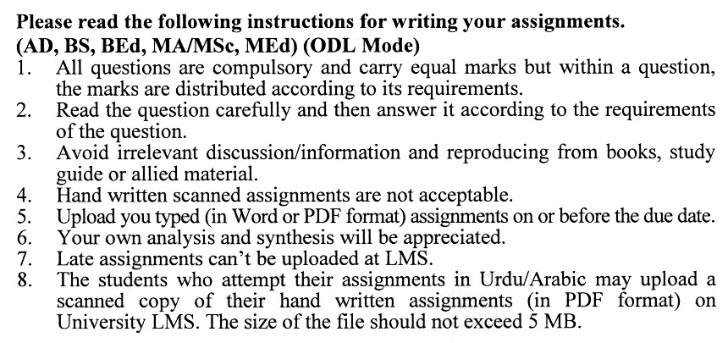

**Total Marks: 100 Pass Marks: 50**

**ASSIGNMENT No. 1**

***Note: Attempt all questions.***

Q. 1 Highlight and briefly explain the factors influencing capital accumulation and discuss the challenges and opportunities associated with enhancing capital formation in the country. **(20)**

Q. 2 Critically analyze the current agricultural marketing policy of Pakistan, focusing on its objectives, structure, and implementation. Discuss how the policy supports the promotion of agricultural goods and services to achieve organizational and national economic goals. **(20)**

Q. 3 Examine the phenomenon of inflation, highlighting its causes and impact on Pakistan's socio-economic structure. Suggest policy interventions and strategies to manage inflation effectively in the country. **(20)**

Q. 4 What steps have been taken by the government to improve the agriculture credit process and what type of institutional support is available in Pakistan for such credits? Explain with examples. **(20)**

Q. 5 Critically evaluate the China-Pakistan Economic Corridor (CPEC) project, discussing its scope, objectives, and potential impact on Pakistan's economic development. Analyze how CPEC could address critical challenges such as infrastructure deficits, energy shortages, and regional connectivity. **(20)**

**ASSIGNMENT No. 2**

**Total Marks: 100 Pass Marks: 50**

***Note: Attempt all questions.***

Q. 1 Describe the key characteristics and trends of Pakistan's foreign trade, focusing on its major export and import commodities, trading partners, and trade balance over the years. **(20)**

Q. 2 Explain the role of exchange rates in shaping Pakistan’s trade dynamics. How has Pakistan dealt with challenges arising from globalization and its commitments to the World Trade Organization (WTO)? **(20)**

Q. 3 How effective has monetary policy been in controlling inflation in Pakistan? Critically analyze the role of monetary management and money supply expansion in addressing inflationary pressures, highlighting the challenges faced by policymakers. **(20)**

Q. 4 Give a comparison of the Poverty Alleviation and Bonded Labor. **(20)**

Q. 5 What are the underlying factors contributing to low saving rates in Pakistan, and how do they impact the country’s monetary stability and economic growth? Evaluate the potential reforms needed to enhance savings and improve monetary outcomes. **(20)**

# COURSE OUTLINES (8432)

**Course: Economy of Pakistan Course Code: 8432**

**Level: BBA (4 Years) Credit Hours: 03**

**Unit-1 ASSESSING PAKISTAN’ DEVELOPMENT**

* 1. Structural Changes
  2. Five Decades and Five Epochs
  3. The Balance Sheet
  4. Conclusion

### Unit-2 AGRICULTURE DEVELOPMENTS

* 1. Development of Agriculture Before the consolidation of British rule
  2. Impact of British colonialism
  3. Feudal or Capitalist
  4. Perception of Feudalism
  5. Crop Production
  6. Green Revolution and Land Reforms
  7. Rural Financial Markets and Agriculture Credit
  8. Mechanization
  9. Agriculture Income Tax
  10. Water Crisis

### Unit-3 INDUSTRIALIZATION PROCESS

* 1. Process of Industrialization in Pakistan 1947–77
  2. Exchange Rates, Trade Policies & Import Substituting Industrialization
     1. Decade of Development
     2. Bhutto Years
  3. Process of Industrialization in Pakistan 1977-on wards
     1. Zia years
     2. Age of Structural Adjustment
     3. Textile industry Crisis
     4. Public Sector Industry has been a failure?
     5. Privatization Process

### Unit-4 BALANCE OF PAYMENTS & TRADE REGIMES

* 1. Pakistan’s Foreign Trade: Basic Facts
  2. Trade Policy and Trade Regimes
  3. Efficiency and Trade Regime (Debate)
  4. Exchange Rate
  5. Dealing with Globalization and WTO

### Unit-5 MONETARY POLICY, SAVINGS & INFLATION

* 1. Monetary Policy and Monetary Management in Pakistan
  2. Money supply and Money expansion
  3. Inflation and Its causes
  4. Low Saving Rates

### Unit-6 FISCAL POLICY

* 1. Important Issues in Public Finance and Resource Mobilization
  2. Does Fiscal Deficit Matters
  3. Critical Concern Regarding Pakistan Fiscal Deficit
  4. Domestic & Foreign Debt Crises
  5. Development of Banking Sector
  6. Equities Market

### Unit-7 MACROECONOMIC DEVELOPMENT

* 1. Before & After 1998
  2. September 11,2001: The Day World Changed
  3. What Happened to the Debt Crisis?
  4. Growing Forex Reserves
  5. Turnaround in the Economy

### Unit-8 Poverty: Trend, Causes and Solution

* 1. Poverty Meaning
  2. Trends in Poverty
  3. Who are Poor and Where do they live?
  4. Why Poverty Returns to Pakistan and Still Persist?
  5. Poverty Alleviation
  6. Poverty and Bonded Labor
  7. Can poverty be eliminated in Pakistan?

### Unit-9 Political Economics

* 1. India & Pakistan: A brief comparison
  2. Theorizing Trade, War and Peace
  3. Trade with India (Benefits and Constraints)
  4. Civilian Bureaucracy and Industrialization
  5. Civilian and Military Bureaucratic Capitalism
  6. Military State (1977–88) and Military Return 1999
  7. Issues in Pakistan’s Economy

**Recommended Book:**

Zaidi, S. Akbar. "Issues in Pakistan's Economy." *OUP Catalogue* (2005).

