ALLAMA IQBAL OPEN UNIVERSITY, ISLAMABAD

**(Department of Business Administration)**

|  |
| --- |
| **WARNING**   1. **PLAGIARISM OR HIRING OF GHOST WRITER(S) FOR SOLVING THE ASSIGNMENT(S) WILL DEBAR THE STUDENT FROM THE AWARD OF DEGREE/CERTIFICATE IF FOUND AT ANY STAGE.** 2. **SUBMITTING ASSIGNMENT(S) BORROWED OR STOLEN FROM OTHER(S) AS ONE’S OWN WILL BE PENALIZED AS DEFINED IN THE “AIOU PLAGIARISM POLICY”.** |

**Course: Logistics Management (9543) Semester: Spring, 2025**

**Level: PGD Credit Hours: 03**

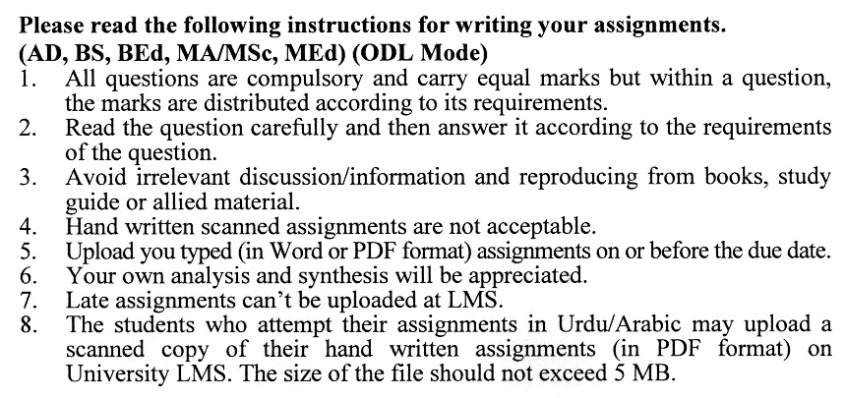

**Total Marks: 100 Pass Marks: 50**

**ASSIGNMENT No. 1**

***Note: Attempt all the questions.***

Q. 1 What is the role of logistics management in ensuring the smooth flow of goods and services in a supply chain? **(20)**

Q. 2 What are the key components of logistics management, and how do they contribute to operational efficiency? **(20)**

Q. 3 How can businesses optimize transportation and distribution to reduce costs and improve delivery performance? **(20)**

Q. 4 What are the challenges faced in logistics management, and how can they be addressed? **(20)**

Q. 5 How does technology, such as automation, GPS, and real-time tracking, enhance logistics operations? **(20)**

**Guidelines FOR ASSIGNMENT # 1**

The student should look upon the assignments as a test of knowledge, management skills, and communication skills. When you write an assignment answer, you are indicating your knowledge to the teacher:

* Your level of understanding of the subject;
* How you think;
* How well you can reflect on your knowledge & experience;
* How well you can use your knowledge in solving problems, explaining situations, and describing organizations and management;
* How professional you are, and how much care and attention you give to what you do.

To answer a question effectively, address the question directly, bring important related issues into the discussion, refer to sources, and indicate how principles from the course materials apply. The student must also be able to identify important problems and implications arising from the answer.

For citing references, writing bibliographies, and formatting the assignment, APA format should be followed.

**ASSIGNMENT No. 2**

**Total Marks: 100 Pass Marks: 50**

This assignment is a research-oriented activity. You are required to obtain information from a business/commercial organization and prepare a report of about 1000 words on the issue allotted to you to be submitted to your teacher for evaluation.

You are required to select one of the following issues according to the last digit of your roll number. For example, if your roll number is P-3427180 then you will select issue # 0 (the last digit): -

**Issues:**

1. Infrastructure Development and Modernization
2. Technology Integration and Digitalization
3. Last-Mile Delivery Solutions
4. Warehouse and Distribution Center Optimization
5. Sustainability and Green Logistics
6. Supply Chain Resilience and Risk Management
7. Cross-Border Logistics and Customs Facilitation
8. Transport and Fleet Management
9. E-commerce and Retail Logistics
10. Cold Chain Logistics

The report should follow the following format:

1. Title page
2. Acknowledgements
3. An abstract (one-page summary of the paper)
4. Table of contents
5. Introduction to the issue (brief history & significance of issue assigned)
6. Practical study of the organization (for the issue)
7. Data collection methods
8. SWOT analysis (strengths, weaknesses, opportunities & threats) relevant to the issue assigned
9. Conclusion (one-page brief covering important aspects of your report)
10. Recommendations (specific recommendations relevant to the issue assigned)
11. References (as per APA format)
12. Annexes (if any)

**GUIDELINES FOR ASSIGNMENT # 2:**

* 1.5 line spacing
* Use headers and subheads throughout all sections
* Organization of ideas
* Writing skills (spelling, grammar, punctuation)
* Professionalism (readability and general appearance)
* Do more than repeat the text
* Express a point of view and defend it.

****